
TECHNOPRENEURSHIP SEMINAR
SCSD3761 - SECTION 02

Innovating Your Business

AQUANTAE
Group Members |   Shahrul Asyraf Bin Muhammad Hisham Segaran | 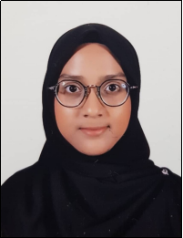  Aqilah Hanim  Binti Mohd Taufik | 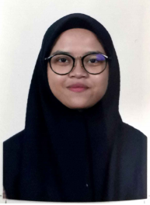  Nur Hidayah Binti Hamri |   Nurul Najiha Binti Hamdan | 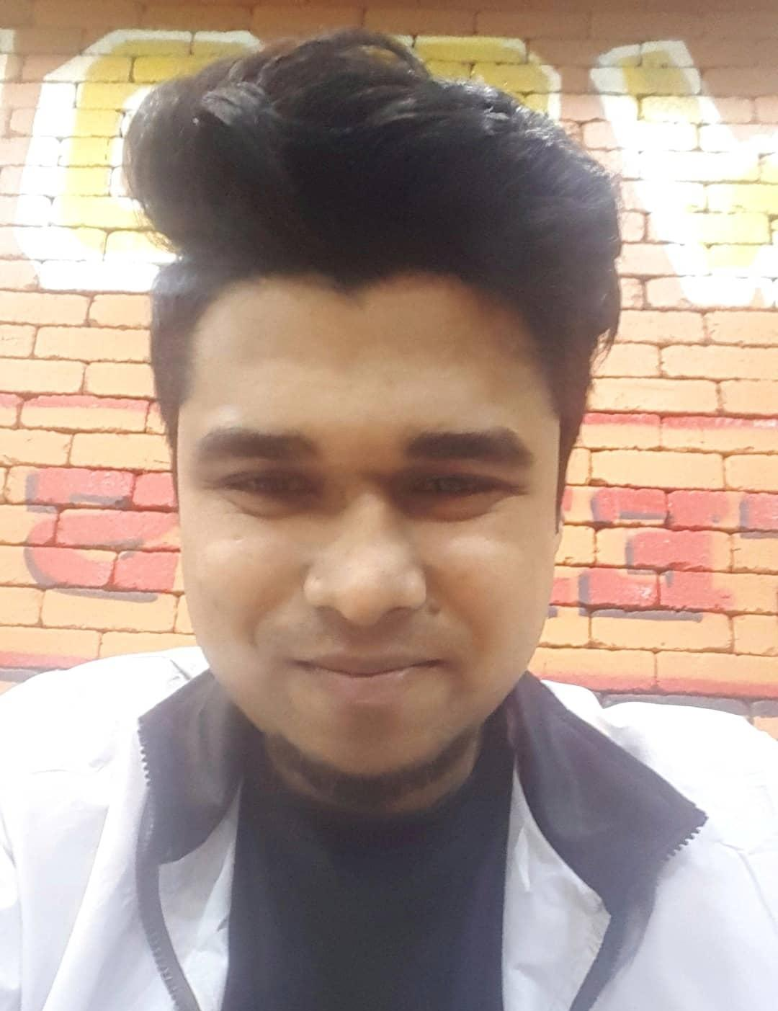  Mohhamad Arif Istiaq
Matrics Number | A17CS0201 | B19EC0006 | B19EC0046 | B19EC0047 | A17CS4028
Section | 24 | 24 | 24 | 24 | 25

Lecturer : Mr. Hairudin Bin Abdul Majid
Due Date : 2nd December 2020 (Wednesday)
Introduction of Cendolah Business
Mr Vathumalai has been in the industry for more than 30 years experience. He realized that the difference in success or failure is not based on your outer appearance or how educated you are. It is all about thinking ahead about what we want to do in our life followed by determination to succeed and prioritize important things into actions. He said that everyone has their own dreams to succeed in life but in order to make it come true, it takes a lot of determination, dedication, self-discipline and effort which is very important to beginner and expert entrepreneurs. Before starting his Cendolah business, he had a vadei business which is a traditional food for Indian but he closed down the business because of the difficulty of financial and lack of R&D (research and development) capabilities.
Mr Vathumalai started Cendolah business in 2005. He said that he always chooses street food for his business because he believed that we must have our own local foods that need to be innovated with new ideas with the latest trends and demands. He did the research about all the street foods in Malaysia and this is the reason why he started Cendolah business to improve Southeast Asia’s favourite dessert.
He reported that innovation is very important for business, industry and technology because without revolution, nothing will change. He took a different outlook for Cendolah business by looking for innovation, started doing the right certification and approach although he has no support from people around him. He started with the cendol kiosk concept and the transformation of the kiosk itself. Then he focused and transformed the concept of syrup used in the cendol about its quality, process technology and certification. He did a lot of events, promotions, and attended a seminar of Malaysia Restaurant Food Festival at PWTC in 2009. He received plenty of support from Johor state government because they understand his innovative idea for cendol dessert until his idea is released into the newspaper as a press release.
Why are trademarks important in the industry?
Mr Vathumalai already applied his trademark from the first day he built his product which is Cendolah. He said that, after he built his brand for 6 years, MyiPo refused to register his trademark and they said that his trademark is so generic. Due to his generic trademark name and they did not want to register it, it crushes his dream and effort after so many years he stands with his trademark.
He did not stop there but he tried to appeal and represent himself and won the legal case about the trade mark and got to register his trademark in 2012. When the first time he wanted to register his trademark name, the MyiPo already gave him Surat Bantahan Kekal for his trademark but fought for it until he won. Many big companies also help him to build his career such as UNIDOR and MARDI. Mr Vathumalai said that this Cendolah is very common among Malaysian so it will go well everywhere such as Malaysian and Indonesian.
After that, they also have a question for Mr Vathumalai which is why the trademark is very important to build the company.m Is it possible to build a trademark after the company already succeeded or made a trademark before the company became successful? He said that ‘‘trademark is very important to a company to protect your idea, the first day you already think to build a company you also must think of the trademark or the brand” . He added “without a brand, it does not work”. Brand is important to show the company to people, without a brand also people find it difficult to identify and remember the company.
Challenges in the industry and during covid-19
Mr Vathumalai says that frustration is a challenge as people are not willing to accept new ideas. The challenge was basically to change people’s perception and mindset. To try new things. That was the biggest hurdle. No one was going to support you. The main thing is money. You might think that the business idea is great but people might not think the same as you do. Most of the time, there will be customer resistance, where people will never appreciate you. All you can do as an entrepreneur is to keep on promoting and start thinking about your marketing strategies. Besides that, he also states that creating a niche market was a challenge.
But Mr Vathumalai did not enter a retail market because people did not accept his product, which led him to go into the bubble tea market. The ingredients of the bubble tea synced in perfectly with his syrup. But he did not want to enter the retail market as he thinks that he does not have the right product yet at the moment. Next, Mr Vathumalai stated about syrup and how it is not an easy product as it comes from coconut. Malaysians, Indonesians and Singaporeans did not like his product. They preferred to have instant cendol instead. But thankfully, Malaysians are consuming his product through bubble teas that are in the market. Continuous R&D equals to having to have a lot of money. He sacrificed a lot of his properties for this business. ‘In innovation, you have to keep on moving. Whatever happens, you have to keep on moving.’He says.
Those were the main challenges he faced from 2004 to 2009. He also stated that an entrepreneur should not give up easily. The perseverance must be there. Innovation is the key to success. When the Covid-19 outbreak hit Malaysia, it was a culture shock for everyone. Business went to a complete standstill. Mr Vathumalai says that an entrepreneur should learn how to adapt. If you don’t, the business will collapse.
That is why over 30 companies had to shut down their businesses. They couldn’t adapt well. This is because they did not change their business models. Luckily in his case, his business is always transforming. Always innovating. That’s why he survived. If not, he doesn’t think that his business will survive. Thankfully, his business is still going strong. His new innovations are keeping the business up on track. He found new customers, a new market and he came on a new level now.
Prototype of Cendolah (Coconut Caramel Drinks)
Mr. Vathumalai surprisingly revealed that Cendolah is not actually doing cendol. It might have started off that way, but somewhere along the line it had changed to doing syrups. Mr. Vathumalai prides himself in being an expert in syrup in Malaysia and calls himself a concocter of syrup. His syrup is bought by big brands and he says that they always buy his product because of ideas and technology. He then revealed some new packaging for his products which was quite odd because it’s the first time a company packaged syrup like this. It was definitely on the next level as he says and he is excited to export the product internationally by next month.
Mr. Vathumalai then continued to show us the cultivation of his 13-year dream come to life. He revealed the prototype for ready to drink cendol in a cup. He said it was not easy to make this idea a realization because coconut is a troublesome ingredient. But during the MCO, he developed a new syrup that would allow his dream to come true. The ready to drink cups will be available next year and his plan is to distribute them using vending machines and also through online marketing. He is also excited to release this product in the global market. It took him 13 to 15 years but he finally made one of his dreams come true.

Financial education before starting business and how to handle
Mr. Vathumalai said that dedication and commitment is a must key thing in the business. He also added that before going to market , first we need to know the market. Because, there is no way we can enter a market without knowing. After knowing the market, we have to launch a product according to the customers' needs. He also added that we have to launch a product by looking at the cost and also how to deliver those products.
He further added that, without financial education management, everything will fail. For a new entrepreneur,he needs to look into the financial part. Adaptation is the main key thing here. Without adaptation, no entrepreneur can survive. Because, the habits of the customers are changing. So new entrepreneurs need to adapt to new things. Furthermore, all the entrepreneurs need to do the paperworks for the financial part. He said that to come up with a new product , a new idea.
He further added that , at the very first of the business ,don't think about the money. Always believe in your idea. Because, the idea is very important. If the idea is very good,all the support will come to you,he added that.

Reflection of report
Reflection (Mohhamad Arif istiaq) : From Mr. Vathumalai’s talk , I came to know a lot of things about financial education as well as how to handle this part . Also, I came to know how the business works. And also I have learned to always keep believing in my dreams.
Reflection (Nur Hidayah) : What I learned from Mr Vathumalai talks is he really likes what he is doing now and he also loves to innovate something that can benefit other people. Since he started thinking about starting this business, he is determined to focus on this business by always learning something new. He met a lot of people to learn how to make his product more quality and the important thing is he has high confidence in extracting product from local street food. That made me feel impressed with high-confidence that he had.
Reflection (Aqilah Hanim) : For my part of the reflection, I’ve learnt a few things. But the main focus comes to handling challenges. In Mr Vathumalai’s talk, he stated that an entrepreneur should never give up hope. To be an entrepreneur, one has to keep moving forward. Even at his age, Mr Vathumalai knows so much about innovating. Seeing how he handles his challenges made me realize how much I would have lost if I gave up hope. I am deeply impressed by him.
Reflection (Nurul Najiha) : From Mr Vathumalai’s talk, the main point that I learned from him is never give up in whatever thing that you want to do in life as long as it is making you happy. Passion and self-discipline are fundamental mindset for someone to continue on what they are doing. Business is not my speciality but from his talk, I know that becoming an entrepreneur is not easy and beautiful as what you see in social media. It takes a lot of time to build your own empire and create the idea so that society understands and trusts what we are doing for the future.
Reflection (Shahrul) : From the talk, the main thing I got is that determination and commitment is two very important things that an entrepreneur needs to have. It took Mr. Vathumalai almost 15 years to get to where he is at now and for that I respect him for it.

