

ASSIGNMENT 2
OUTPUT PRIMITIVE OPENGL
SCSV 2213-01: FUNDAMENTAL OF COMPUTER GRAPHICS

LECTURER
DR. NORHAIDA BINTI MOHD SUAIB

PREPARED BY
AIMI BINTI RUSDI (B19EC0001)
AQILAH HANIM BINTI MOHD TAUFIK (B19EC0006)

Bachelor of Computer Science (Computer Graphics and Multimedia Software)
© 2020 All Right Reserved
TABLE OF CONTENTS

Title | Page
- Introduction | 1
- Development of the Paint Program | 2 - 8
- DDA Lines  - Coding  - Output | 9  10
- Midpoint of Circle  - Coding  - Output | 11  12
- Midpoint of Ellipse  - Coding  - Output | 13 - 14  15
- Full Opengl Coding  - Coding  - Output | 16 - 20  21
- References | 22

INTRODUCTION
In order to create a picture, it has to be thoroughly particularized by the set of intensities for the pixel positions in the display. Pixel arrays described into the frame buffer or the set of basic geometric are to develop the shape and colours of the objects. For an example, straight lines and the fill in polygon areas. The formation of any object is is known as output primitives.
The basic elements creating a graphic are called output primitives. Output primitives can be assembled into more complex structures. Each and every output primitive is specified with input coordinate data and other information about the form that the object is to be displayed. For example, points, lines and circles all have specified coordinates.

DEVELOPMENT OF THE PAINT PROGRAM
- Line (DDA Algorithm)

void dda(int x0, int y0, int xend, int yend) {
glColor3f(1.0, 0.0, 0.0); //Set pixel to red
glPointSize(5.0f);
glBegin(GL_LINES);
// writes pixels on the frame buffer with the current drawing color
glVertex2i(xstart, ystart); // sets vertex
glVertex2i(xend, yend);
glEnd();
}

Using DDA algorithm to construct a line is far more easier than using Brasenham’s line algorithm. glVertex2i(xstart, ystart) represents the starting vertex of the line while glVertex2i(xend, yend) represents the ending vertex of the line. DDA attempts to generate the points between the starting and the ending vertex. glColor3f(1.0, 0.0, 0.0) sets the colour of the line. In our example, we chose to use the colour red. glPointSize(5.0f) specifies the size of the point. glBegin(GL_LINES) shows that there are pairs of vertices used to draw segments. glBegin and glEnd limits the vertices that defines the group of primitives.

- Midpoint of Circle

void midCircle(int xCenter, int yCenter, int radius) {
glColor3f(1.0, 0.0, 1.0); //Set pixel to purple
int x = 0;
int y = radius;
int p = 1 - radius; //rounded to 1 for integer radius

while (x < y) { //literates to draw the first sector
x++;
if (p < 0) //midpoint is inside the circle
p += 2 * x + 1;
else { //midpoint outside or at circle
y--;
p += 2 * (x - y) + 1;
}

glBegin(GL_POINTS);//set using vertex instead of setPixel

glVertex2i(xCenter + x, yCenter + y);
glVertex2i(xCenter - x, yCenter + y);
glVertex2i(xCenter + x, yCenter - y);
glVertex2i(xCenter - x, yCenter - y);
glVertex2i(xCenter + y, yCenter + x);
glVertex2i(xCenter - y, yCenter + x);
glVertex2i(xCenter + y, yCenter - x);
glVertex2i(xCenter - y, yCenter - x);

glEnd();
}

//OPTIONAL -> Center of circle
glBegin(GL_POINTS);
glVertex2i(xCenter, yCenter);
glEnd();
}

Circle represents a set of points that are all at the same distance from the center point. Symmetry algorithm is used to create the circle in our program. glColor3f(1.0, 0.0, 1.0) sets the colour of the circle to purple. Computations are reduced by considering the symmetry of circles in eight octants on the xy plane. All pixel positions are generated around the circle by calculating the points within the sector from x = 0 to x = y.

while (x < y) { //literates to draw the first sector
x++;
if (p < 0) //midpoint is inside the circle
p += 2 * x + 1;
else { //midpoint outside or at circle
y--;
p += 2 * (x - y) + 1;
}

(x < y) is written to draw the first sector of the circle. (p < 0) means that the midpoint is inside the circle and the pixel on scan line y is closer to the circle boundary and the calculations needed to use are p += 2 * x + 1. Otherwise, the calculations that will be used is p += 2 * (x - y) + 1 meaning that the midpoint is outside or at the circle.

- Midpoint of Ellipse

void ellipse(int xc, int yc, int rx, int ry)
{
glColor3f(0.0, 0.0, 1.0); //Set pixel to blue
//float xc = 250, yc = 250, rx = 100, ry = 60;
//already declared in mouse value 4
float rxSq = rx * rx;
float rySq = ry * ry;
float x = 0, y = ry, p;
float px = 0, py = 2 * rxSq * y;

glBegin(GL_POINTS);

glVertex2d(xc + x, yc - y);
glVertex2d(xc - x, yc - y);
glVertex2d(xc - x, yc + y);
glEnd();

An ellipse is an elongated circle. It has a set of points having an equal sum distance from two fixed positions. glColor3f(0.0, 0.0, 1.0) sets the colour of the ellipse to blue. Parameters rx, ry and xc, yc are used to determine points (x, y) for an ellipse in standard position centered on the origin. The points will be shifted so that the ellipse will be centered at (xc, yc).

p = rySq - (rxSq * ry) + (0.25 * rxSq);
while (px < py)
{
x++;
px = px + 2 * rySq;
if (p < 0)
p = p + rySq + px;
else {
y--;
py = py - 2 * rxSq;
p = p + rySq + px - py;
}
glBegin(GL_POINTS);
glVertex2d(xc + x, yc + y);
glVertex2d(xc + x, yc - y);
glVertex2d(xc - x, yc - y);
glVertex2d(xc - x, yc + y);
glEnd();
}
p = rySq * (x + 0.5) * (x + 0.5) + rxSq * (y - 1) * (y - 1) - rxSq * rySq;
while (y > 0) {
y--;
py = py - 2 * rxSq;
if (p > 0)
p = p + rxSq - py;
else {
x++;
px = px + 2 * rySq;
p = p + rxSq - py + px;
}
}

Similarly like the circle, (px < py) is written to draw only the first sector of the ellipse. The parameter of midpoint ellipse is considered by p = rySq * (x + 0.5) * (x + 0.5) + rxSq * (y - 1) * (y - 1) - rxSq * rySq. It has the three different properties. (p < 0) means that the midpoint is inside the ellipse boundary. (p = 0) means that the midpoint is on the ellipse boundary. (p > 0) means that the midpoint is outside the ellipse boundary.

- Menu Button
void menu(int num) {
if (num == 0) {
glutDestroyWindow(window);
exit(0);
}
else {
value = num;
}
glutPostRedisplay();
}

The menu button was created for the user to easily choose between three primitives. glutDestroyWindow(window) is to exit the output window. if (num == 0) shows that the value to exit the window is 0. value = num on the other hand shows that other values represents different other submenus. glutPostRedisplay() shows that the current window needs to be redisplayed.
void setMenu(void) {
submenu_id = glutCreateMenu(menu); //Creating the setmenu
glutAddMenuEntry("DDALine", 2); //adding an entry for the menu
glutAddMenuEntry("Circle", 3);
glutAddMenuEntry("Ellipse", 4);
menu_id = glutCreateMenu(menu); //to create menu function
glutAddMenuEntry("Quit", 0);
glutAddMenuEntry("Clear", 1); //right click use for clear drawing
glutAddSubMenu("Draw", submenu_id);
glutAttachMenu(GLUT_RIGHT_BUTTON); //user uses RIGHT button to click
}

Three different menus with one of them having three other submenus were created for this program. DDA Line, Circle, Ellipse, Quit, Draw and Clear. submenu_id = glutCreateMenu(menu) is used to create the submenu. glutAddMenuEntry is used to add an entry to the current menu. menu_id = glutCreateMenu(menu) is used to create menu function and glutAttachMenu(GLUT_RIGHT_BUTTON) is for the user to lick the right button of the mouse to use this function.
- Mouse

void mouse(int button, int state, int mousex, int mousey)
{

if (button == GLUT_LEFT_BUTTON && state == GLUT_DOWN)
{
if (value == 2) { //right click
if (point == 0) { //how many points done
xstart = mousex;
ystart = 480 - mousey;
point++;
setPixel(xstart, ystart);
}

else {
xend = mousex;
yend = 480 - mousey;
dda(xstart, ystart, xend, yend);
}
}

The void mouse(int button, int state, int mousex, int mousey) function is used to register the mouse callback, which handles the position (x, y) of the mouse in the window. Button parameter for mouse includes GLUT_LEFT_BUTTON, GLUT_MIDDLE_BUTTON, or GLUT_RIGHT_BUTTON. The function if (value == 2) shows that the mouse has clicked on the DDA Line submenu.. Each value represents different menus and submenus.

DDA LINES CODING
void dda(int x0, int y0, int xend, int yend) {
glColor3f(1.0, 0.0, 0.0); //Set pixel to red
glPointSize(5.0f);
glBegin(GL_LINES);
// writes pixels on the frame buffer with the current drawing color
glVertex2i(xstart, ystart); // sets vertex
glVertex2i(xend, yend);
glEnd();
}

//mouse
if (button == GLUT_LEFT_BUTTON && state == GLUT_DOWN)
{
if (value == 2) { //right click
if (point == 0) {//how many points done
xstart = mousex;
ystart = 480 - mousey;
point++;
setPixel(xstart, ystart);
}
else {
xend = mousex;
yend = 480 - mousey;
dda(xstart, ystart, xend, yend);
}
}

//display
else if (value == 2) { //2nd click on mouse for dda
glutMouseFunc(mouse);
}

DDA LINES OUTPUT

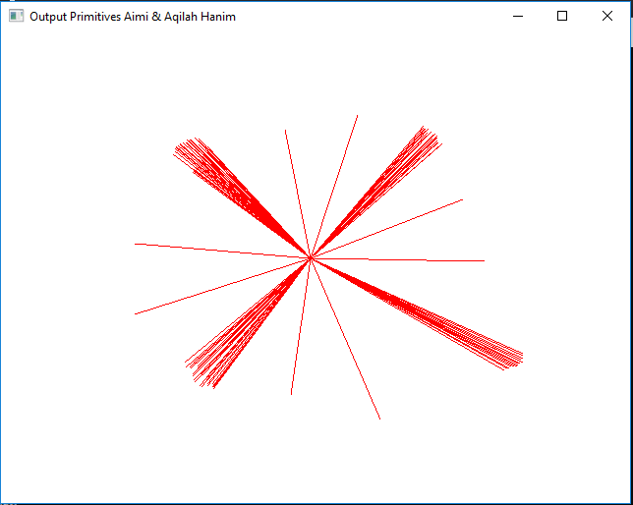

MIDPOINT OF CIRCLE CODING
void midCircle(int xCenter, int yCenter, int radius) {
glColor3f(1.0, 0.0, 1.0); //Set pixel to purple
int x = 0;
int y = radius;
int p = 1 - radius; //rounded to 1 for integer radius

while (x < y) { //literates to draw the first sector
x++;
if (p < 0) //midpoint is inside the circle
p += 2 * x + 1;
else { //midpoint outside or at circle
y--;
p += 2 * (x - y) + 1;
}

glBegin(GL_POINTS);
glVertex2i(xCenter + x, yCenter + y);
//set using vertex instead of setPixel
glVertex2i(xCenter - x, yCenter + y);
glVertex2i(xCenter + x, yCenter - y);
glVertex2i(xCenter - x, yCenter - y);
glVertex2i(xCenter + y, yCenter + x);
glVertex2i(xCenter - y, yCenter + x);
glVertex2i(xCenter + y, yCenter - x);
glVertex2i(xCenter - y, yCenter - x);

glEnd();
}

//OPTIONAL -> Center of circle
glBegin(GL_POINTS);
glVertex2i(xCenter, yCenter);
glEnd();
}

//mouse
else if (value == 3) {

if (point == 0) {
xCenter = mousex;
yCenter = 480 - mousey;
point++;
setPixel(xCenter, yCenter);
}
else {
int x1 = mousex;
int x2 = 480 - mousey;
radius = int(distance(xCenter, yCenter, x1, x2));
midCircle(xCenter, yCenter, radius);
}
}

MIDPOINT OF CIRCLE OUTPUT

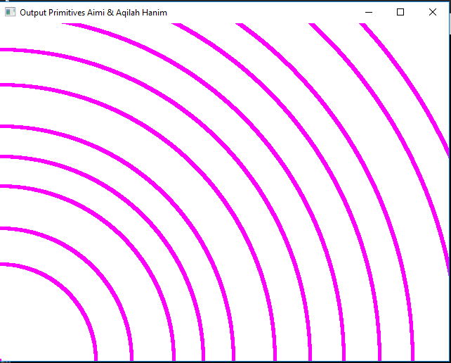

MIDPOINT OF ELLIPSE CODING
void ellipse(int xc, int yc, int rx, int ry)
{
glColor3f(0.0, 0.0, 1.0); //Set pixel to blue
//float xc = 250, yc = 250, rx = 100, ry = 60;
//already declared in mouse value 4
float rxSq = rx * rx;
float rySq = ry * ry;
float x = 0, y = ry, p;
float px = 0, py = 2 * rxSq * y;

glBegin(GL_POINTS);

glVertex2d(xc + x, yc - y);
glVertex2d(xc - x, yc - y);
glVertex2d(xc - x, yc + y);
glEnd();

p = rySq - (rxSq * ry) + (0.25 * rxSq);
while (px < py)
{
x++;
px = px + 2 * rySq;

if (p < 0)
p = p + rySq + px;
else {
y--;
py = py - 2 * rxSq;
p = p + rySq + px - py;
}

glBegin(GL_POINTS);

glVertex2d(xc + x, yc + y);
glVertex2d(xc + x, yc - y);
glVertex2d(xc - x, yc - y);
glVertex2d(xc - x, yc + y);
glEnd();
}

p = rySq * (x + 0.5) * (x + 0.5) + rxSq * (y - 1) * (y - 1) - rxSq * rySq;

while (y > 0) {
y--;
py = py - 2 * rxSq;

if (p > 0)
p = p + rxSq - py;
else {
x++;
px = px + 2 * rySq;
p = p + rxSq - py + px;
}

}
}

MIDPOINT OF ELLIPSE CODING

OUTPUT MIDPOINT OF ELLIPSE

HG

glBegin(GL_POINTS);

glVertex2d(xc + x, yc + y);
glVertex2d(xc + x, yc - y);
glVertex2d(xc - x, yc - y);
glVertex2d(xc - x, yc + y);
glEnd();
glFlush();
}
}

//mouse
else if (value == 4) {

if (point == 0) {
xc = mousex;
yc = 480 - mousey;
point++;
setPixel(xc, yc);
}
else if (point == 1) {
int x1 = mousex;
int x2 = 480 - mousey;
point++;
xr = int(distance(xc, yc, x1, x2));
}
else {
int x11 = mousex;
int x22 = 480 - mousey;
yr = int(distance(xc, yc, x11, x22));
ellipse(xc, yc, xr, yr);
}
}
}

MIDPOINT OF ELLIPSE OUTPUT

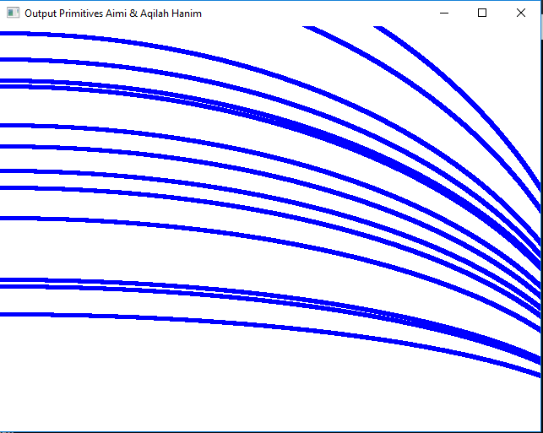

FULL OPENGL CODING
//AIMI BINTI RUSDI (B19EC0001)
//AQILAH HANIM BINTI MOHD TAUFIK (B19EC0006)
#include<Windows.h>
#include<GL/Glut.h> //includes the opengl, glu, and glut header files
#include<stdlib.h> //includes the standard library header file
#include<math.h> //for calculation

static int window;
static int menu_id;
static int submenu_id; //initializing values
static int point = 0; //to count the amount of points input
int value; //value is for menu

float r, g, b, xstart, ystart, xend; //declare for dda
float yend, step, xinc, yinc, x, y, radius, xc, yc; //declare for midCircle
float xCenter, yCenter, xr, yr; //declare for ellipse

void setPixel(int x, int y)
{
glColor3f(1.0, 0.0, 0.0); //Set pixel to black
glPointSize(2.0);
glBegin(GL_POINTS);
glVertex2i(x, y); //Set pixel coordinates
glEnd();
}

float distance(int xi, int yi, int xj, int yj) { // to calculate the distance between the first coordinate and second coordinate
return sqrt(pow(xj - xi, 2) + pow(yj - yi, 2)); //formula of distance
}

void dda(int x0, int y0, int xend, int yend) {
glColor3f(1.0, 0.0, 0.0); //Set pixel to red
glPointSize(5.0f);
glBegin(GL_LINES); // writes pixels on the frame buffer with the current drawing color
glVertex2i(xstart, ystart); // sets vertex
glVertex2i(xend, yend);
glEnd();
}
void midCircle(int xCenter, int yCenter, int radius) {
glColor3f(1.0, 0.0, 1.0); //Set pixel to purple
int x = 0;
int y = radius;
int p = 1 - radius; //rounded to 1 for integer radius

while (x < y) { //literates to draw the first sector
x++;
if (p < 0) //midpoint is inside the circle
p += 2 * x + 1;
else { //mid point outside or at circle
y--;
p += 2 * (x - y) + 1;
}

glBegin(GL_POINTS);
glVertex2i(xCenter + x, yCenter + y); //set using vertex instead of setPixel
glVertex2i(xCenter - x, yCenter + y);
glVertex2i(xCenter + x, yCenter - y);
glVertex2i(xCenter - x, yCenter - y);
glVertex2i(xCenter + y, yCenter + x);
glVertex2i(xCenter - y, yCenter + x);
glVertex2i(xCenter + y, yCenter - x);
glVertex2i(xCenter - y, yCenter - x);

glEnd();
}

//OPTIONAL -> Center of circle
glBegin(GL_POINTS);
glVertex2i(xCenter, yCenter);
glEnd();
}

void ellipse(int xc, int yc, int rx, int ry)
{
glColor3f(0.0, 0.0, 1.0); //Set pixel to blue
//float xc = 250, yc = 250, rx = 100, ry = 60; //already declared in mouse value 4
float rxSq = rx * rx;
float rySq = ry * ry;
float x = 0, y = ry, p;
float px = 0, py = 2 * rxSq * y;

glBegin(GL_POINTS);

glVertex2d(xc + x, yc - y);
glVertex2d(xc - x, yc - y);
glVertex2d(xc - x, yc + y);
glEnd();

p = rySq - (rxSq * ry) + (0.25 * rxSq);
while (px < py)
{
x++;
px = px + 2 * rySq;
if (p < 0)
p = p + rySq + px;
else {
y--;
py = py - 2 * rxSq;
p = p + rySq + px - py;
}

glBegin(GL_POINTS);

glVertex2d(xc + x, yc + y);
glVertex2d(xc + x, yc - y);
glVertex2d(xc - x, yc - y);
glVertex2d(xc - x, yc + y);
glEnd();
}

p = rySq * (x + 0.5) * (x + 0.5) + rxSq * (y - 1) * (y - 1) - rxSq * rySq;

while (y > 0) {
y--;
py = py - 2 * rxSq;

if (p > 0)
p = p + rxSq - py;
else {
x++;
px = px + 2 * rySq;
p = p + rxSq - py + px;
}
glBegin(GL_POINTS);

glVertex2d(xc + x, yc + y);
glVertex2d(xc + x, yc - y);
glVertex2d(xc - x, yc - y);
glVertex2d(xc - x, yc + y);
glEnd();
glFlush();
}
}

void mouse(int button, int state, int mousex, int mousey)
{

if (button == GLUT_LEFT_BUTTON && state == GLUT_DOWN)
{
if (value == 2) { //right click
if (point == 0) { //how many points done
xstart = mousex;
ystart = 480 - mousey;
point++;
setPixel(xstart, ystart);
}

else {
xend = mousex;
yend = 480 - mousey;
dda(xstart, ystart, xend, yend);
}
}
else if (value == 3) {
if (point == 0) {
xCenter = mousex;
yCenter = 480 - mousey;
point++;
setPixel(xCenter, yCenter);
}
else {
int x1 = mousex;
int x2 = 480 - mousey;
radius = int(distance(xCenter, yCenter, x1, x2));
midCircle(xCenter, yCenter, radius);
}
}

else if (value == 4) {

if (point == 0) {
xc = mousex;
yc = 480 - mousey;
point++;
setPixel(xc, yc);
}

else if (point == 1) {
int x1 = mousex;
int x2 = 480 - mousey;
point++;
xr = int(distance(xc, yc, x1, x2));
}

else {
int x11 = mousex;
int x22 = 480 - mousey;
yr = int(distance(xc, yc, x11, x22));
ellipse(xc, yc, xr, yr);
}
}
}

else if (button == GLUT_RIGHT_BUTTON && state == GLUT_DOWN) { //undo the drawing

glClearColor(1, 1, 1, 0);
glClear(GL_COLOR_BUFFER_BIT);
while (point > 0) {
point--;
}
}
}
void menu(int num) {
if (num == 0) {
glutDestroyWindow(window);
exit(0);
}
else {
value = num;
}
glutPostRedisplay();
}
//function to create menu items
void setMenu(void) {
submenu_id = glutCreateMenu(menu); //Creating the setmenu
glutAddMenuEntry("DDALine", 2); //adding an entry for the menu
glutAddMenuEntry("Circle", 3);
glutAddMenuEntry("Ellipse", 4);
menu_id = glutCreateMenu(menu); //to create menu function
glutAddMenuEntry("Quit", 0);
glutAddMenuEntry("Clear", 1); //right click use for clear drawing
glutAddSubMenu("Draw", submenu_id);
glutAttachMenu(GLUT_RIGHT_BUTTON); //user uses RIGHT button to click
}

void display(void)
{
glMatrixMode(GL_PROJECTION);
glLoadIdentity();
gluOrtho2D(0.0, 640.0, 0.0, 480.0);

if (value == 1) {
glClearColor(1, 1, 1, 0);
glClear(GL_COLOR_BUFFER_BIT);
}

//applying conditions on values(dda, midCircle & ellipse)
else if (value == 2) { //2nd click on mouse for dda
glutMouseFunc(mouse);
}
else if (value == 3) { //3rd click on mouse for midCircle
glutMouseFunc(mouse);
}
else if (value == 4) { //4th click on mouse for ellipse
glutMouseFunc(mouse);
}
glFlush(); // flushes the frame buffer to the screen
}

int main(int argc, char** argv)
{
glutInit(&argc, argv);
glutInitWindowSize(640, 480);
//sets the width and height of the window in pixels
glutInitWindowPosition(10, 10);
//sets the position of the window in pixels from top left corner
glutInitDisplayMode(GLUT_SINGLE | GLUT_RGB);
//creates a single frame buffer of RGB color capacity.
window = glutCreateWindow("Output Primitives Aimi & Aqilah Hanim"); //creates the window as specified by the user as above.
setMenu();
glClearColor(1, 1, 1, 0);
glClear(GL_COLOR_BUFFER_BIT);
glutDisplayFunc(display);
//links the display event with the display event handler(display)
glutMainLoop();//loops the current event
}

OUTPUT PRIMITIVES

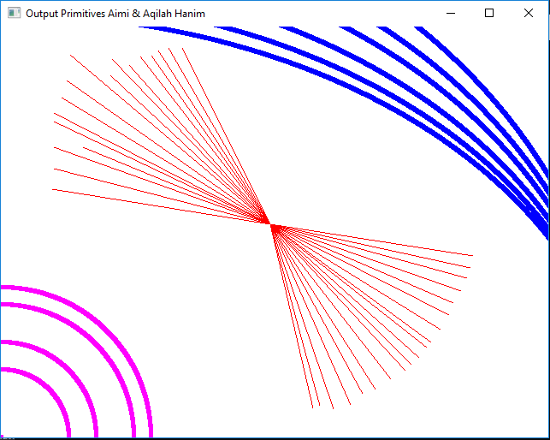

REFERENCES
- Hearn, Baker & Carithers. (2014). Computer Graphics with OpenGL. United States of America. Pearson Education Limited.

- CS2401 Computer Graphics. (n.d.). Unit 1 - 2D Primitives [PDF file]. Retrieved from: http://fmcet.in/CSE/CS2401_uw.pdf

- Programming Guide. (2019). How to Create Menus and Sub Menus in Computer Graphics [Youtube Channel]. Retrieved from: https://www.youtube.com/watch?v=5zCOYjfari0

- Learn in Urdu. (2017). How to Make Paint Tool in OpenGL [Youtube Channel]. Retrieved from: https://www.youtube.com/watch?v=pdbvLYIWq9M

- OpenGL Projects. (2015). OpenGL Project Implementation of Graphics Editor MS Paint [Youtube Channel]. Retrieved from: https://www.youtube.com/watch?v=zCQH1e5lHOM

- ZappyNet Tutorial. (2019). OpenGL Tutorial: Mouse Event Handling in OpenGL with Source Code [Youtube Channel]. Retrieved from: https://www.youtube.com/watch?v=BPs6kPglOyw

- Doru Ionescu. (2017). Paint Editor with Different Controls - Mouse Events with C#(Csharp) Visual Studio [Youtube Channel]. Retrieved from: https://www.youtube.com/watch?v=qvDoVGASJ2E

- Doru Ionescu. (2017). Simple Paint Editor with Mouse Events Visual Studio C# Windows Form [Youtube Channel]. Retrieved from: https://www.youtube.com/watch?v=ekjQOQQRuL4

- Dinesh. (2016). How to Draw Geometric Primitives in OpenGL using Visual Studio 2015 [Youtube Channel]. Retrieved from: https://www.youtube.com/watch?v=xD60f91nKFw

