SCSV 2113
HUMAN COMPUTER INTERACTION
(Session 2020/2021 Semester 2)
School of Computing
Universiti Teknologi Malaysia

P3 - CONCEPTUAL PHYSICAL
[VISION +]

LECTURER
NOR ANITA FAIROS BINTI ISMAIL
(Section 01)

GROUP NO 5 (Auspicious)
Prepared by
MAIZATUL AFRINA SAFIAH BINTI SAIFUL AZWAN A20EC0204
MADINA SURAYA BINTI ZHARIN A20EC0203
NAYLI NABIHAH BINTI JASNI A20EC0105
MADIHAH BINTI CHE ZABRI A20EC0074
NURFARRAHIN BINTI CHE ALIAS A20EC0121
SAFIRA NURUL IZZA A18CS0323

Submission 1: Interaction Metaphors

Connect with other devices:

Bluetooth service - A wireless technology service that can exchange data between different devices at the same time. Even though this service can only connect within a short range, but this service is more reliable than other wireless services.

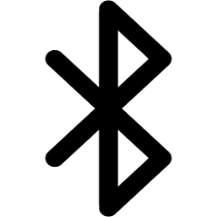

Wifi - A wireless technology that allows lots of devices to connect to the Internet. Can be connected to lots of devices.


The users can choose either to use bluetooth service or wifi to connect other devices with Vision+. These two services, especially wifi, can make sure the users can access the schedules and reminders that were set by users anywhere and anytime in case they forgot or do not want to wear the spectacles. However, users can use the spectacles such as saved, insert and delete schedules even without an internet connection. This can ease the burden especially for the students who can not afford to buy internet or for those who want to save on internet quota usage.

Add/Delete/Edit:
Add Schedule - This is a good metaphor for adding any activity in the schedule, because you are actually adding it when you want to produce a schedule.


Deleting Schedule - Removing the unnecessary activity in your schedule.



Edit - Edit the schedule whenever you make a mistake or you want to change it. This is a good metaphor because it allows you to arrange your schedule.



Vision+ has all of the functions above to make sure the user can easily control and make sure their schedule is still on track. Beside that, Vision+ will notify the users everytime the users make any changement.

Charging the spectacles:
Charge - Refill the energy with free-battery automatically, so you can use it anytime, anywhere.

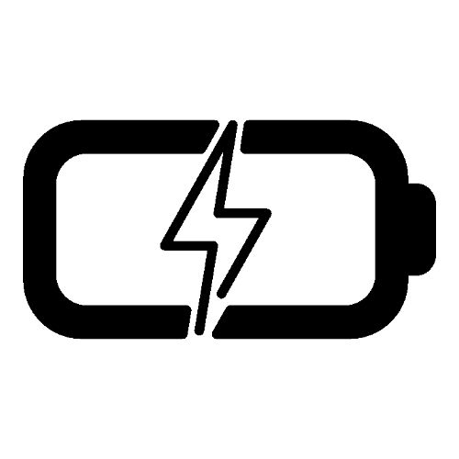

There is a specific case for Vision+ and the case comes with a charger. Whenever the users want to keep the spectacle in the given case, it will automatically charge. So, the case not only can keep plus protect Vision+ from any damage and scratch but it also makes sure our place is tidy without any wire for charging purposes.

Submission 2: Storyboard Hand Sketching

Task 1: Connecting a device with Vision+

In this task, the users can connect Vision+ with any device through bluetooth. The bluetooth setting should be conducted by the device and search up “V+” and connect it. When the device shows that it is connected to Vision+, then it is ready to be used.

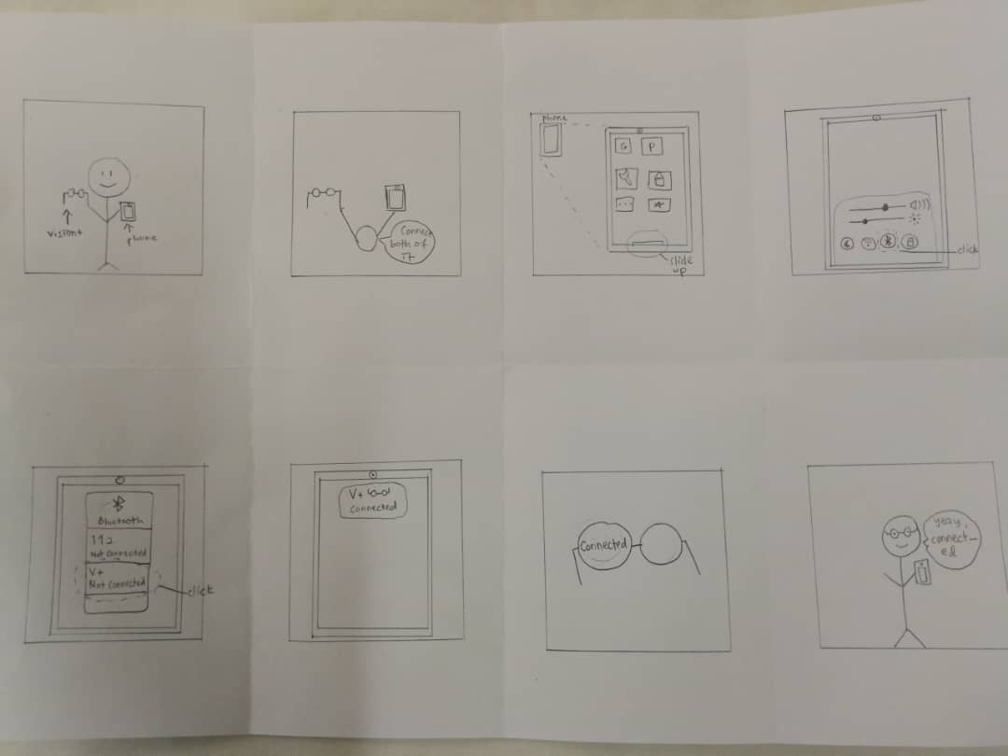

Task 2: Set, view and delete

In this task, the user can set reminders by using voice recognition. Vision+ will automatically recognise the voice when someone says “Hey Vee!”. After setting reminders, the user could view it directly from the glass of the spectacles or at the phone. If displaying through the glass disturbs the view, the user can just switch off Vision+ by pressing the power button next to the glass or use voice recognition. Lastly, if the user wants to delete the reminders, they can also do it by using voice recognition or simply delete it from the phone.
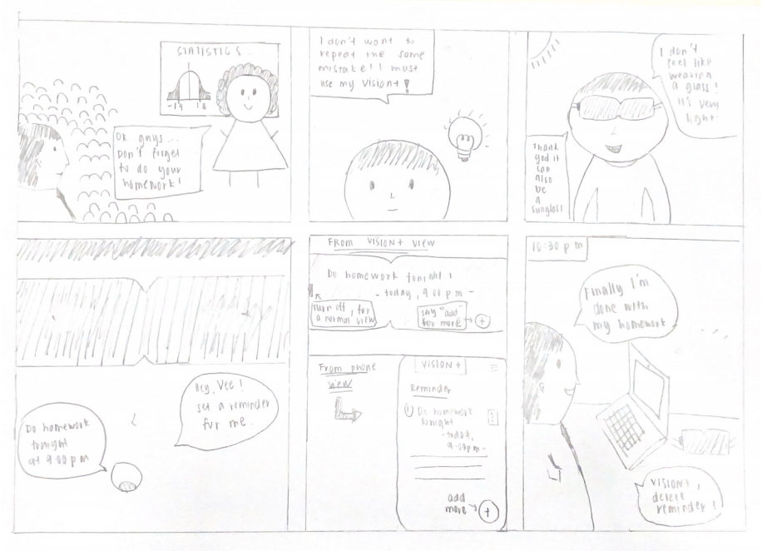

Task 3: Keep and Charge Vision+

This task shows how to keep and charge Vision+. Vision+ comes with a case and charger pod. The case is customized so that it can be used with the charger pod in addition to eliminating the use of cable which sometimes can be messy. Keeping the Vision+ is as simple as the normal spectacles which keep it inside the case. However, here is the catch, to charge it, users just have to keep Vision+ inside the case and put the case on top of the charger pod and it will charge it until full.
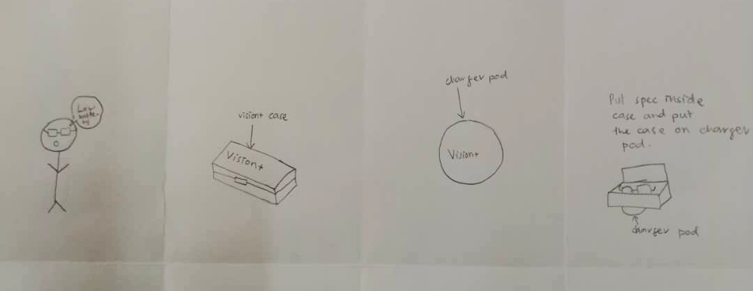

Submission 3: Layout Screen Design - LFP

Task 1: Connecting a device with Vision+

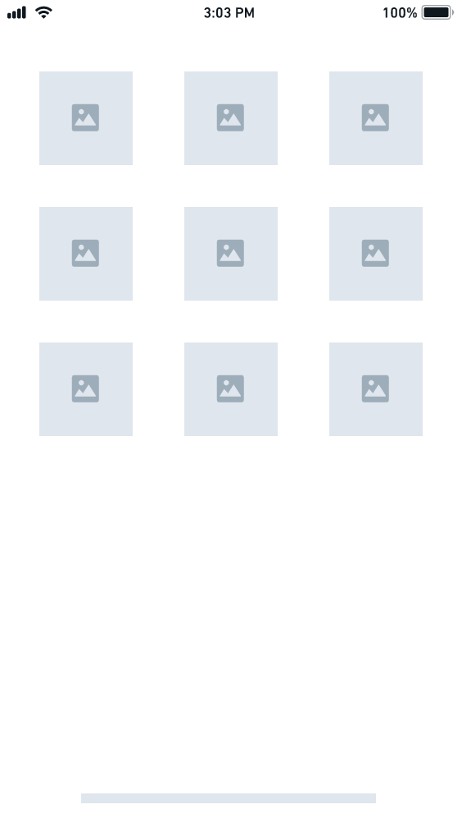 | 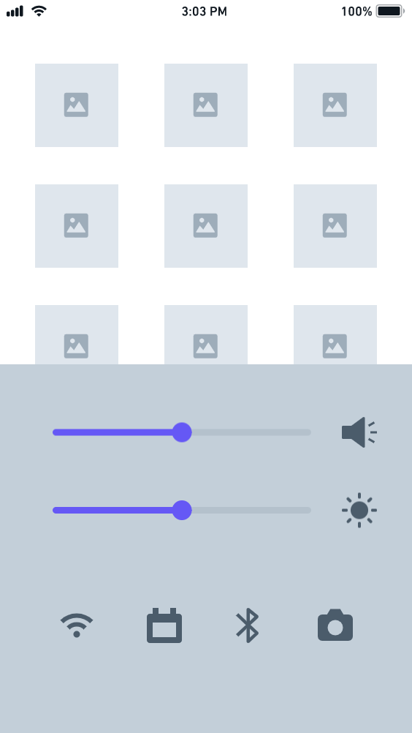 | 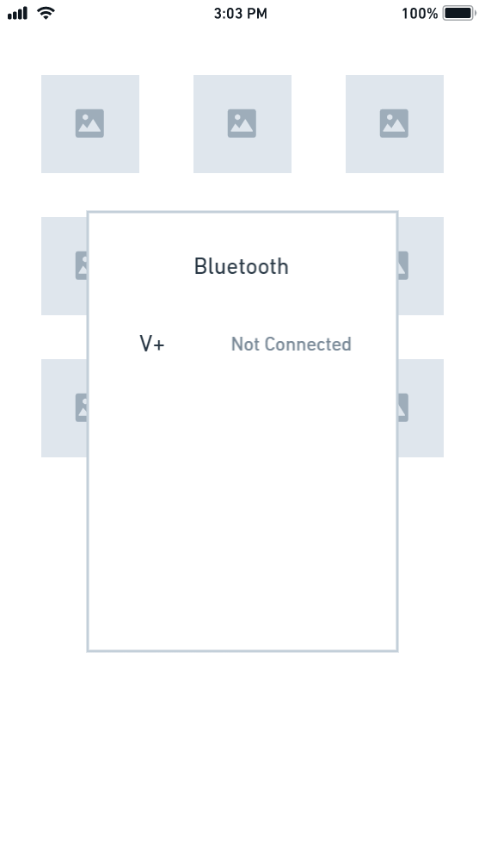 | 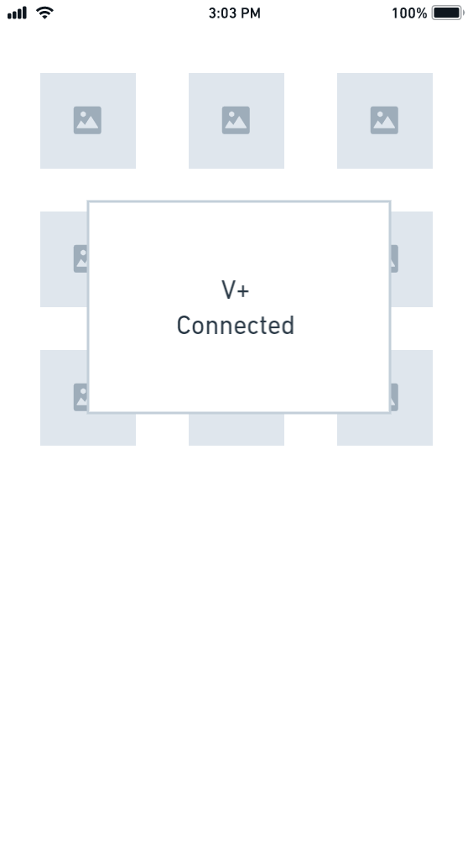

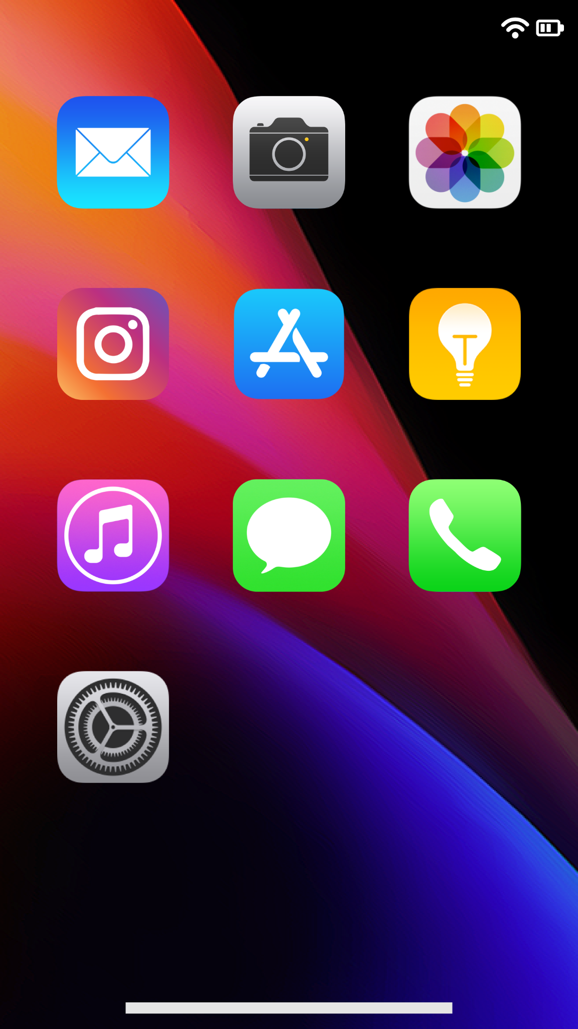 | 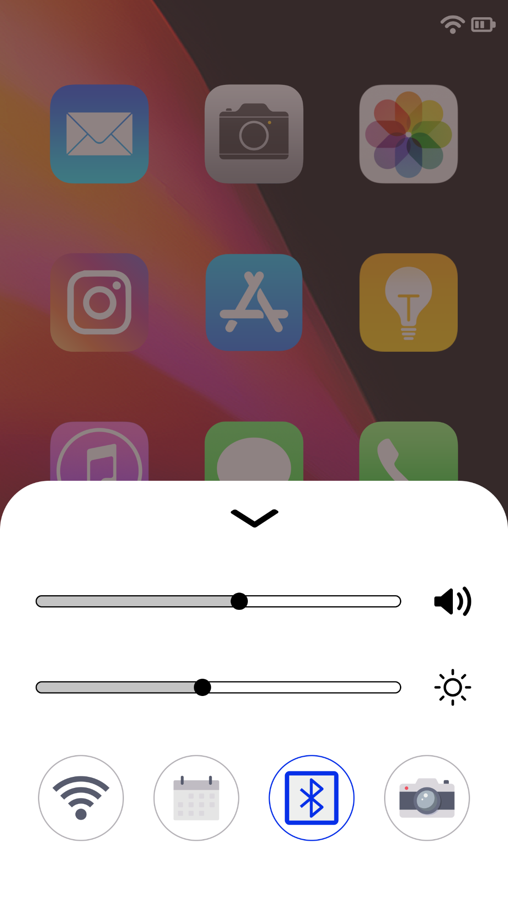 | 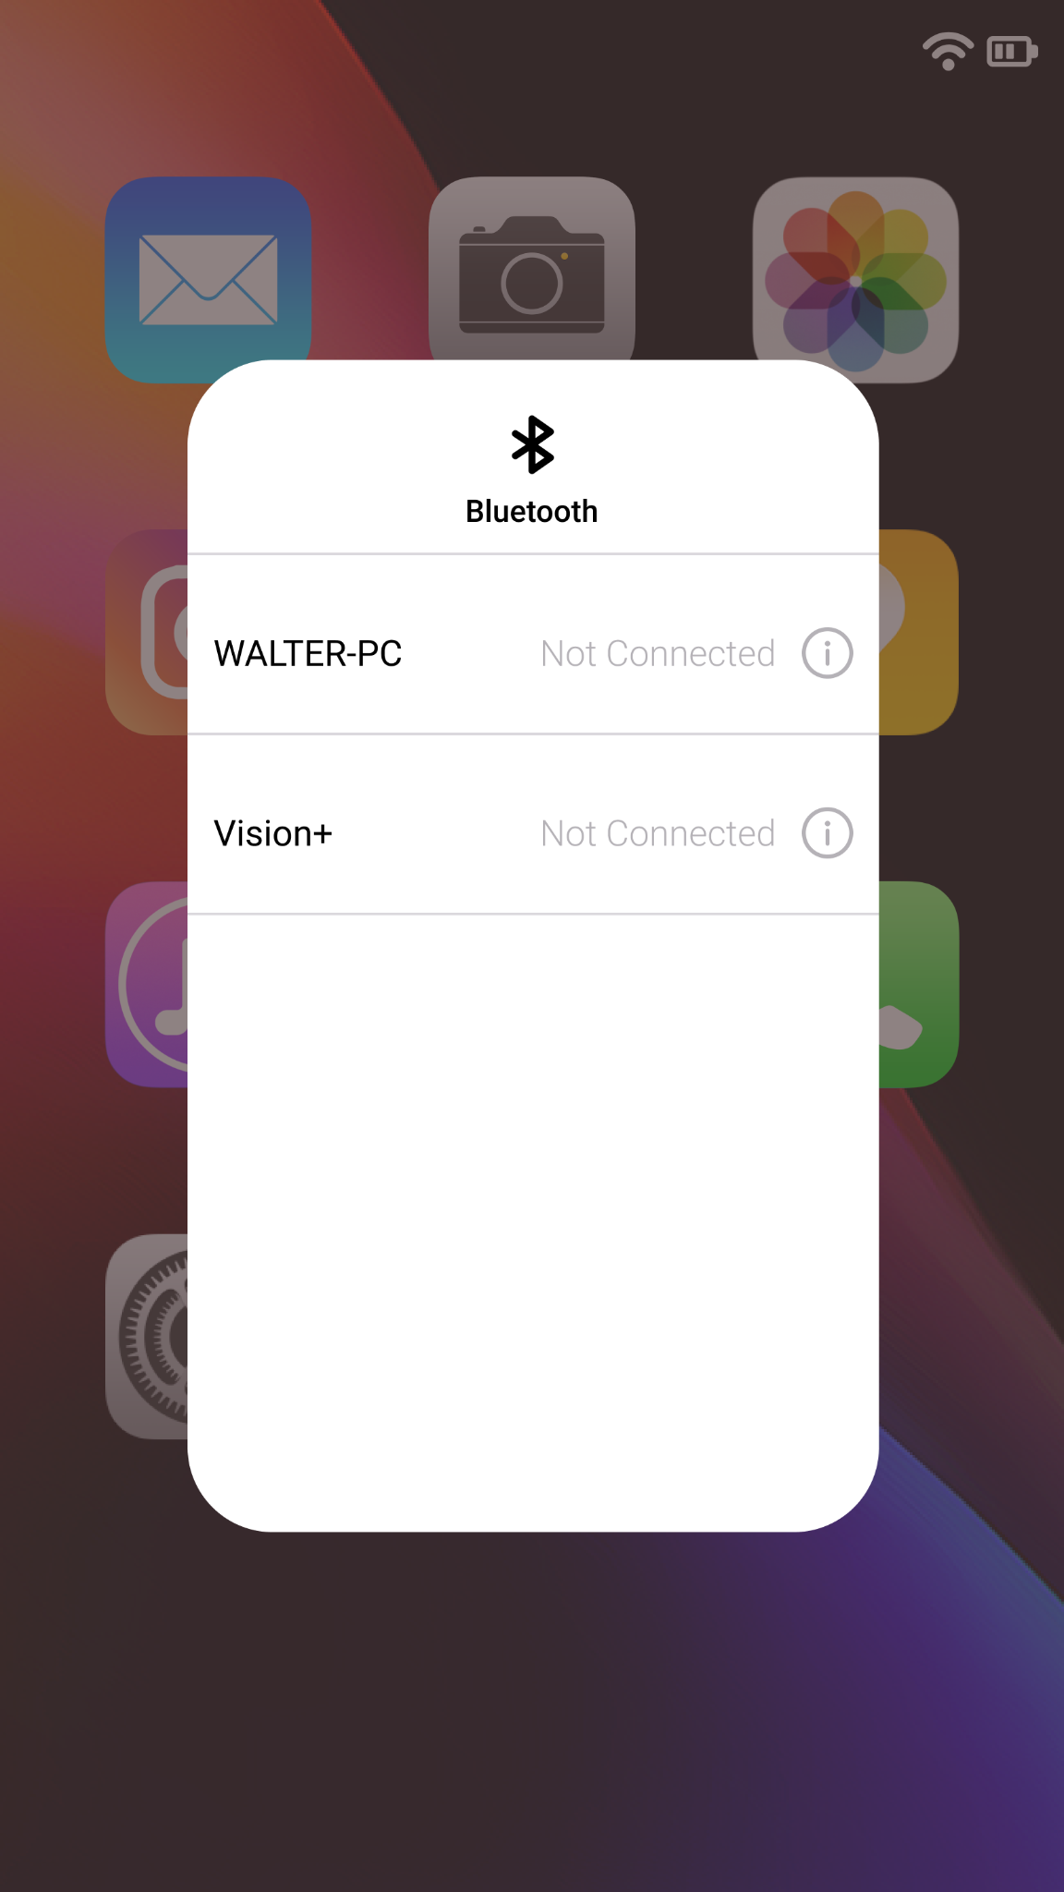 | 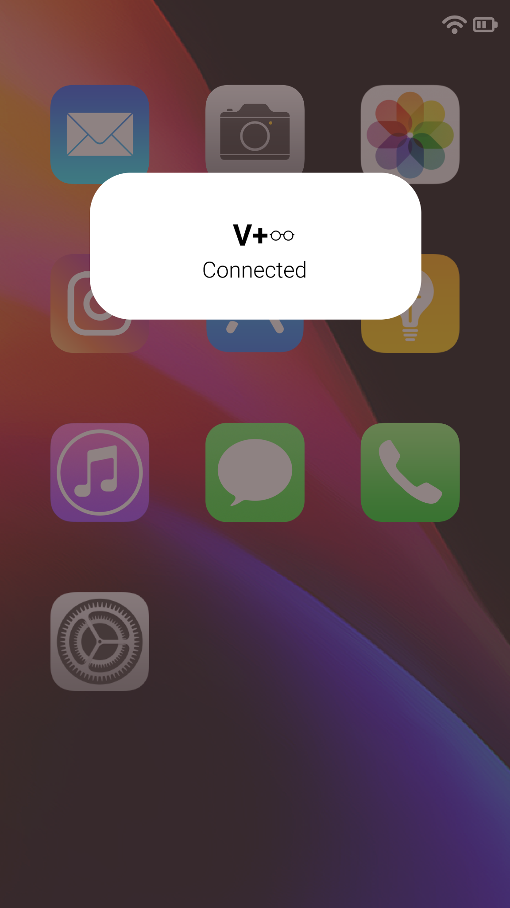

Task 2: Set, view and delete

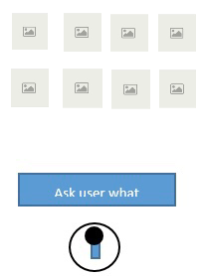 | 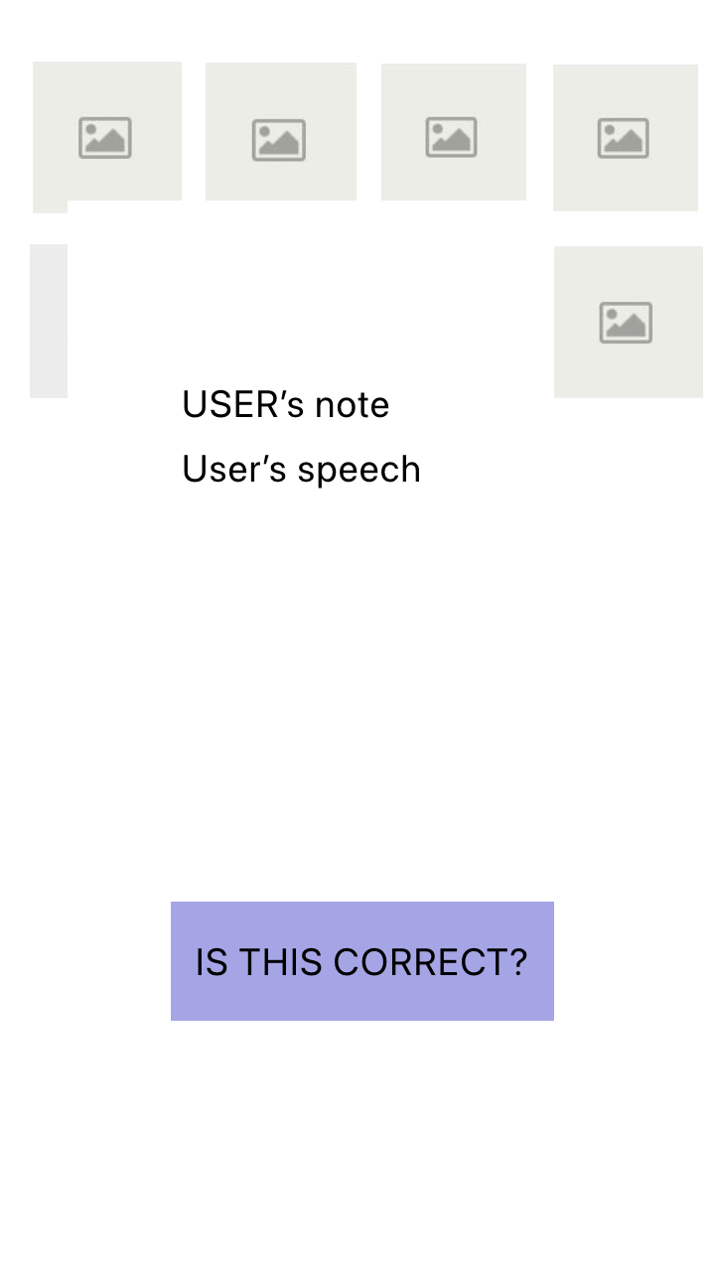 | 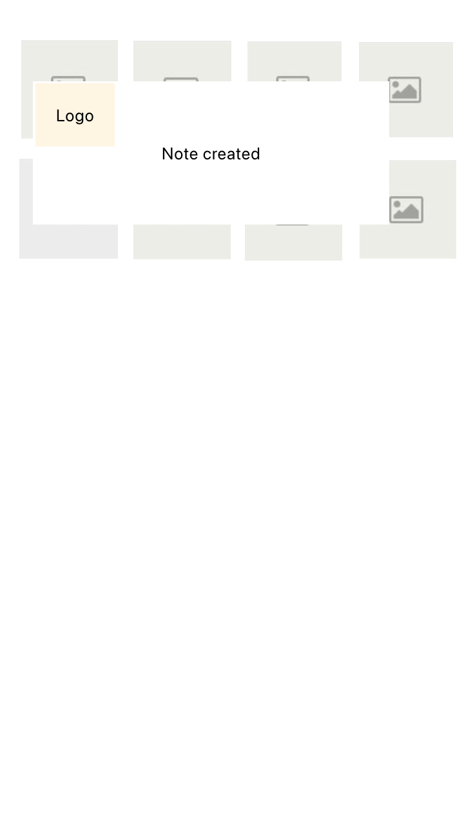 | 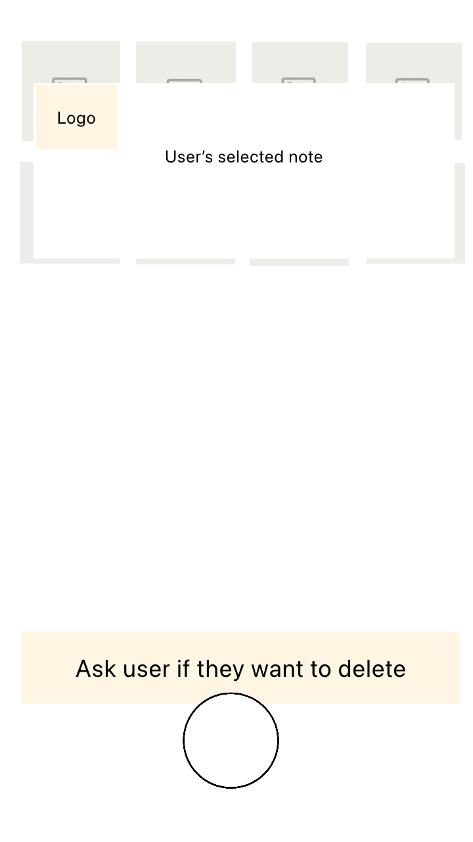

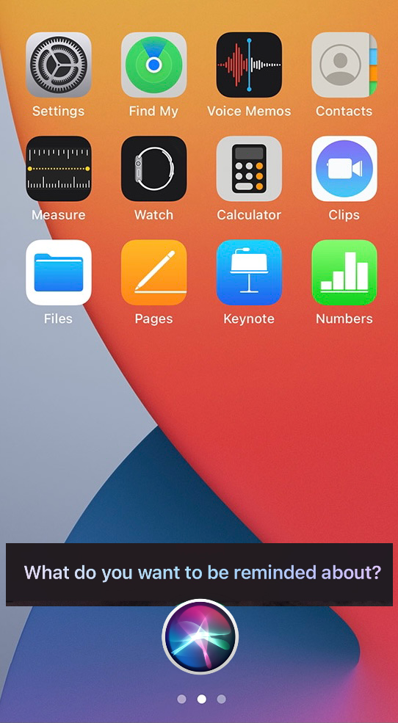 | 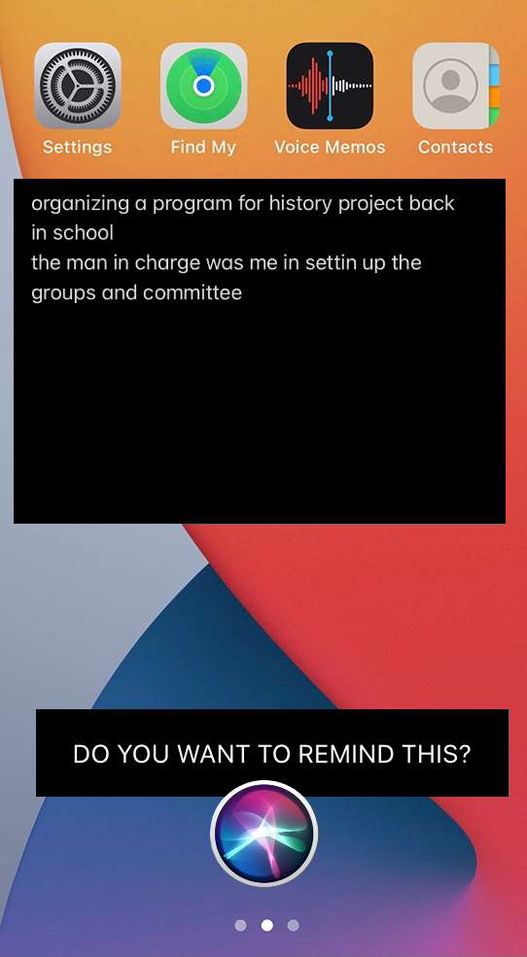 | 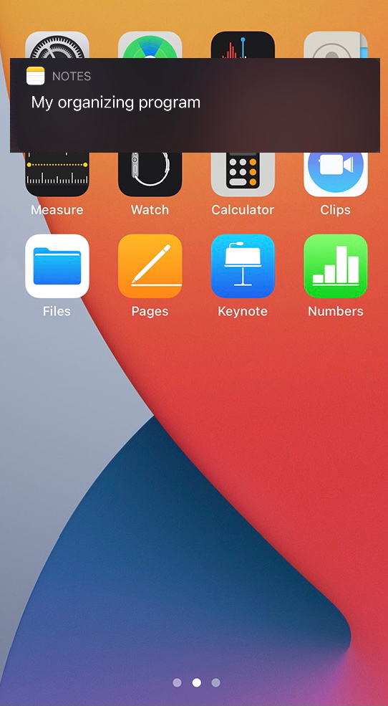 | 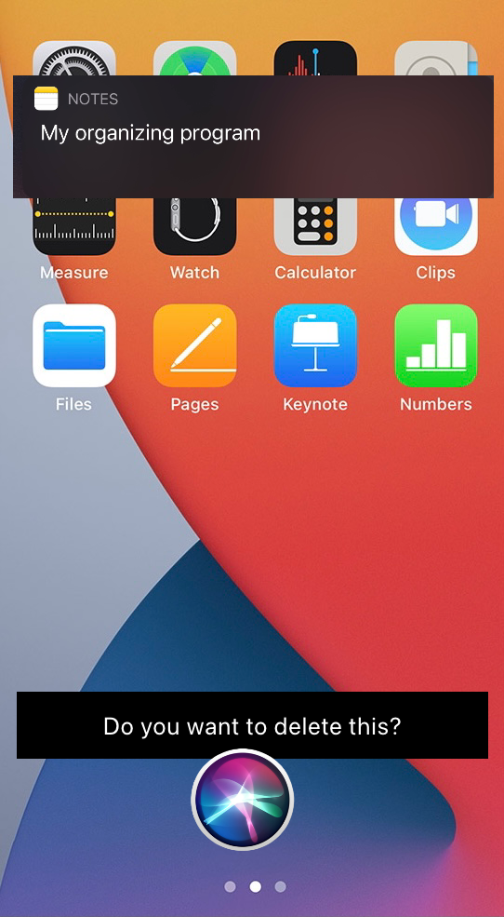

Task 3: Keep and Charge Vision+
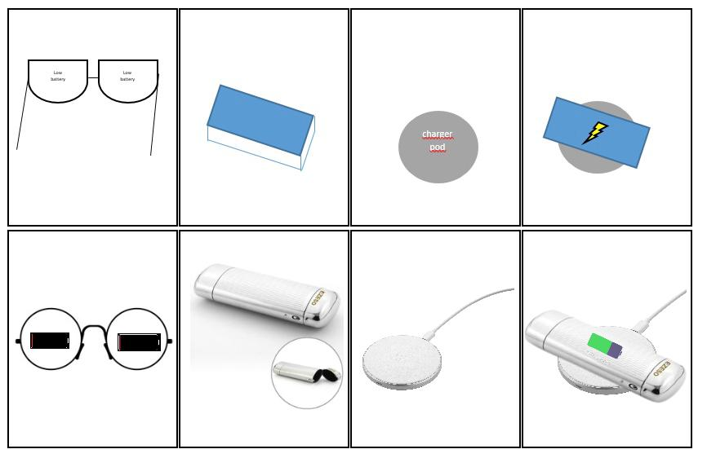

Justification of the layout screen design (LFP) based on Shneiderman’s Eight (8) Golden Rules:

- Strive for Consistency
- Consistency requires a sequence of actions that should be in similar situations. For example, Vision+ uses identical terminology at the home screen and uses the same icons at every page to make sure the user can easily use it.

- Enable frequent users to use shortcuts
- Shortcuts are made to reduce the number of interactions and to increase the pace of interaction. For example, Vision+ has a voice recognition function as a shortcut so it can process the instruction from the user.

- Offer informative feedback
- There should be some system feedback for every operator action. For example, Vision+ will notify the users if there are any new schedules added in the system, edited or deleted from the system so that the users are aware of what actions that they took.

- Design dialog to yield closure
- Sequence of actions that should be organized. For example, Vision+ will pop out a message such as “Done Edited”, “Done Added” and “Done Deleted” to proof that action/instruction from the users are completely processed and executed by the system.

- Offer simple error handling
- Error handling is made to make sure users do not make big errors. For example, in Vision+, when a user sets his/her schedule and if suddenly the schedule is actually clashed with another schedule, the system will automatically notify the user so that he/she can set it on another date.

- Permit easy reversal of actions
- This feature relieves anxiety since the user knows that error can be undone. For example, Vision+ that mainly focuses on managing the users schedules has an edit and a delete function to make sure users insert the correct information or data.

- Support internal locus of control
- The internal locus of control strongly desires that they are in charge and the system will respond to their actions. For Vision+, it will be notified in a dialog box for every action taken by the user.

- Reduce short-term memory load
- To reduce short-term memory load, the displays must be simple, multiple page displays be consolidated, window-motion frequency be reduced and others. For example, Vision+ has only one screen page and can not display multiple pages.

