

LAB ASSIGNMENT 2

DATABASE (WBL)
SECP2523 – 01
LECTURER’S NAME: DR. NOR HAWANIAH ZAKARIA

TITLE: JUSTLEE BOOKS DATABASE

NAME | MADINA SURAYA BINTI ZHARIN
MATRIC NO. | A20EC0203
SECTION | 01

Contents
PART A 2
PART B 5
PART C 7

PART A
Generate and test two SQL queries for each of the following tasks: a) the SQL statement needed to perform the stated task with the traditional approach, and b) the SQL statement needed to perform the stated task with the JOINs keyword. Apply table aliases in all queries.
- Determine the profit of each book sold to Jake Lucas, using the actual price the customer paid (not the book’s regular retail price). Sort the results by order date. If more than one book was ordered, sort the results by profit amount in descending order. Perform the search using the customer’s name, not the customer number.
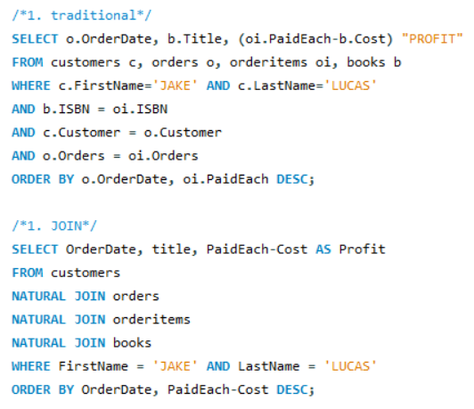

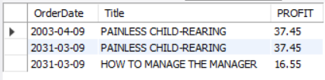

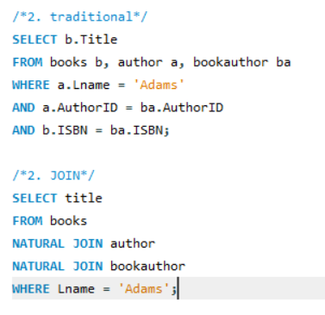
- Which books were written by an author with the last name Adams? Perform the search using the author’s name.

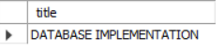
- What gift will a customer who orders the book Shortest Poems receive? Use the actual book retail value to determine the gift.
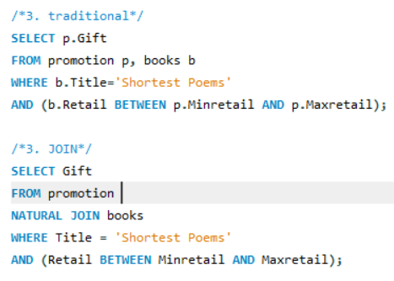
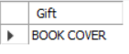

- Identify the authors of the books Becca Nelson ordered. Perform the search using the customer’s name.
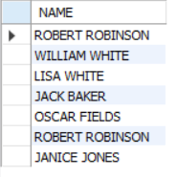
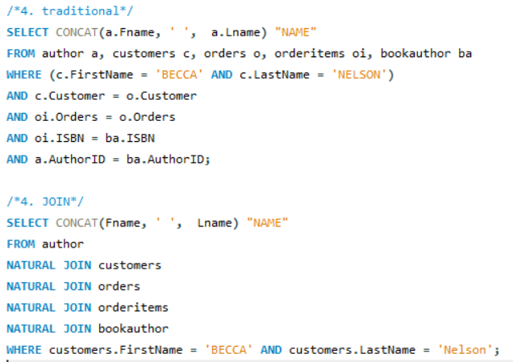

- Display a list of all books in the BOOKS table. If a book has been ordered by a customer, also list the corresponding order number and the state in which the customer resides.
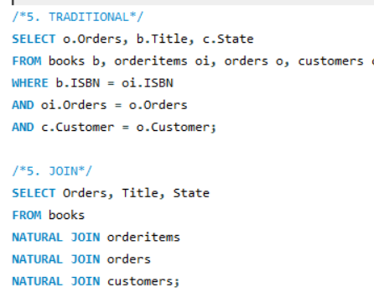

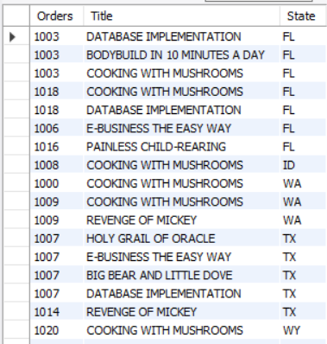
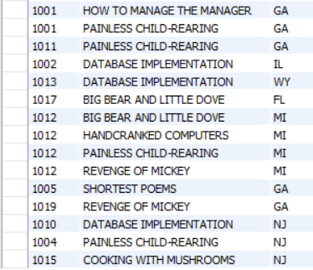

- An EMPLOYEES table was added to the Just Lee Books database to track employee information. Display a list of each employee ‘s name, job title, and manager ‘s name. Use column aliases to clearly identify employee and manager name values. Include all employees in the list and sort by manager name.

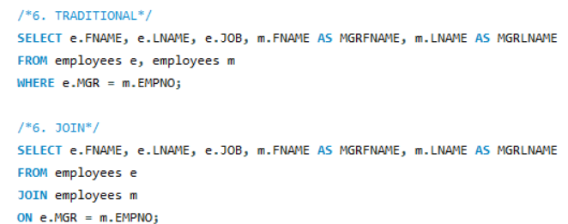

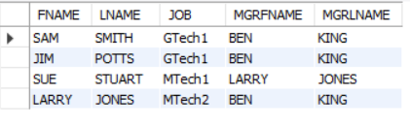

PART B

- Determine how many books are in the cooking category.
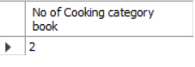
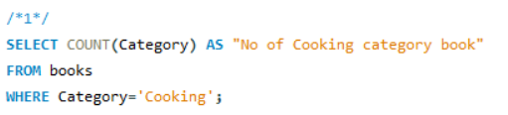

- Display the number of books with a retail price of more than $30.00.

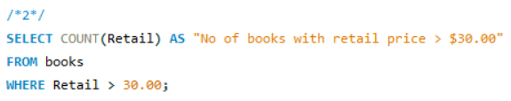
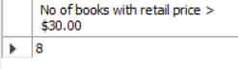

- Display the most recent publication date of all books sold by just Lee Books.
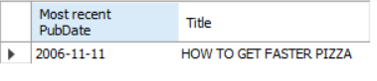
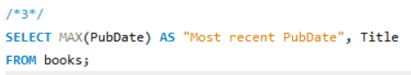

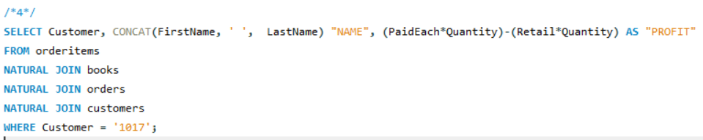
- Determine the total profit generated by sales to customer 1017. Note: Quantity should be reflected in the total profit calculation.

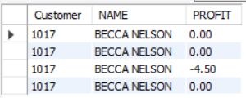

- List the retail price of the least expensive book in the computer category.
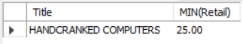
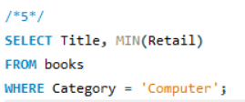

- Determine the average profit generated by orders in the ORDERS table. Note: The total profit by order must be calculated before finding the average profit.
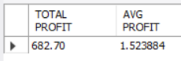

- Determine how many orders have been placed by each customer. Do not include in the results any customer who hasn’t recently placed an order with Just Lee Books.
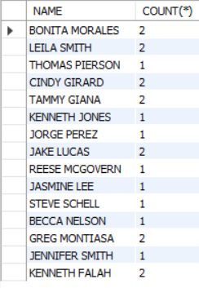
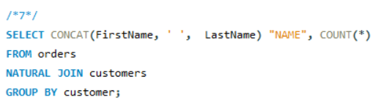

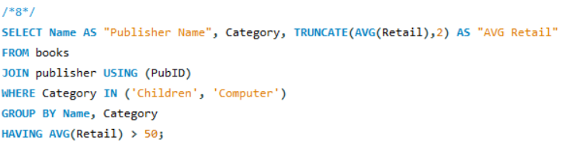
- Determine the average retail price of books by publisher name and category. Include only the categories Children and Computer and the groups with an average retail price greater than $50.

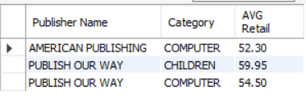

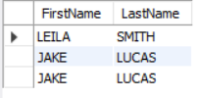
- List the customers living in Georgia or Florida who have recently placed an order totalling more than $80.
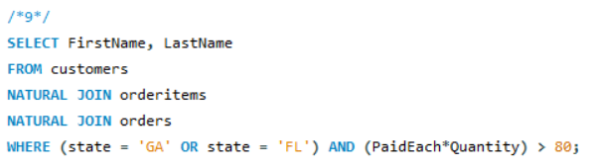

- What’s the retail price of the most expensive book written by Lisa White?
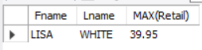
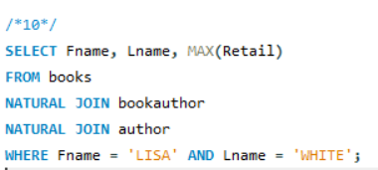

PART C

- List the book title and retail price for all books with a retail price lower than the average retail price of all books sold by JustLee Books.
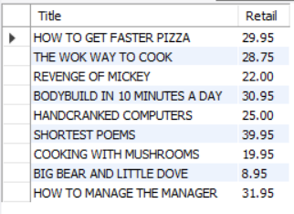
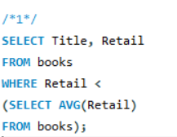

- Determine which books cost less than the average cost of other books in the same category.
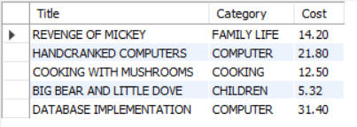
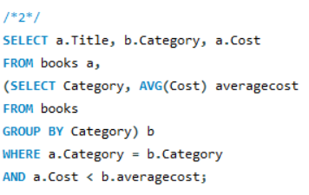

- Determine which orders were shipped to the same state as order 1014.
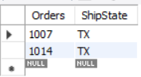
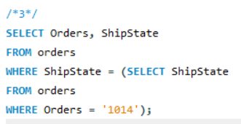

- Determine which orders had a higher total amount due than order 1008.
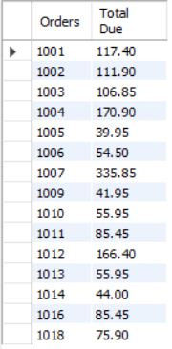
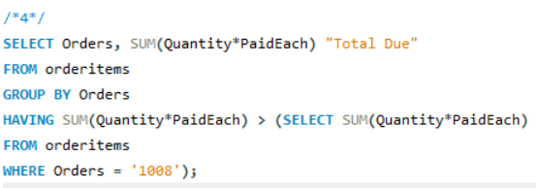

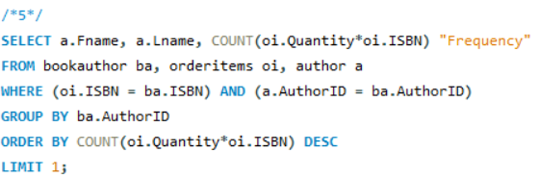
- Determine which author or authors wrote the books most frequently purchased by customers of JustLee Books.

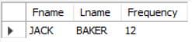

- List the title of all books in the same category as books previously purchased by customer 1007. Don’t include books this customer has already purchased.
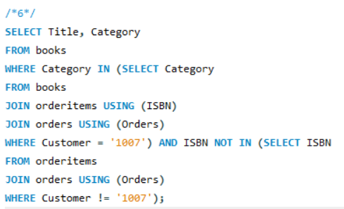
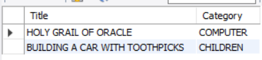

- List the shipping city and state for the order that had the longest shipping delay.
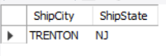
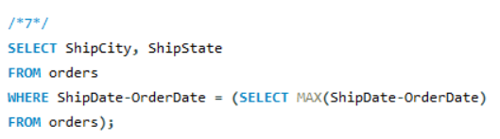

- Determine which customers placed orders for the least expensive book (in terms of regular retail price) carried by JustLee Books.
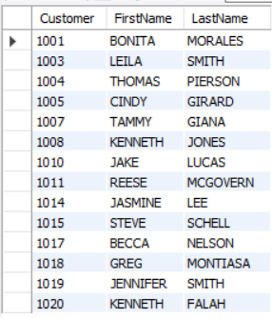
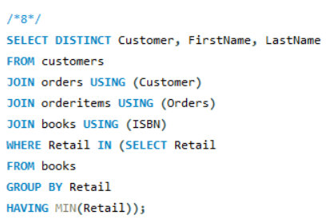

- Determine the number of different customers who have placed an order for books written or cowritten by James Austin.
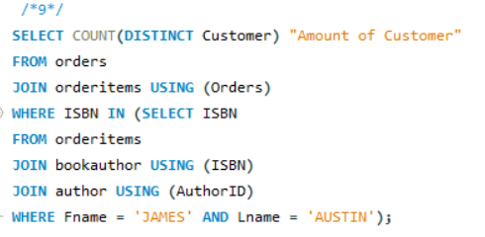

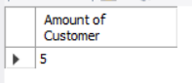

- Determine which books were published by the publisher of The Wok Way to Cook.
