

ASSIGNMENT 1

DATA STRUCTURE AND ALGORITHM
SECJ 2013 – 02

TITLE: SORTING

GROUP NO: 6
NO. | NAME | MATRIC NUMBER
1 | MADINA SURAYA BINTI ZHARIN | A20EC0203
2 | GOO YE JUI | A20EC0191
3 | HONG PEI GEOK | A20EC0044
4 | QAISARA BINTI ROHZAN | A20EC0133

Table of Contents
Table of Contents 2
BUBBLE SORT 3
IMPROVED BUBBLE SORT 5
INSERTION SORT 10
MERGE SORT 13
QUICK SORT 15
REFLECTION 16
CODING 17
BUBBLE SORT 17
Ascending (ARRAY A) 17
Descending (ARRAY B) 19
IMPROVED BUBBLE SORT 21
Ascending (ARRAY A) 21
Descending (ARRAY B) 23
SELECTION SORT 25
Ascending (ARRAY B) 25
Descending (ARRAY B) 26
INSERTION SORT 28
Ascending (ARRAY B) 28
Descending (ARRAY B) 29
MERGE SORT 31
Ascending (ARRAY A) 31
Descending (ARRAY B) 33
QUICK SORT 35
Ascending(ARRAY A) 35
Descending (ARRAY B) 38

BUBBLE SORT
- 100 130 170 18 1 6 [ascending order]
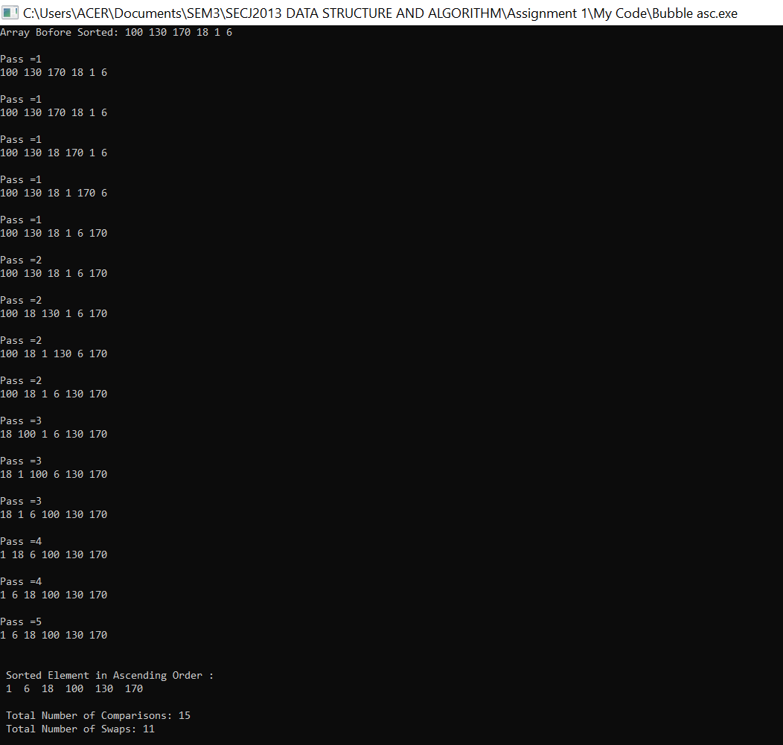

- 2 13 15 9 16 17 [descending order]
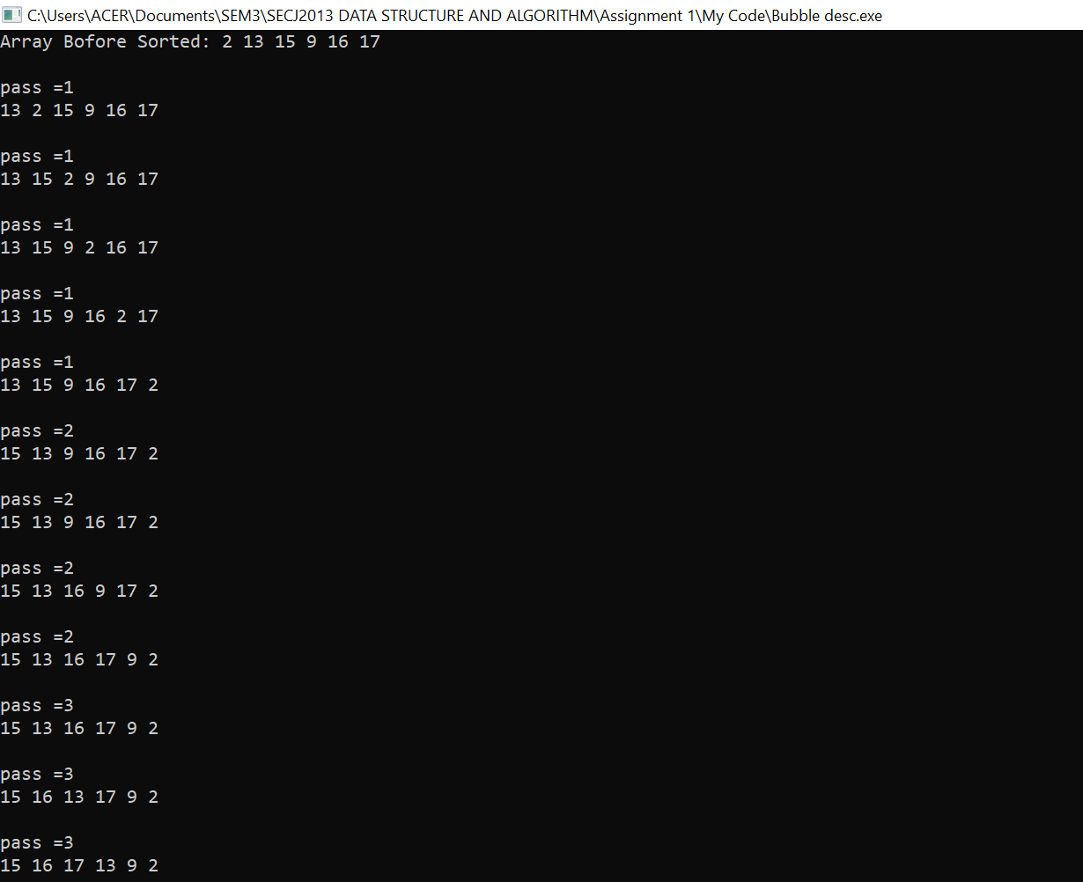
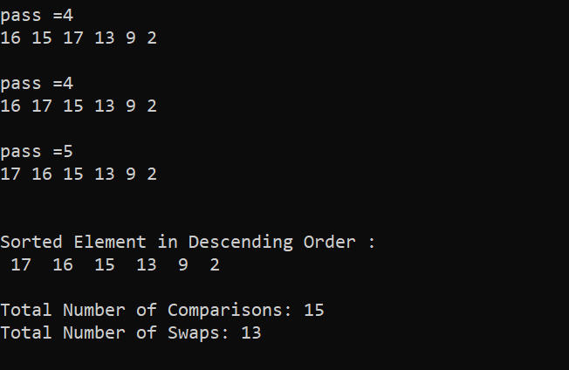

Discussion:
For the first array, bubble sort takes 15 total number of comparisons and 11 swaps process in order to sort array a in ascending order while it also takes 15 total number of comparisons to sort array b in descending order. However, the total number of swaps is 13 for array b. This is because the number of comparisons for the worse case and best case is the same and the difference is the number of swapping elements.
Generally, the number of comparisons between elements in Bubble Sort can be stated as follows:
(n-1) + (n-2) + …… + 2 + 1 = n (n-1) / 2 = O(n²)

IMPROVED BUBBLE SORT
- 100 130 170 18 1 6 [ascending order]
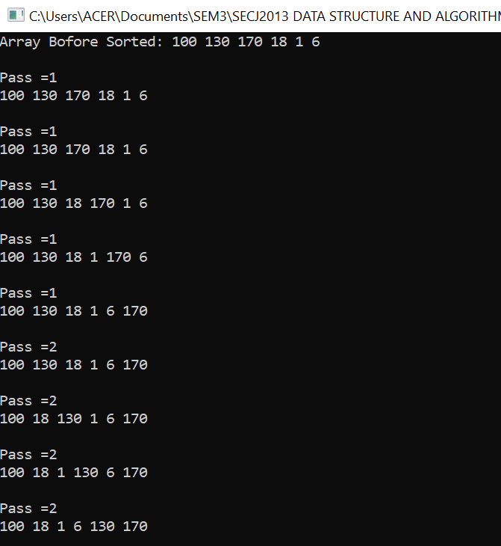
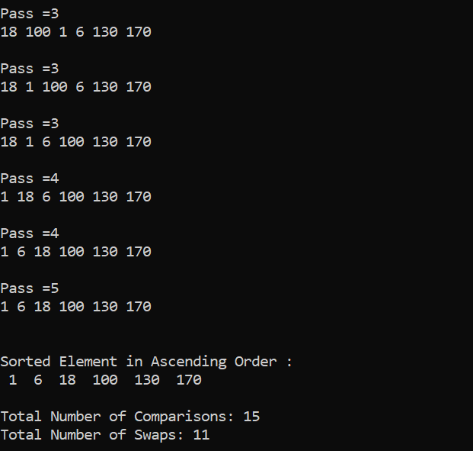
- 2 13 15 9 16 17 [descending order]
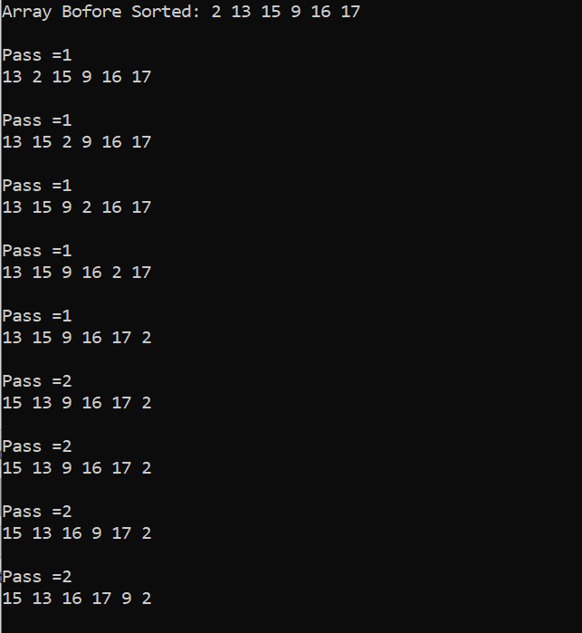
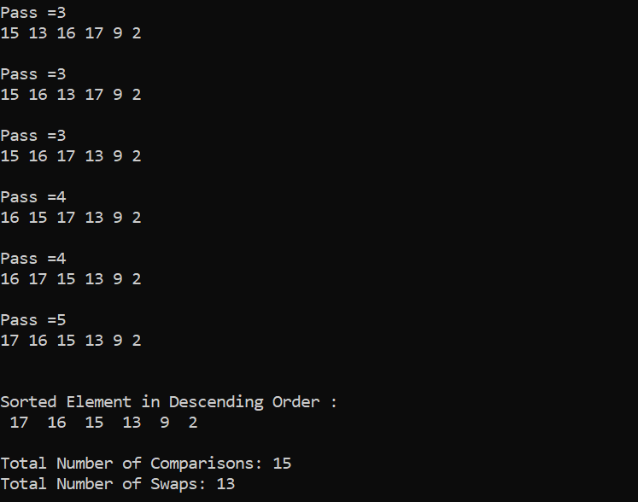
Discussion:
For the first array, improved bubble sort takes 15 total number of comparisons and 11 swaps process in order to sort array a in ascending order while it also takes 15 total number of comparisons to sort array b in descending order. However, the total number of swaps is 13 for array b. This is because the number of comparisons for the worse case and best case is the same and the difference is the number of swapping elements. Although improved bubble sort has the same number of comparisons and swaps with the bubble sort for this case, it has extra features to check whether the array is already sorted.
Generally, the number of comparisons between elements in Bubble Sort can be stated as follows:
(n-1) + (n-2) + …… + 2 + 1 = n (n-1) / 2 = O(n²)
SELECTION SORT
1. Ascending Order
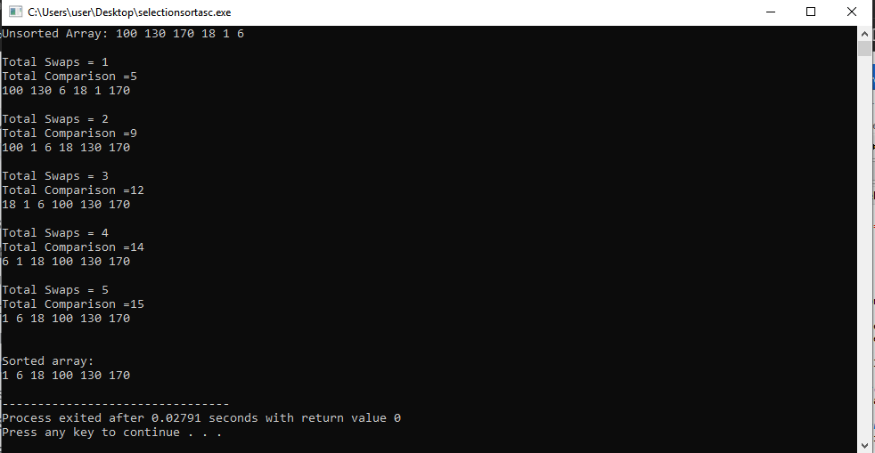

Descending Order

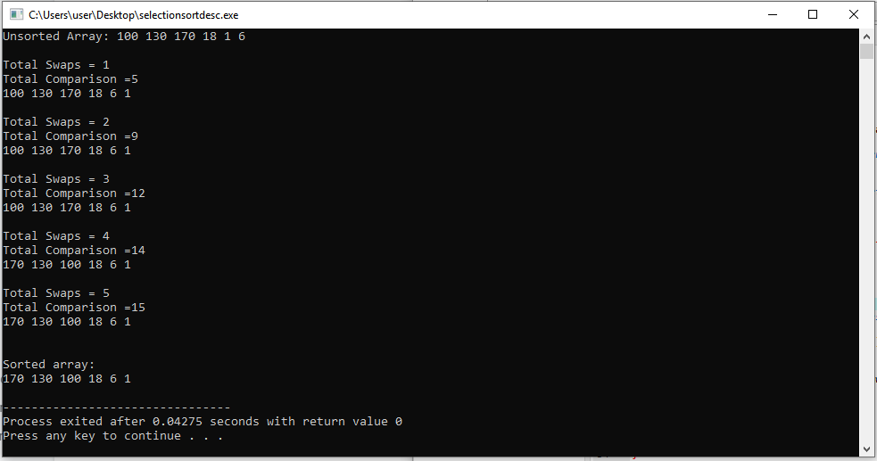

2. Ascending Order
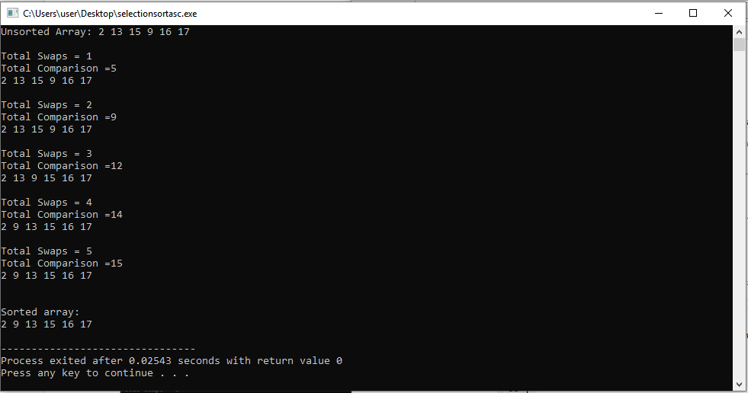

Descending Order
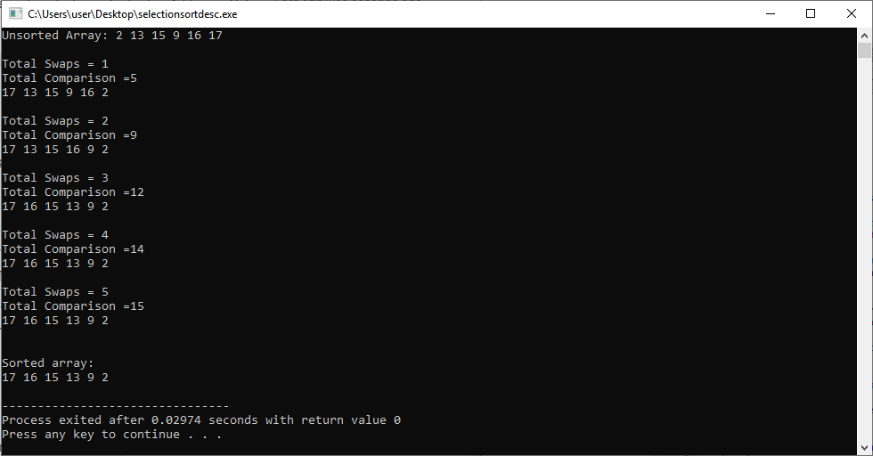

Selection Sort Analysis

For selection sort, the total comparison in each iteration is :(n-1) + (n-2) + ….. 2 + 1, which can be stated as (n(n-1))/2 = O(n^2). For BOTH array cases {100, 130, 170, 18, 1, 6}, {2 ,13 ,15 ,9 , 16, 17}, the total number of swaps and comparisons (5 and 15) are the same in terms of ascending and descending. Hence, the efficiency of selection sort does not depend on the initial arrangement of the data regardless of worst case, best case, or average case. It will only be affected by the size of the array as smaller arrays will be sorted faster. Hence, selection sort is a sorting method that you would favor while sorting small arrays compared to large arrays.

INSERTION SORT
1. Ascending Order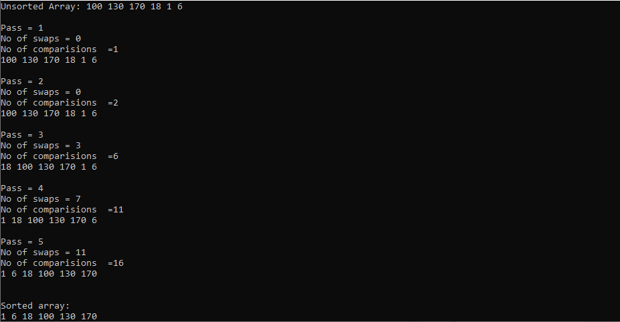
Descending Order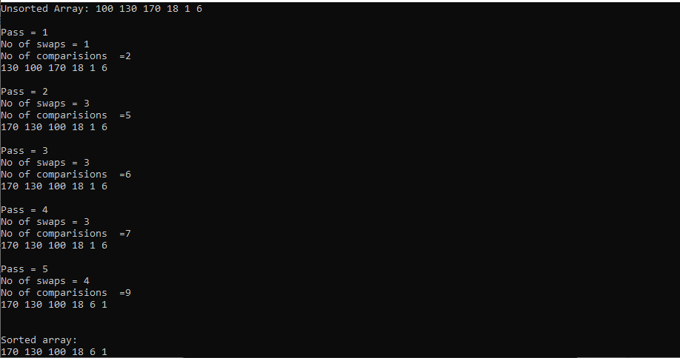
2. Ascending Order
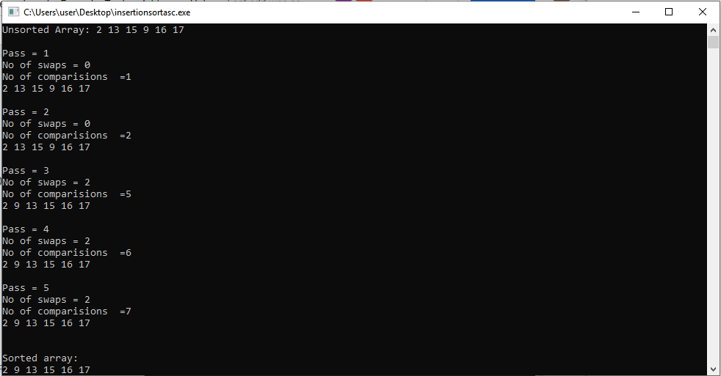

Descending Order
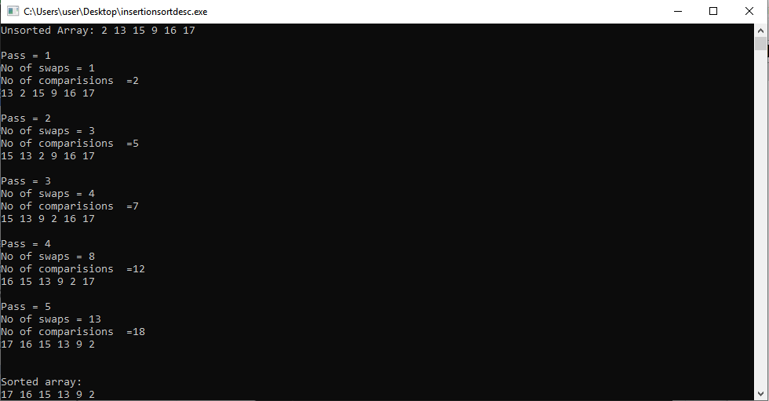

Insertion Sort Analysis

 | Array A(Ascending/Descending) | Array B(Ascending/Descending)
Swaps | 11 / 4 | 2 / 13
Comparisons | 16 / 9 | 7 / 18

In terms of efficiency, insertion sort depends on the initial arrangement with time complexity of O(n^2) in the average and worst case, and O(n) in the best case. The more initially arranged the array, the more efficient it is. For very small arrays, it is very efficient.

MERGE SORT
Ascending
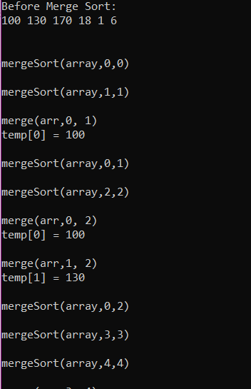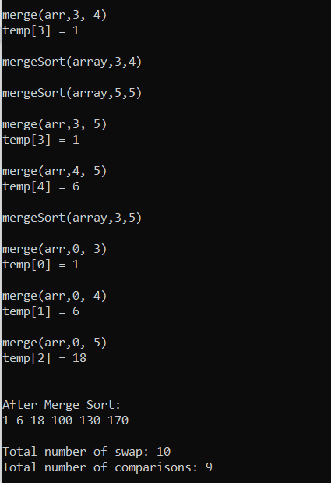

Descending
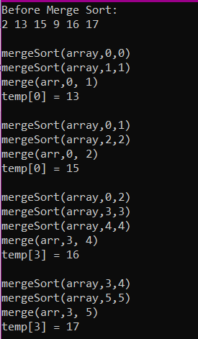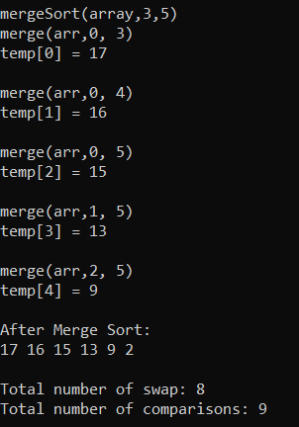

ANALYSIS

In both cases, (ascending and descending) array sort, we can see that the number of swaps and comparisons are slightly different depending on the initial order of the array items. Thus, both are not a worst case but an average case. Although the cases are different, the time complexity are still the same which is O (n * log₂n). Therefore, we can conclude that merge sort can give a fast-sorting process as it requires equal amount of space as the unsorted array. However, it is not recommended for searching large, unsorted arrays.

QUICK SORT
- 100 130 170 18 1 6 [ascending order]
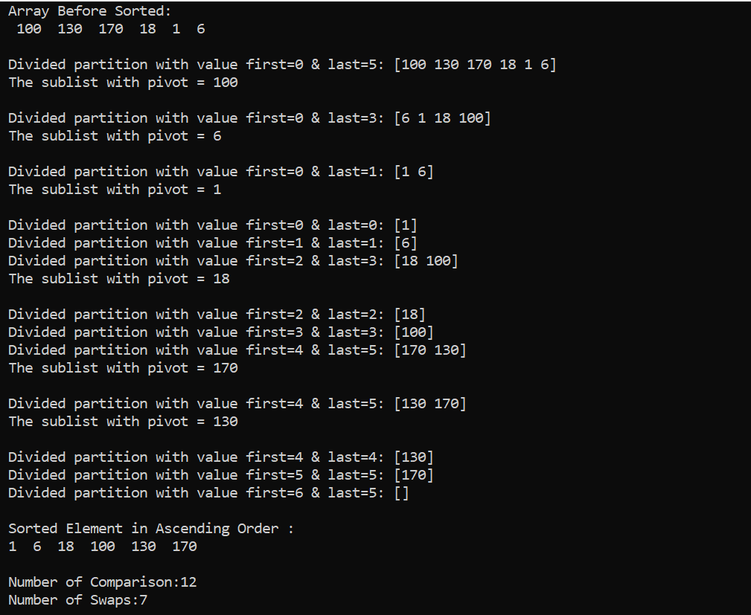

- 2 13 15 9 16 17 [descending order
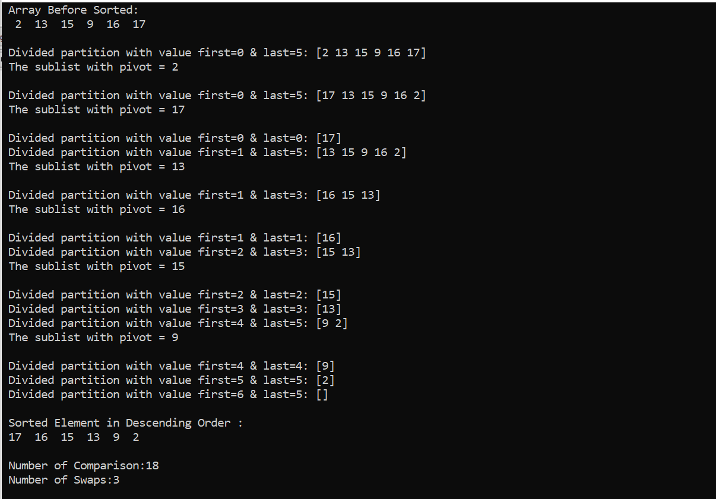

ANALYSIS

Quick Sort | Ascending | Descending
Swaps | 7 | 3
Comparisons | 12 | 18

From what I have understood from doing this assignment is that the quicksort sorting algorithm’s efficiency is based on the pivot value. In accordance to both the cases (ascending and descending order), both the quicksort are average cases with the time complexity of O(n * log₂n). Hence, we can conclude that quicksort is generally a fast and efficient sorting algorithm, and it can also cater moderately large arrays. However, the worst-case for a quicksort algorithm has a time complexity of O($n^{2}$). We can prevent the worst-case scenario by choosing a random value as the pivot as long as the pivot value is not the smallest item or the largest item.

REFLECTION
This assignment had tested my understanding for this sorting topics a lot. However, there are still a lot of things that I need to do to make sure I am fully understand as this topic are quite complicated. For this assignment, I am in charge on doing the merge sort algorithm. Therefore, by watching some videos, I can understand how it works and implement it into this assignment. As for the other sorting style, I still take some time to understand it and by seeing other people works, I can understand a little bit more but still need to polish. From my humble opinion, watching some videos can improve my understanding more as although I understand the concept well, it is still hard to implement it to coding. Thus, step-by-step illustration and tutorial on coding are very helpful.

As for the grouping, all my team members cooperate well on finishing their part. Based on what I see, they could understand their part well and are good on doing the coding. They also try to finish this assignment within the time given. Lastly, I hope that I could improve my understanding and do my best for the upcoming test.

CODING

BUBBLE SORT

Ascending (ARRAY A)
#include<iostream>

using namespace std;

int main()
{
int num=6, data[6]={100,130,170,18,1,6}, temp;
int pass, compare=0, swap=0;

cout << "Array Bofore Sorted: ";
for(int i=0;i<num;i++)
{
cout << data[i] << " ";
}
cout << endl << endl;

for (pass =1;pass < num; pass++ )
{
// moves the largest element to the
// end of the array
for (int x = 0; x < num - pass; x++) {

//compare adjacent elements
compare++;
if ( data[x]>data[x+1] )
{ // swap elements
swap++;
temp = data[x];
data[x] = data[x+1];
data[x+1] = temp;
}
cout << "Pass =" << pass <<endl;
cout << data[0] << " " << data[1] << " "<< data[2] << " " << data[3] << " "<< data[4] << " " << data[5] << endl << endl;
}
}

cout<<"\n Sorted Element in Ascending Order : \n";
for(int i=0; i<num; i++)
{
cout<<" ";
cout<<data[i]<<" ";
}

cout << "\n\n Total Number of Comparisons: " << compare << endl;
cout << " Total Number of Swaps: " << swap << endl;

return 0;
}

Descending (ARRAY B)
#include<iostream>

using namespace std;

int main()
{
int num=6, data[6]={2,13,15,9,16,17}, temp;
int pass, compare=0, swap=0;

cout << "Array Bofore Sorted: ";
for(int i=0;i<num;i++)
{
cout << data[i] << " ";
}
cout << endl << endl;

for (pass =1;pass < num; pass++ )
{
for (int x = 0; x < num-pass; x++) {

//compare adjacent elements
compare++;
if ( data[x]<data[x+1] )
{ // swap elements
swap++;
temp = data[x];
data[x] = data[x+1];
data[x+1] = temp;
}
cout << "pass =" << pass <<endl;
cout << data[0] << " " << data[1] << " "<< data[2] << " " << data[3] << " "<< data[4] << " " << data[5] << endl << endl;
}
}

cout<<"\nSorted Element in Descending Order : \n";
for(int i=0; i<num; i++)
{
cout<<" ";
cout<<data[i]<<" ";
}

cout << "\n\nTotal Number of Comparisons: " << compare << endl;
cout << "Total Number of Swaps: " << swap << endl;

return 0;
}

IMPROVED BUBBLE SORT

Ascending (ARRAY A)
#include<iostream>

using namespace std;

int main()
{
int num=6, i, data[6]={100,130,170,18,1,6}, temp;
int pass, compare=0, swap=0;
bool sorted=false;

cout << "Array Bofore Sorted: ";
for(int i=0;i<num;i++)
{
cout << data[i] << " ";
}
cout << endl << endl;

for (pass =1; (pass < num) && !sorted; pass++ )
{
sorted=true;
// moves the largest element to the
// end of the array
for (int x = 0; x < num - pass; x++) {

//compare adjacent elements
compare++;
if ( data[x]>data[x+1] )
{ // swap elements
swap++;
temp = data[x];
data[x] = data[x+1];
data[x+1] = temp;
sorted=false;
}

cout << "Pass =" << pass <<endl;
cout << data[0] << " " << data[1] << " "<< data[2] << " " << data[3] << " "<< data[4] << " " << data[5] << endl << endl;
}
}

cout<<"\nSorted Element in Ascending Order : \n";
for(int i=0; i<num; i++)
{
cout<<" ";
cout<<data[i]<<" ";
}

cout << "\n\nTotal Number of Comparisons: " << compare << endl;
cout << "Total Number of Swaps: " << swap << endl;

return 0;
}

Descending (ARRAY B)
#include<iostream>

using namespace std;

int main()
{
int num=6, i, data[6]={2,13,15,9,16,17}, temp;
int pass, compare=0, swap=0;
bool sorted=false;

cout << "Array Bofore Sorted: ";
for(int i=0;i<num;i++)
{
cout << data[i] << " ";
}
cout << endl << endl;

for (pass =1; (pass < num) && !sorted; pass++ )
{
sorted=true;
for (int x = 0; x < num - pass; x++) {

//compare adjacent elements
compare++;
if ( data[x]<data[x+1] )
{ // swap elements
swap++;
temp = data[x];
data[x] = data[x+1];
data[x+1] = temp;
sorted=false;
}

cout << "Pass =" << pass <<endl;
cout << data[0] << " " << data[1] << " "<< data[2] << " " << data[3] << " "<< data[4] << " " << data[5] << endl << endl;
}
}

cout<<"\nSorted Element in Descending Order : \n";
for(int i=0; i<num; i++)
{
cout<<" ";
cout<<data[i]<<" ";
}

cout << "\n\nTotal Number of Comparisons: " << compare << endl;
cout << "Total Number of Swaps: " << swap << endl;

return 0;
}

SELECTION SORT

Ascending (ARRAY B)
#include <iostream>
using namespace std;

/* Function to print an array */
void printArray(int arr[], int size)
{
int i;
for (i=0; i < size; i++)
cout << arr[i] << " ";
cout << endl;
}

void swap(int& x, int& y)
{
int counters = 0;

int temp = x;
x = y;
y = temp;

}

void selectionSort(int arr[], int n)
{
int counterc2;
int counterc1 = 0;
int swaps = 0;
for (int last = n-1; last >= 1; --last)
{
// select largest item in theArray
int largestIndex = 0;

// largest item is assumed start at index 0
for (int p=1;p <= last; ++p)
{
counterc1++;
if (arr[p] > arr[largestIndex]){
largestIndex = p;
}
counterc2 = counterc1;
} // end for

// swap largest item Data[largestIndex] with
// Data[last]
swap(arr[largestIndex],arr[last]);
swaps++;

cout << "\nTotal Swaps = " << swaps << endl;
cout << "Total Comparison =" << counterc2 << endl;
printArray(arr, n);

} // end for

}

// Driver program to test above functions
int main()
{
int arr[] = {2 ,13 ,15 ,9 , 16, 17};
int n = sizeof(arr)/sizeof(arr[0]);

cout << "Unsorted Array: ";
printArray(arr, n);
selectionSort(arr, n);
cout << "\n\nSorted array: \n";
printArray(arr, n);
return 0;
}

Descending (ARRAY B)
#include <iostream>
using namespace std;

/* Function to print an array */
void printArray(int arr[], int size)
{
int i;
for (i=0; i < size; i++)
cout << arr[i] << " ";
cout << endl;
}

void swap(int& x, int& y)
{
int counters = 0;

int temp = x;
x = y;
y = temp;

}

void selectionSort(int arr[], int n)
{
int counterc2;
int counterc1 = 0;
int swaps = 0;
for (int last = n-1; last >= 1; --last)
{
// select largest item in theArray
int largestIndex = 0;

// largest item is assumed start at index 0
for (int p=1;p <= last; ++p)
{
counterc1++;
if (arr[p] < arr[largestIndex]){
largestIndex = p;
}
counterc2 = counterc1;
} // end for

// swap largest item Data[largestIndex] with
// Data[last]
swap(arr[largestIndex],arr[last]);
swaps++;

cout << "\nTotal Swaps = " << swaps << endl;
cout << "Total Comparison =" << counterc2 << endl;
printArray(arr, n);

} // end for

}

// Driver program to test above functions
int main()
{
int arr[] = {2 ,13 ,15 ,9 , 16, 17};
int n = sizeof(arr)/sizeof(arr[0]);

cout << "Unsorted Array: ";
printArray(arr, n);
selectionSort(arr, n);
cout << "\n\nSorted array: \n";
printArray(arr, n);
return 0;
}

INSERTION SORT

Ascending (ARRAY B)
#include<iostream>

using namespace std;

void printArray(int arr[], int size)
{
int i;
for (i=0; i < size; i++)
cout << arr[i] << " ";
cout << endl;
}

void insertionSort(int data[], int n)
{
int item;
int pass, insertIndex;
int swap; int comp = 0;

for(pass=1; pass<n; pass++)
{
insertIndex = pass;
comp++;

while((insertIndex >0) &&(data[insertIndex -1] > data[insertIndex]))
{
if(data[insertIndex -1]>data[insertIndex])
{
comp++;
}
item = data[insertIndex -1];
data[insertIndex-1]= data[insertIndex];
data[insertIndex] = item;
swap++;
insertIndex --;
}

cout << "\nPass = " << pass << endl;
cout << "No of swaps = " << swap << endl;
cout << "No of comparisions =" << comp << endl;
printArray(data, n);
//insert item at the right place
}
}

int main()
{
int arr[] = {2 ,13 ,15 ,9 , 16, 17};
int n = sizeof(arr)/sizeof(arr[0]);

cout << "Unsorted Array: ";
printArray(arr, n);
insertionSort(arr, n);
cout << "\n\nSorted array: \n";
printArray(arr, n);
return 0;
}

Descending (ARRAY B)
#include<iostream>

using namespace std;

void printArray(int arr[], int size)
{
int i;
for (i=0; i < size; i++)
cout << arr[i] << " ";
cout << endl;
}

void insertionSort(int data[], int n)
{
int item;
int pass, insertIndex;
int swap; int comp = 0;

for(pass=1; pass<n; pass++)
{
insertIndex = pass;
comp++;

while((insertIndex >0) &&(data[insertIndex -1] < data[insertIndex]))
{
if(data[insertIndex -1]<data[insertIndex])
{
comp++;
}
item = data[insertIndex -1];
data[insertIndex-1]= data[insertIndex];
data[insertIndex] = item;
swap++;
insertIndex --;
}

cout << "\nPass = " << pass << endl;
cout << "No of swaps = " << swap << endl;
cout << "No of comparisions =" << comp << endl;
printArray(data, n);
//insert item at the right place
}
}

int main()
{
int arr[] = {2 ,13 ,15 ,9 , 16, 17};
int n = sizeof(arr)/sizeof(arr[0]);

cout << "Unsorted Array: ";
printArray(arr, n);
insertionSort(arr, n);
cout << "\n\nSorted array: \n";
printArray(arr, n);
return 0;
}

MERGE SORT

Ascending (ARRAY A)
#include <iostream>
using namespace std;

// merge sort sorting algorithm
int count = 0;
int comparison = 0;

//merge function
void merge (int arr[], int l, int m, int r)
{
int i=l; //starting index for left subarray
int j=m+1; //starting index for right subarray
int k=l; // starting index for temporary

int temp[6];

while (i<=m && j<=r)
{
cout << endl << "merge(arr," << i << ", " << j << ")"<< endl;
comparison++;
if(arr[i]<=arr[j])
{
temp[k]=arr[i];
i++;
count++;
cout << "temp[" << k << "] = " << temp[k] << endl;
}
else
{
temp[k]=arr[j];
j++;
count+=m-i;
cout << "temp[" << k << "] = " << temp[k] << endl;
}
k++;
}
while(i<=m)
{
temp[k]=arr[i]; // copy all element from left subarray to temp
i++;
k++;
}
while (j<=r)
{
temp[k]=arr[j]; // copy all element from right subarray to temp
j++;
k++;
}
for(int s=l;s<=r;s++)
{
arr[s]=temp[s];
}
}

//merge sort function
void mergeSort(int array[], int left, int right)
{
if(left<right)
{
int mid = (left+right)/2;
mergeSort(array, left, mid);
cout << endl << "mergeSort(array," << left << "," << mid << ")" << endl;
mergeSort(array, mid+1, right);
cout << endl << "mergeSort(array," << mid+1 << "," << right<< ")" << endl;
merge(array, left, mid, right);
}
}

int main()
{
int myarr[6] = {100, 130, 170 ,18, 1, 6};

cout << "Before Merge Sort: " << endl;
for(int i = 0; i < 6; i++)
{
cout << myarr[i] << " ";
}
cout << endl << endl;

// merge function
mergeSort(myarr, 0, 5);

cout << endl << endl << "After Merge Sort: " << endl;
for(int i = 0; i < 6; i++)
{
cout << myarr[i] << " ";
}

cout << endl << endl << "Total number of swap: " << count;
cout << endl << "Total number of comparisons: " << comparison;
return 0;
}

Descending (ARRAY B)
#include <iostream>
using namespace std;

// merge sort sorting algorithm
int count = 0;
int comparison = 0;

//merge function
void merge (int arr[], int l, int m, int r)
{
int i=l; //starting index for left subarray
int j=m+1; //starting index for right subarray
int k=l; // starting index for temporary

int temp[6];

while (i<=m && j<=r)
{
cout << endl << "merge(arr," << i << ", " << j << ")"<< endl;
comparison++;
if(arr[i]>arr[j])
{
temp[k]=arr[i];
i++;
count++;
cout << "temp[" << k << "] = " << temp[k] << endl;
}
else
{
temp[k]=arr[j];
j++;
count+=m-i;
cout << "temp[" << k << "] = " << temp[k] << endl;
}
k++;
}
while(i<=m)
{
temp[k]=arr[i]; // copy all element from left subarray to temp
i++;
k++;
}
while (j<=r)
{
temp[k]=arr[j]; // copy all element from right subarray to temp
j++;
k++;
}
for(int s=l;s<=r;s++)
{
arr[s]=temp[s];
}
}

//merger sort function
void mergeSort(int array[], int left, int right)
{
if(left < right)
{
int mid = (left+right)/2;
mergeSort(array, left, mid);
cout << endl << "mergeSort(array," << left << "," << mid << ")";
mergeSort(array, mid+1, right);
cout << endl << "mergeSort(array," << mid+1 << "," << right<< ")";
merge(array, left, mid, right);
}
}

int main()
{
int myarr[6] = {2,13,15,9,16,17};

cout << "Before Merge Sort: " << endl;
for(int i = 0; i < 6; i++)
{
cout << myarr[i] << " ";
}

cout << endl;

// merge function
mergeSort(myarr, 0, 5);

cout << endl << "After Merge Sort: " << endl;
for(int i = 0; i < 6; i++)
{
cout << myarr[i] << " ";
}

cout << endl << endl << "Total number of swap: " << count;
cout << endl << "Total number of comparisons: " << comparison;
return 0;
}

QUICK SORT

Ascending(ARRAY A)
#include <iostream>

using namespace std;

int comparison = 0;
const int MAX_VAL = 6;
int swaps = 0;

void printPartition (int array[],int first,int last){

cout<<" Divided partition with value first="<<first<<" & last="<<last<<": [";
for(int i = first; i <=last; i++){
cout << array[i];
if(i!=last)
cout<<" ";
}

cout<<"]\n";
}

//Function to rearrange array, finds pivot value (partition point)
int partition(int array[],int first,int last){

int pivot, temp;
int loop, cutPoint, bottom, top;

pivot=array[first];
cout << " The sublist with pivot = " << pivot << endl << endl;
bottom=first;
top=last;
loop=1;

while(loop){

while(array[top]>pivot)
{
top--;
comparison++;
}

while(array[bottom]<pivot)
{
bottom++;
comparison++;
}

if(bottom<top){
//change pivot place
temp=array[bottom];
array[bottom] = array[top];
array[top] = temp;
swaps++;
}

else
{
loop = 0; //loop false
cutPoint = top;
}

} //end while

return cutPoint;

} // end partition

void quickSort(int array[],int first,int last){

int cut;

printPartition(array,first,last);
if(first<last)
{
cut=partition(array,first,last);
quickSort(array,first,cut);
quickSort(array,cut+1,last);
}
}

int main()
{
int data[]={100, 130, 170, 18, 1, 6};
//To display Unsorted Array list
cout << " Array Before Sorted: \n ";

for(int i=0;i< MAX_VAL;i++)
{
cout << " "<< data[i] << " ";
}
cout << endl << endl;

quickSort(data,0,MAX_VAL-1);
cout<<"\n Sorted Element in Ascending Order : \n";

//print the array
for(int i=0; i<MAX_VAL; i++)
{
cout<<" ";
cout<<data[i]<<" ";
}

cout<<endl;

// calculate the total of comparison & swaps
cout<<"\n Number of Comparison:"<<comparison<<endl;
cout<<" Number of Swaps:"<<swaps<<endl;

return 0;
}

Descending (ARRAY B)
#include <iostream>
using namespace std;

int comparison = 0;
const int MAX_VAL = 6;
int swaps = 0;

void printPartition (int array[],int first,int last){

cout<<" Divided partition with value first="<<first<<" & last="<<last<<": [";
for(int i = first; i <=last; i++){
cout << array[i];
if(i!=last)
cout<<" ";
}
cout<<"]\n";
}

//Function to rearrange array, finds pivot value (partition point)
int partition(int array[],int first,int last){

int pivot, temp;
int loop, cutPoint, bottom, top;

pivot=array[first];
cout << " The sublist with pivot = " << pivot << endl << endl;
bottom=first;
top=last;
loop=1;

while(loop){

while(array[top]<pivot)
{
top--;
comparison++;
}

while(array[bottom]>pivot)
{
bottom++;
comparison++;
}

if(bottom<top){
//change pivot place
temp=array[bottom];
array[bottom] = array[top];
array[top] = temp;
swaps++;
}

else
{
loop = 0; //loop false
cutPoint = top;
}
} //end while
return cutPoint;
} // end partition

void quickSort(int array[],int first,int last){

int cut;

printPartition(array,first,last);
if(first<last)
{
cut=partition(array,first,last);
quickSort(array,first,cut);
quickSort(array,cut+1,last);
}
}

int main()
{
int data[]={2 , 13, 15 ,9 ,16 ,17};
//To display Unsorted Array list
cout << " Array Before Sorted: \n ";

for(int i=0;i< MAX_VAL;i++)
{
cout << " "<< data[i] << " ";
}
cout << endl << endl;

quickSort(data,0,MAX_VAL-1);
cout<<"\n Sorted Element in Descending Order : \n";

//print the array
for(int i=0; i<MAX_VAL; i++)
{
cout<<" ";
cout<<data[i]<<" ";
}

cout<<endl;

// calculate the total of comparison & swaps
cout<<"\n Number of Comparison:"<<comparison<<endl;
cout<<" Number of Swaps:"<<swaps<<endl;

return 0;
}

