RESUME
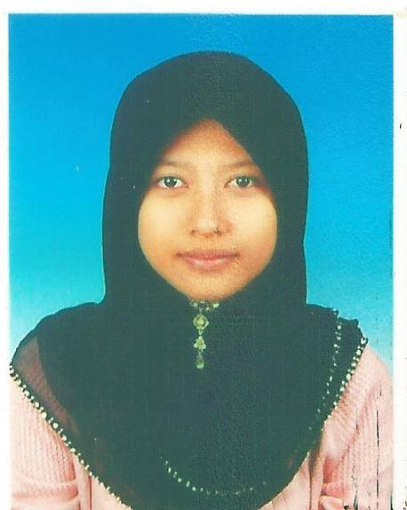
PERSONAL DETAILS

Name : Nur Azrina Binti Mohd Azman Race : Malay
Date of Birth : 18th December 1993 Nationality : Malaysia
Gender : Female Address : No.540, Batu 18 Air
Marital Status : Single Hitam, 83500, Muar,
NRIC : 931218-01-5500 Johor Darul Takzim.
Age : 22 Phone : 017-2369647
Religion : Islam Email : nurazrina_123@yahoo.com
EDUCATION BACKGROUND

Level : Bachelor Degree, 2011– Present
University : Universiti Teknologi Malaysia, Johor Bahru
Field of Study : Engineering (electrical)
Current CGPA : 3.27

Level : Foundation (Program Express MARA-UTM), 2011
University : Universiti Teknologi Malaysia (Jan - May)
Field of Study : Science and Engineering
Result (CGPA) :3.62

Level : Malaysian Certificate of Education (SPM), 2010
Institution : Maktab Rendah Sains MARA Muar
Result : 3A+ 2A 1A- 3B+

SPECIAL SKILLS

Computer Skills : Expert in using Microsoft Office (Word, Excel, Power Point),
: MATLAB, P-SPICE, and AVR Studio Software
: Ability in using Boolean C++ Software, Power World Software, Cx-Programmer, and SCADA OMRON software.
Communication Skills : Able to speak and write in Malay and English fluently
Laboratory Skills : High ability in handling experiment set up in the laboratory and experienced in handling instrument
Strengths : Able to swiftly fit in and adapt to a new working environment and work under pressure
: Excellent in generating ideas, solving problems, critical, positive thinking, responsible, confident and dynamic team player
: Able to handle a team with tolerant, cooperation and peaceful
: Able to take criticism restfully
: Have great enthusiasm in discovering new things.
EXTRA CURRICULAR ACTIVITIES

2014 : Participate in the MyINOVASI 2014

2013 : Participate in Global Outreach Program to Seoul National University, South Korea.
: Active Member of Kelab Bakti Siswa(KBS), Kolej 9/10, UTM (2012-present)
: Facilitator of orphanage motivation program, ‘Ar-Rayyan’

2012 : Participate in 1st UTM International Equine Seminar 2012
: Committee member in UTM International Johor Horse Show 2012
: Facilitator for Motivation Camp in SMK. Teknik Terengganu
: Participate in ‘TINTEC T-TEST 2012’ Program in Kuala Terengganu
: Participate in Motivation Program ‘Andaiku Tahu’ Kolej 9/10

2011 : Crew for Minggu Transformasi Mahasiswa (MTM) Program Ekspress
UTM-MARA Sesi 2011/2012.
. : Participate in industrial visit to Singapore for First Year Experience (FYE) program
: Participate in First Year Experience (FYE) Camp.

2010 : National Physics Quiz 2010
: National Chemistry Quiz 2010
UTM PROFESSIONAL SKILSS CERTIFICATE

- ISO 9001:2008 Quality Management System Requirement
- How to Manage Your Personal Finance
- Harvard Business School – Case Study
- How To Get Yourself Employed (HTGYE)
REFERENCES

Mr. Mohd Zaki Bin Daud
Academic Advisor,
Faculty of Electrical Engineering,
Universiti Teknologi Malaysia,
81310 Skudai,
Johor Darul Takzim.
Tel : 0197281924

