

4TH IR TECHNOLOGY

ARTIFICIAL INTELLIGENCE (AI)

LOW FIDELITY PROJECT

PART 2

REPORT

SECP1513-11 GROUP 6
TECH_Pentagon

NAME | MATRIC NUMBER
OMAR RASHID AHMED | A20EC4069
ABDULLAH NAFIS | A20EC4060
MUHAMMAD ADAM LUQMAN BIN HAMZAH | A21EC0201
MUHAMMAD NABIL BIN KAMIL | A21EC0086
AHMED ALI YUSUF | A20EC4084

TABLE OF CONTENT

PART | CONTENTS | PAGE
1 | Introduction | 3
2 | Description: Problem Statement | 4
3 | Description: Proposed Solution | 5
4 | Teamworking | 6
5 | AWS Architecture Explanation | 7
6 | Business Process Flow | 9
7 | Mockup Explanation | 10
8 | Reflection | 14

INTRODUCTION

The connection between humans and physical devices, as well as devices in the real world, is rising in popularity, and it necessitates the use of a natural and intuitive methodology. Life has become an increasing demand based on this concept and living well. As a result, how to grow pets in a simple manner has recently been a hot topic. The Internet of Things technology is used to investigate the ability of computation, communication, and control technologies to improve human-pet interaction. This project aims to improve the ability of location awareness in pets and to assist pet owners in quickly training their pets to limit their activity and eating. Extensive testing findings show that our proposed approach is effective in treating illness and reducing symptoms. Our research not only demonstrates a significant advancement in the pet monitor system as it relates to Internet of Things concepts, but it also demonstrates how the internet of things can be used to solve problems .

DETAIL STEP AND DESCRIPTION

PROBLEM STATEMENT:
The initiative of this proposed project is to solve a series of problems that clients face in their daily lives, such as difficulty performing routine tasks. This initiative aims to promote the adoption of 4th IR technology among customers to improve their quality of life.

- This type of technology has yet to be implemented because the cost might exceed the expectation. It puts stress towards the owners and pets themselves since not everyone can afford highly priced products.

- Separation anxiety is a real deal for animals, especially those who are still young and cannot take care of themselves properly without humans’ presence. They will need to fight loneliness in such a poor state. With anxiety and depression, their sulky eyes might break our hearts too as owners.

- Busy pet owners is the most focused problem in this project. There are many types of lack of devotion towards pets such as short of commitment, unsuitable lifestyle or not enough attention. Most of the time, people are busy doing things they are responsible for, and cannot simply get away from that.

PROPOSED SOLUTIONS:
Smart pet application helps clients to save time and lead a healthier lifestyle by supervising and monitoring their beloved animals which are sometimes considered as part of a family. It is also cost efficient because clients do not have to get separate devices for the same features as it is all in one application. It comes with a variety of combination features. Users’ satisfactions are improved by integrating smartness into technology-enabled pet tools by reducing user input workload.

- Smart applications help organize and manage adopted pets by combining gadgets with pet tasks such as feeding, grooming, live location, fitness, and hygiene.

- With the development of the smart pet system, one of its capabilities is one app that gives users control over their precious partners anytime, anywhere, or to monitor, helping them prepare for their absence.

- A complete function which varies accordingly to users’ needs. Most importantly, the interface is highly interactive and accessible, giving chance to both older or younger generations to use it easily. In a simpler word, it is an application for all including those who are not tech-savvy.

TEAMWORKING

My teammates and I each have a specific role. Before starting the report, I assigned tasks according to skill. We focused on teamwork skills such as organizational and planning skills, decision making skills, problem solving skills, and communication skills. The person responsible for creating the low fidelity mockups worked with software called Proto.io. This software helps you design user interfaces like the Smart Pet in a mobile application. To create an AWS Architecture diagram and business flow diagram, a representative created a detailed flow chart for the service desk and reviewed the company's revenue and customer data. This should be done by someone with organizational and planning skills. We have assigned a group member to edit the video for the project video. His creativity allowed him to use his imagination to come up with new ideas and provide interesting videos that we can produce. The last two members have been decided to contribute by explaining the problem of the project and presenting a solution. With each of us assigned to our respective roles, we have successfully managed to develop a proposal of a smart pet system.

AWS ARCHITECTURE EXPLANATION

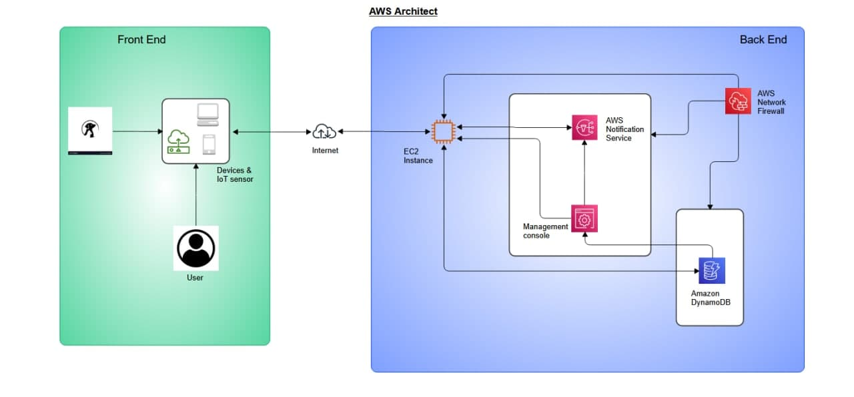

Explanation

Services of AWS in Architecture:

EC2 Instance: EC2 is a virtualization technique that acts as a stand-in for a physical server on which our applications can be run. The Amazon Elastic Compute Cloud (EC2) is a service that allows corporate subscribers to run applications on a computer system. Rather to purchasing and setting up our own hardware, Amazon gives us almost unlimited virtual machines to run our apps while they take care of the hardware.

Amazon Simple Notification Service: The Amazon Simple Notification Service (Amazon SNS) is a fully managed messaging service for both A2A and A2P communication. It can help to minimize costs by simplifying application architecture. Publisher systems can send up to ten messages in a single API call using message batching. Subscriber systems that use message filtering get only the messages that are relevant to them. Each communication published on Amazon SNS is stored across multiple data centers that are geographically dispersed. Amazon SNS implements a message delivery retry policy if a subscribing system is unavailable. Also it can can shift messages to dead-letter queues if they can't be delivered before the delivery retry policy expires (DLQ).

Amazon DynamoDB: Amazon DynamoDB is indeed a fully managed NoSQL database service with smooth scaling and efficient with reliable performance. Customer don't have to worry about system maintenance, setup and configuring, duplication, software patching, or cluster scalability with DynamoDB because it offloads the administrative requirements of managing and controlling a distributed database. DynamoDB also supports encryption , which reduces the time and effort needed to safeguard confidential material.

Amazon Management Console: The Amazon Web Services Management Console is a web-based interface for Amazon Web Services (AWS). Customers can use the portal to manage their cloud computing, cloud storage, and other Amazon Web Services infrastructure services. Elastic Compute Cloud, Amazon Simple Storage Service, Elastic Load Balancing, AWS OpsWorks, AWS Identity and Access Management, and CloudWatch are all accessible through the Management Console.

AWS Network Firewall: AWS Network Firewall is a managed solution that makes it simple to set up crucial network security for all of the Amazon VPCs (VPCs). Customer don't have to worry about deploying or managing infrastructure because the service can be set up in just a few clicks and scales automatically with your network traffic. The configurable rules engine in AWS Network Firewall allows user to create firewall rules that offer them fine-grained control over network traffic, such as limiting outbound Server Message Block (SMB) requests to prevent malicious activity from spreading.

Business Process Flow
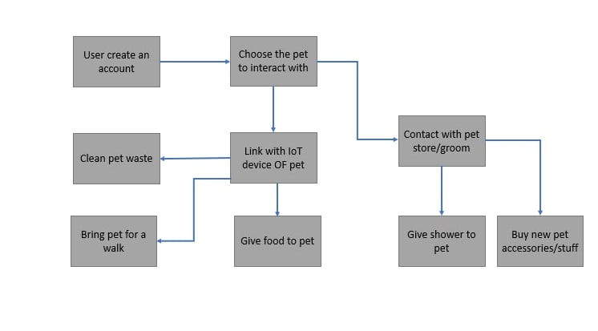
Description:
At first, users create an account to log in to the application. Several users of such a application generally need to choose the pet to interact with link IoT device of pet, the users can get cleaning pet waste, bring pet for a walk, and give food to pet, then the user contact with pet store/groom, after that they give shower to pet, and that they need to buy new pet accessories or stuff.

Low Fidelity Mockup and Explanation
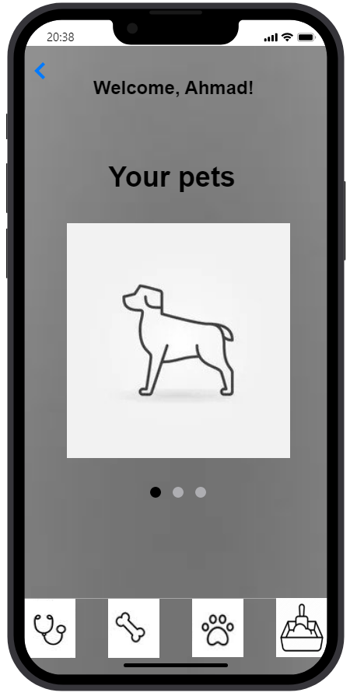
SCREEN 1 SCREEN 2
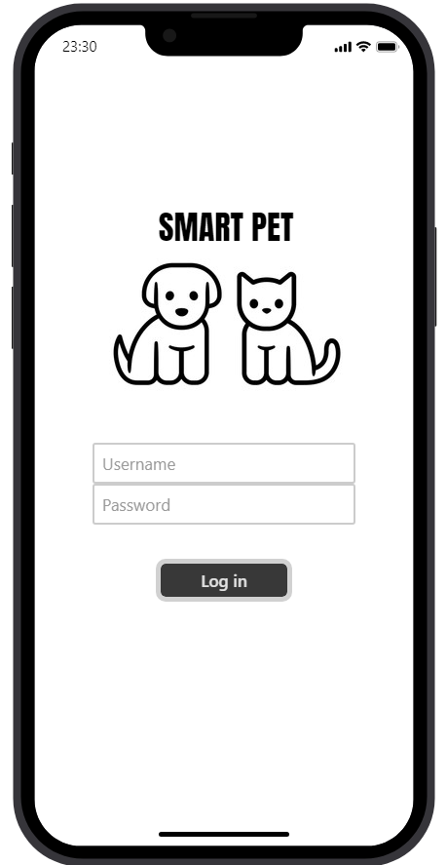
For this Smart Pet Prototype App, it contains 8 screens including the login page. Firstly, when the users downloaded and opened the app they will see the login page where the users will see the username part which the users need to sign in to use the functions in the apps. They need to insert their username and password in the password to make sure the account is in good privacy and secured. After they fill the information needed, the users need to click the ‘Log in’ button to continue into the app.

Next, is the home page screen . As shown in screen 2 , the homepage is the welcome page . This page shows your pet that you have.It is horizontally scrollable which you can see your other pets too and as shown in screen 2 Ahmad has a dog. On the top left is the back icon to go back to the login page (screen 1). Going to the bottom part of this page you can see 4 square boxes that will direct you to a specific screen. The user can choose what he/she wants to do. For example , the user can click the health and fitness button to go to that page which is shown in screen 3 .
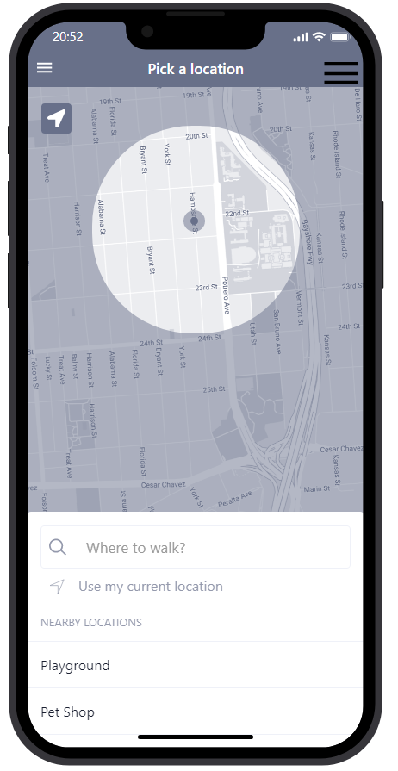
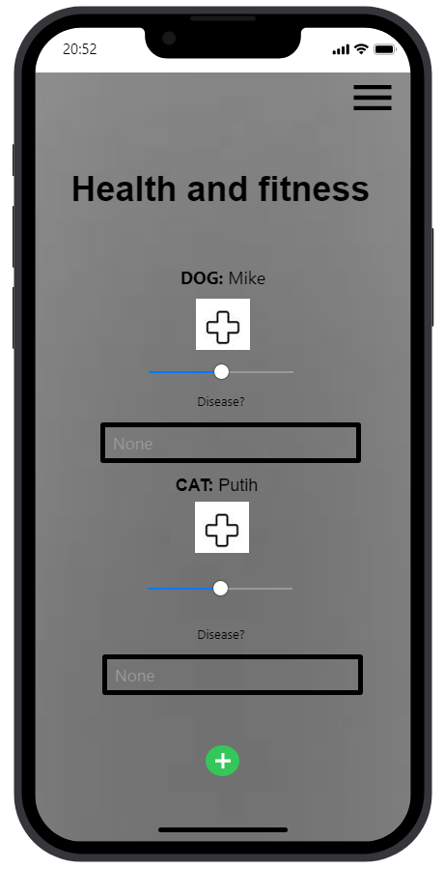
SCREEN 3 SCREEN 4
SCREEN 3
This page is about Health and fitness , that’s to say it's used to check the dog's health . In this page the user has to put pet name and disease if there is any as shown in screen 3. Also, at the bottom of the page you can see a plus icon to add up other pets information regarding their health and fitness. On the top right page is the home icon which will direct the user back to homepage (screen 2). Also as you can see, every page will have the back button on the top left page that will bring the user to the previous page when pressed.
SCREEN 4
This page is about fitness and it's just a continuation of the previous page ,in which you can choose the second box and it will navigate to this page.The user has to choose a location to walk and also pick a nearby location that you can go to and it is related to user pet history. So, it will make it easier to choose a location without opening up other navigation app.

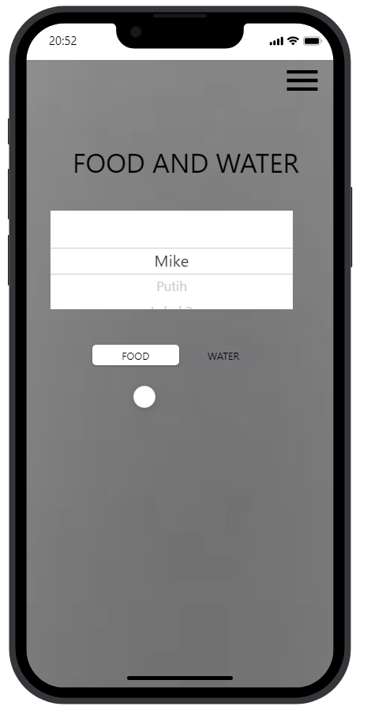
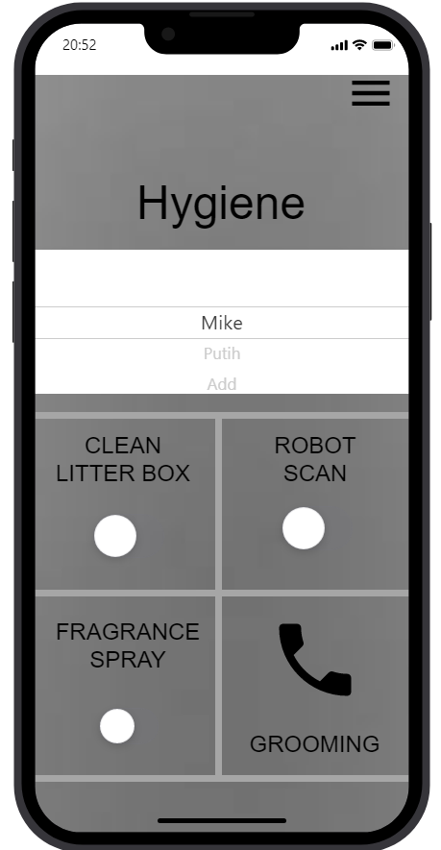
SCREEN 5 SCREEN 6
SCREEN 5
This page is about the pet food and water whereby the user has to select or enter the type of food he/she wants for the pet, in this case dog . Also, it has the on/off switch button that will deliver the signal to the user home either to feed your pet or give them water. You must have internet connection otherwise it will not connect to your smart feeder pet at home and use it.
SCREEN 6
The screen here is about Pet Hygiene . The user needs to select or enter the best way to keep the pet hygiene good and clean . You can choose to turn on either of those three switches, which is clean litter box to clean the litter box and robot scan to scan some urine or stain waste and clean automatically by the robot or the fragrance spray to make your house smell nicer without bad odor produced from your pet waste. Other than that, there is a phone icon which will be directed to screen 7.
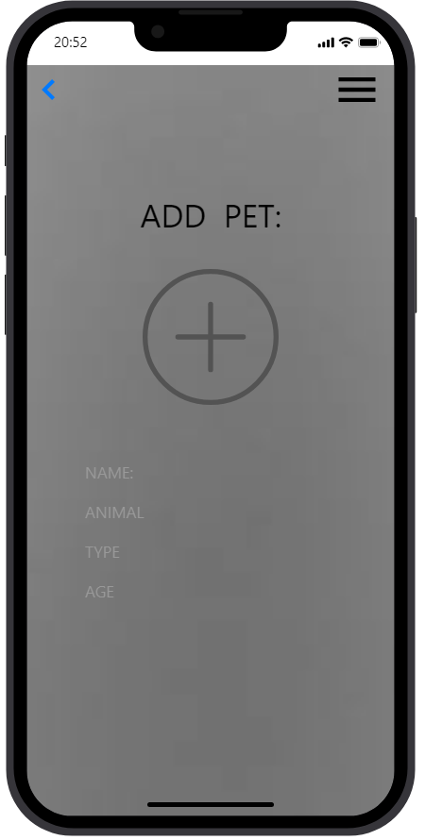
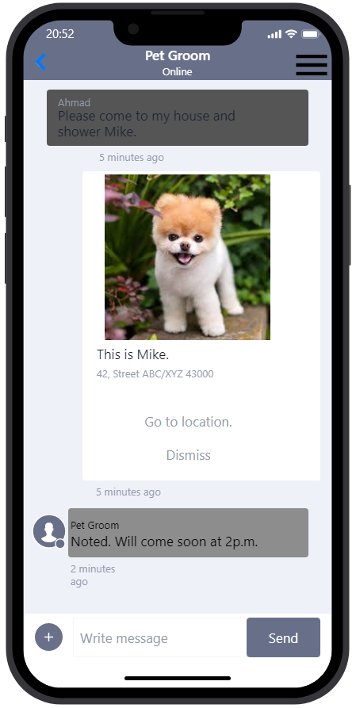
SCREEN 7 SCREEN 8
SCREEN 7
This screen page is about chatting with a pet store/pet groom. In the best way to proceed for this case Ahmed the user needs dog Mike showered and cleaned by the pet groom as shown in the SCREEN 7 . You can also go back to the hygiene page (Screen 6) by clicking the back icon on the top left page.
SCREEN 8
The last page will directed to when you tap the add button in the homepage (screen 2) This page is about providing pet information , that’s to say the user needs to add pet (animal , name , type and age ) This information will automatically update to your profile and ready to use other function in this app.

REFLECTION

Muhammad Nabil bin Kamil

During this group project, I have learned so many things. I have gained a lot of knowledge that will be beneficial in the future. The Smart Pet is very interesting since it incorporates 4IR technology and also assists me in developing crucial soft skills such as digital skills, communication skills, and teamwork skills. With the help of friends and family, I was able to maintain my motivation to complete this project. Upon completing this project my group and I divided the tasks to make it easier and manageable.

My part is to do the low fidelity mockup and we decided to use proto.io to make the prototype of a Smart Pet App. I learned a lot in designing the app which was hard for me at first. I managed to finish this project and my team members also helped a lot by doing their own part. We also help out each other if we have any problems and difficulty on doing this project. Other than that, I learn about AWS Architecture and its functionality through youtube and also during my learning from the AWS modules. They give good explanations and help a lot upon completing this project.

The challenges that I faced during completing this project were one of them is the difficulty to discuss with other group members. This is because we are currently at home and away from each other and this also affects our communication and discussion in making the project. However, we have a telegram group and this makes our project much easier and for all of us to give out the ideas and discuss which is the best. Other than that, I found that making the low fidelity prototype using online software is difficult. This is because I have zero knowledge on design and its function. This problem is solvable and I learned how to make the prototype app through youtube and search it up on the internet.

Next, after finishing this project my plan is to level up my skill in soft skills, especially in designing low fidelity prototypes. For example, I decided to learn more in prototype software such as AdobeXD, Sketch, InVision Studio, Axure, Craft, Proto.io and Marvel. As that being said I have to work hard to achieve this aim and make improvements to upcoming projects as well as being a productive student.

Muhammad Adam Luqman bin Hamzah

Personally, I think I'm in a position to leverage the knowledge and experience I've gained, especially in the areas of Industry Revolution 4.0 such as cloud computing, the Internet of Things, and the application of elements such as artificial intelligence. After completing this project, research conducted will be focusing on the importance of IR4.0 as it is an important element of global progress. I believe that all the knowledge gained can be applied to future problems efficiently, especially in future careers in the IT field. I take inspiration from my group and smart pet application to further enhance my fundamentals by discovering other key elements and working on the project's goal of improvising existing advanced technology. My motivation to continue is my pure enthusiasm and curiosity to learn more about our target topics. I find it fascinating how each unique component has its own capabilities and how it connects with evolving technology. In addition, I tried to complete my assigned tasks as soon as possible so I can save most of my time and immerse myself in other activities. With that intent, I can feel the willingness to carry out my part of the project.

The problem I faced when completing this project was mainly that my teammates and I couldn't work face-to-face because we had online classes and lived far away from each other. However, the solution to this problem was to discuss it online from time to time. I completed this project online and it was still successful. Another problem I faced was that I didn't have a deep knowledge of a smart application, which made it difficult to understand the concepts and technologies implemented in it. However, I am grateful because Dr. Muhammad Iqbal Tariq bin Idris had given me much clearer idea of ​​how this system work with the help from the internet as well as my friends. They had given me a lot of information and I was able to deepen my understanding. Otherwise, my knowledge about this project would have been so little.

After finishing this project, I would like to continue participating in such projects in the future. This type of project is one of my experiences and it helps my portfolio because it's fun to complete the project and I can improve my skills in all areas. I believe that implementing AI in our environment can change the world for the better. I would like to participate in various programs and workshops that will help me to enhance my knowledge on this subject. I sincerely hope that this will make the lives of people around us more convenient. In order to maximize my potential, I will utilize the knowledge and experience I have gained so far to carry out my future work. I have more time and want to know more about related IT topics.

To unleash my potential in industry, I will take every opportunity to do as much as possible in every project I work on while studying. Being able to do it alone is comforting and accustomed to the ability to complete tasks on my own, especially if assigned to me. I would like to attend all the structured workshops that will be held because I can find out new things by attending them. I will try to study not only in formal classes like college, but also in informal classes that will help me grow as a student.

Ahmed Ali Yusuf

In this whole project, I have been both delighted and intimidated by the prospect of completing it. This project allows me to learn a variety of new skills, such as the AWS Architecture Diagram. Aside from that, new knowledge such as inventive concept generation and modern-day fashion in IoT are among the many new things I've learned. The understanding and trip that I would acquire when I finished this assignment is the drive for me to complete this task. I am a naturally interested student, and despite any reservations, I will demonstrate my willingness to study all the new information in this project.
One of my biggest challenges, when I was working on this project, was a lack of expertise on AWS Architecture Diagram. When I initially read the rubrics that included the AWS Architecture Diagram, I thought this was going to be difficult work for me because I am new to it. With answers such as attending AWS Badge modules and learning how to make an amazing and functional AWS Architecture Diagram on YouTube. Finally, I was able to develop the AWS Architecture Diagram and provide a specific and detailed rationale for it.
Following the completion of this worry, my path will be to continue learning new things in order to broaden my expertise in information technology. Because the current world is geared toward digitisation and mobilisation, it is critical for an individual to comprehend as much technical knowledge as possible. As a result, I choose to take advantage of possibilities to learn related Information Technology skills such as programming, artificial intelligence, software program development, and many more.
Numerous upgrades, such as my verbal exchange skill and participation capacities, are critical for me to continue to improve in this topic, which is expected to be extremely competitive in the future. Communication skills are essential to developing since they allow for cooperation and teamwork in the future workplace. Simultaneously, participation ability is required since efficient and collaborative teamwork will be equally crucial in the future. As a result, as I am typically constant and never stop growing these talents, I will continue to improve all of them till I reach the pinnacle.

Abdullah Nafis
The notion of completing this project has energized me throughout the journey. This project has provided me with the opportunity to master a range of new skills. I've worked on cloud architecture and AWS architecture and have learned how to design them. I have learned about EC2 Instances, Amazon SNS, Amazon Management Console, and other services, as well as how to use them in different scenarios. While working as part of a team, I have also improved my critical thinking ability, communication skills, and time management skills. My goal in completing this project is to acquire and learn the skills I'll need in my real life, and to be able to use them effectively where they'll be most useful.
However, while working on the project, we have encountered a variety of challenges, some of which were tough to resolve. It was difficult to discuss together or arrange a meeting as we have to do this project online and we all are from different time zones. Aside from that, we had minor concerns that were readily resolved. In addition, all of my team members were really helpful throughout the whole project. Despite all of the major or minor concerns, we have worked together and completed the project.
To sum up, I can say that I will do my best to learn more about these topics and to work on these issues so that I can gain a better understanding of them. I'll also strive to use my project-related work experience in other areas in order to improve. To enhance my potential, I must become more pleasant in order to learn more. I need to learn more about technology and information systems, as well as work on additional projects and events. I need to be more sincere and better manage my time. I'm at the end of the line, and I need to work hard to maximize my potential in the field.

OMAR RASHID AHMED
First and foremost I would like to thank our lecturer for this semester and especially this course has been great and smooth. Now there are variety of things that gained and learned over the course for example cloud computing , this was my first time ever to go a little deep into it , I can at least now say to some what extent I have knowledge about cloud computing though really not an expert . There is also augmented reality , now this is really very advanced technology and it gets me excited to what it can do and how it does things .
I have also been part of the Tech_Pentagon group which contains 5 members . It has been a pleasure and fun working with these guys . Anyhow we faced some challenges e.g different time zones , that’s to say we are mostly from different countries and hence it’s a little bit difficult to conduct meetings or set meeting time , the challenge of not being able to work together face to face . personally the main challenge that I have faced is poor internet connection , that’s to say with the internet I have it was difficult to take part in meetings or even join classes although I managed most of the time .
In conclusion , with the knowledge I have gained over the course that has really got me excited , I will really be looking forward to learning them or even taking part in other projects that are related to these kinds of topics .
Thank you so much sir and God bless you

