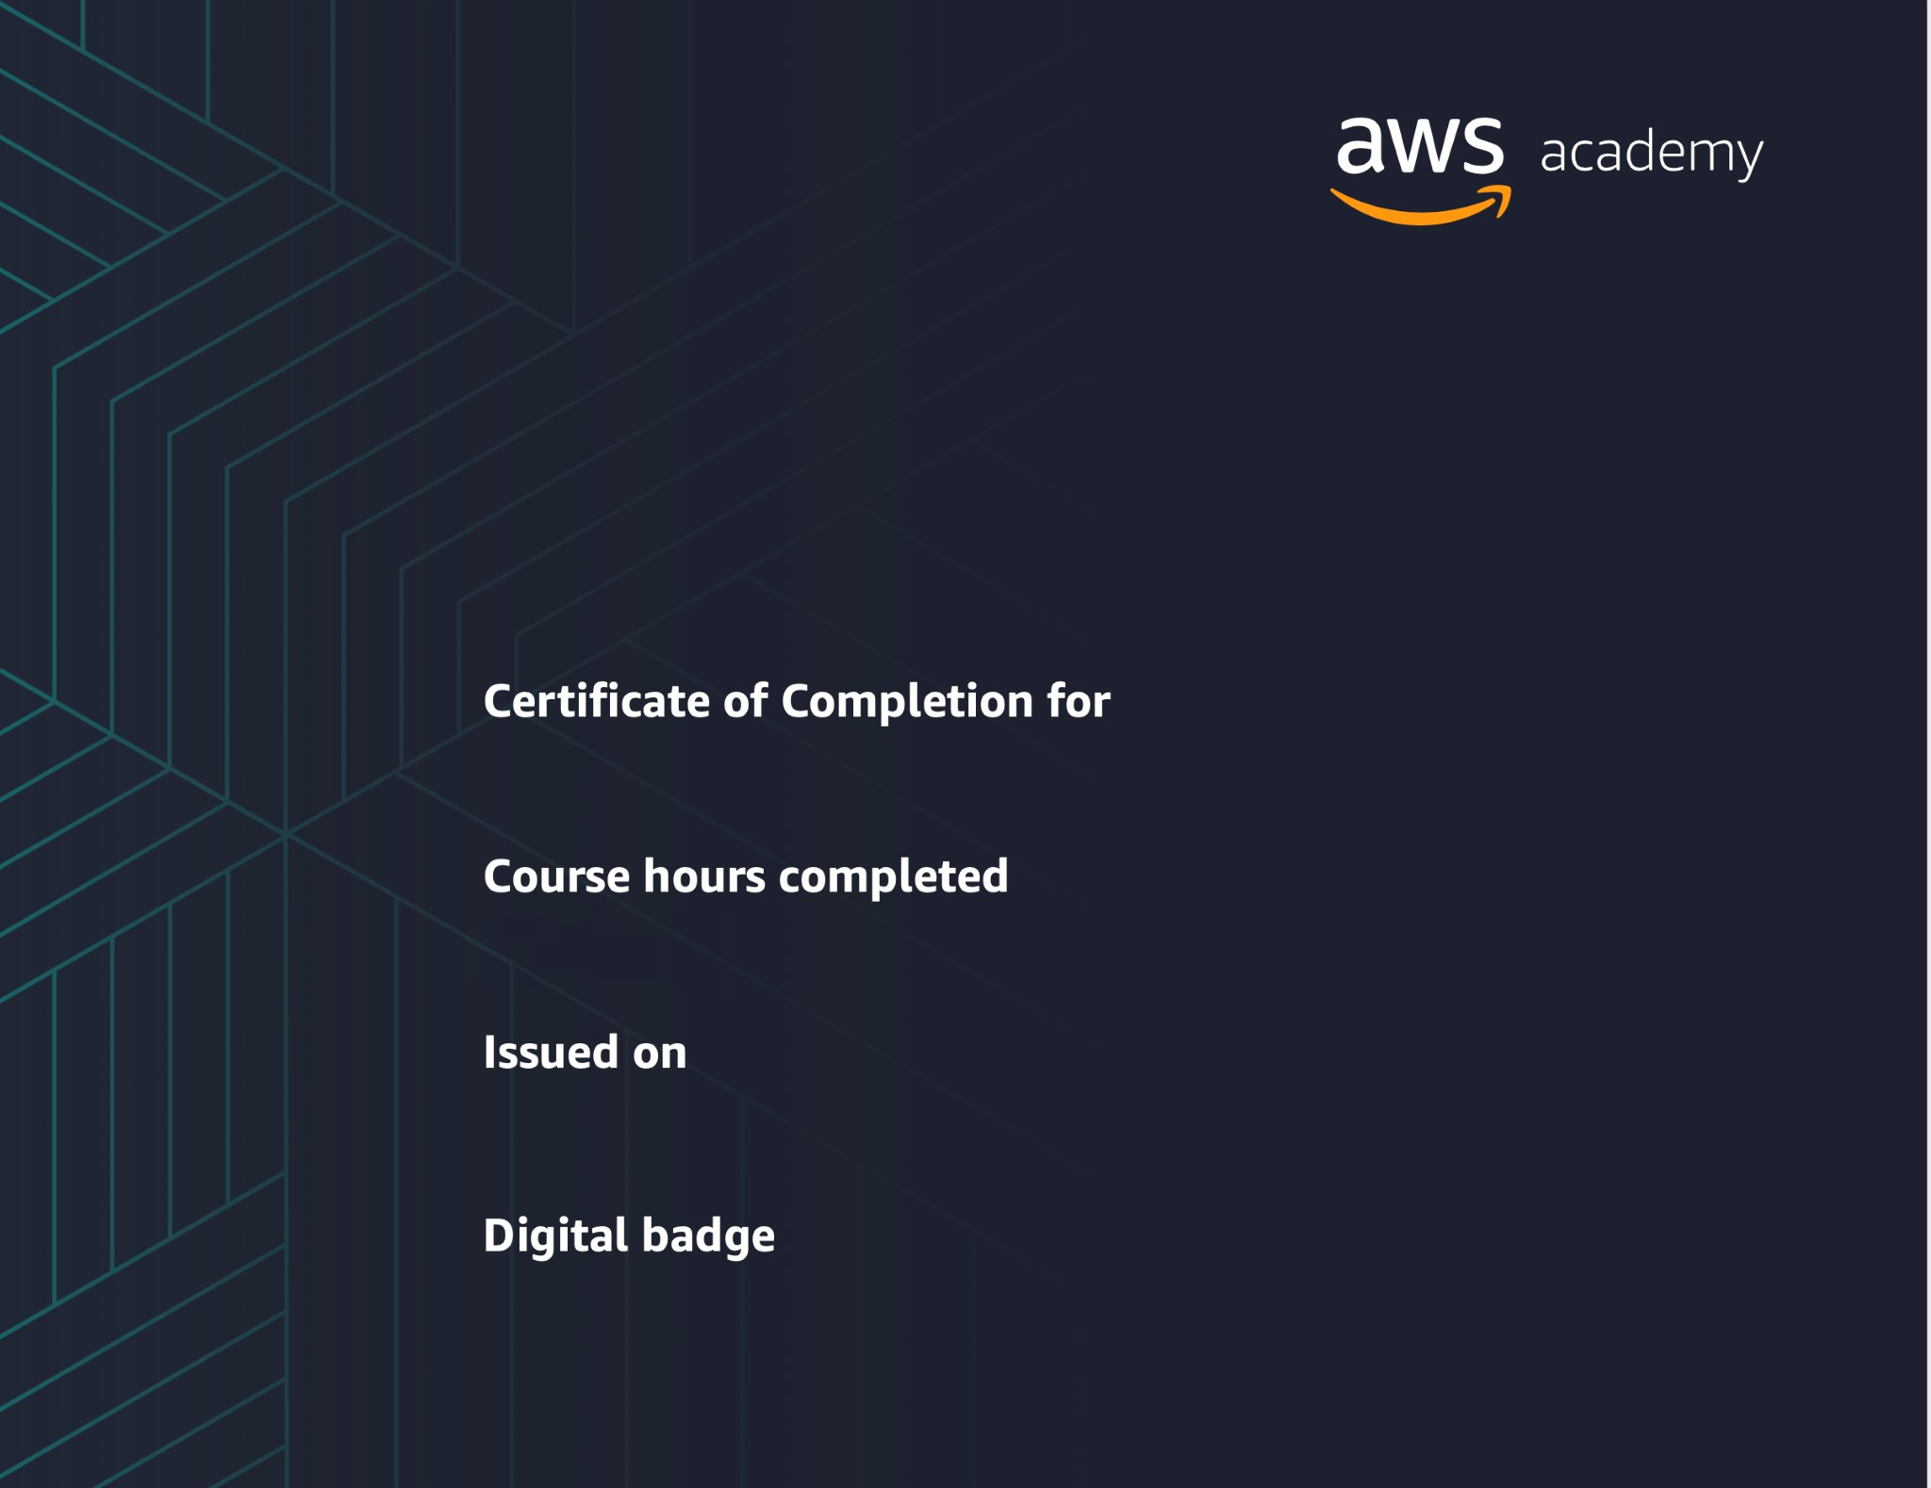
Farzad Chowdhury
AWS Academy Graduate - AWS Academy Cloud Foundations
12/31/2021
https://www.credly.com/go/3rDQBQaO
20
hours
Powered by TCPDF (www.tcpdf.org
)

