

School of Computing

Faculty of Engineering of Comput

UNIVERSITI TEKNOLOGI MALAYSIA

COURSE | : SECR1013 DIGITAL LOGIC
SESSION/SEM | : 2021/2022-1
LAB 3 | : SYNCHRONOUS DIGITAL COUNTER
NAME | : …………Oon Yee Sem…………………………………….
DATE | : ………16/1/2022………………………….………….

Identifying the Properties of Flip flops and Counter

A. Aims
- Expose the student with experience on constructing synchronous counter circuit using Flip-Flop IC, Basic Gate ICs in DEEDS.
- Promote critical thinking among students by analysing the given circuit and identifying the behaviour of the digital circuit.

B. Objectives
The objectives of this lab activity are to:
- Implement a synchronous counter circuit into physical circuit using Flip-Flops, Basic Gates, and Switches in DEEDS.
- Completing the next-state table of the counter circuit.
- Sketch the state diagram of the counter circuit.
- Identify the properties of the counter.

PART A (Synchronous and Asynchronous Input)

- Draw a single J-K flip-flop in DEEDS.
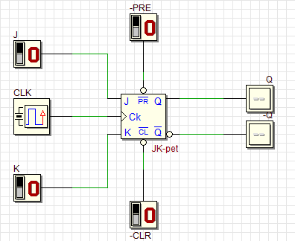

- Simulate the circuit to determine the logic level for each input combinations in Table 1 so that the desired result can be realized.
Table 1
 | Asynch Input |  | Synchronous Input |  |  | Output
Desired Result | $$\overline{PRE}$$ | $$\overline{CLR}$$ | J | K | CLK | Q
- Set initial value Q = 0 | 1 | 0 | X | X | -- | 0
- Output Q stays the same in synchronous mode | 1 | 1 | 0 | 0 | ⇓ | 0
- Output Q become 1 in asynchronous mode | 0 | 1 | X | X | ⇓ | 1
- Output Q is not the previous Q | 1 | 1 | 1 | 1 | ⇓ | 0
- SET Q in asynchronous mode | 0 | 1 | X | X | ⇓ | 1
- RESET Q in synchronous mode | 1 | 1 | 0 | 1 | ⇓ | 0

- Which state that JK flip-flop has, but not on SR flip-flop?
JK flip- flop has toggle state when J = 1, K=1, while SR flip-flop does not have toggle state, it is invalid state when S=1 and R=1 in SR flip-flop
- Identify whether the JK flip flop in 7476, is a positive-edge triggered or negative-edge triggered flip flop.
The 7476 is a master slave JK and the 74LS76 is a negative-edge triggered JK flip-flog.

PART B (Design of a Synchronous Counter)

Figure 1 shows a fruit basket that will be used to lift a bunch of apples to the main container. The fruit basket can contain a maximum of 7 apples. Initially the fruit basket is empty. We have a bunch of apples that we want to put into the basket one by one. Once the basket is full, we have to lift the basket to the man container and pull out the apples one by one until the basket is empty. Sensor X will sense the counting sequence of the counter while sensor Z controls the movement of the lid.

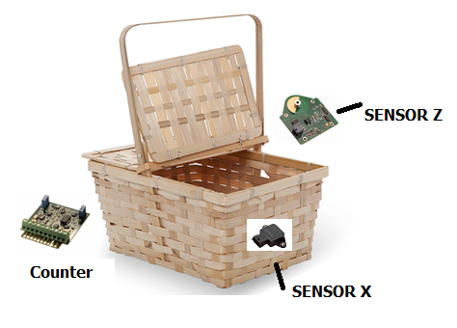  Lid  lid |   Bunch of apples
Figure 1

The following are the operations of the fruit basket:
Input:
- We can only put in or take out one apple at a time.
- We cannot take out an apple when the basket is empty (the basket remains empty).
- We cannot add an apple when the basket is full (the basket remains full).
- Sensor X in the basket will sense a LOW signal when the number of apples is incremented or sense a HIGH signal when the number of apples is decremented.

Output:
- A circuit in sensor Z at the lid will send a HIGH signal and close the basket when the basket is full, otherwise the lid will remain open.

You are asked to design and built an up/down counter using positive edge-triggered T flip-flops to count the apples in the basket and control the sensor at the lid of the basket.
- Draw the state diagram for the counter. Please indicate input/output for each transition.

- List all the characteristics of this counter.

- Built the next state and transition table using the header in Table 2.

Table 2
InputX | Present State |  |  | Next State |  |  | T FF Transition |  |  | OutputZ
InputX | Q2 | Q1 | Q0 | Q2+ | Q1+ | Q0+ | T2 | T1 | T0 | OutputZ
0 | 0 | 0 | 0 | 0 | 0 | 1 | 0 | 0 | 1 | 0
0 | 0 | 0 | 1 | 0 | 1 | 0 | 0 | 1 | 1 | 0
0 | 0 | 1 | 0 | 0 | 1 | 1 | 0 | 0 | 1 | 0
0 | 0 | 1 | 1 | 1 | 0 | 0 | 1 | 1 | 1 | 0
0 | 1 | 0 | 0 | 1 | 0 | 1 | 0 | 0 | 1 | 0
0 | 1 | 0 | 1 | 1 | 1 | 0 | 0 | 1 | 1 | 0
0 | 1 | 1 | 0 | 1 | 1 | 1 | 0 | 0 | 1 | 0
0 | 1 | 1 | 1 | 0 | 0 | 0 | 1 | 1 | 1 | 1
1 | 0 | 0 | 0 | 1 | 1 | 1 | 1 | 1 | 1 | 1
1 | 0 | 0 | 1 | 0 | 0 | 0 | 0 | 0 | 1 | 0
1 | 0 | 1 | 0 | 0 | 0 | 1 | 0 | 1 | 1 | 0
1 | 0 | 1 | 1 | 0 | 1 | 0 | 0 | 0 | 1 | 0
1 | 1 | 0 | 0 | 0 | 1 | 1 | 1 | 1 | 1 | 0
1 | 1 | 0 | 1 | 1 | 0 | 0 | 0 | 0 | 1 | 0
1 | 1 | 1 | 0 | 1 | 0 | 1 | 0 | 1 | 1 | 0
1 | 1 | 1 | 1 | 1 | 1 | 0 | 0 | 0 | 1 | 0

4)Get the optimized Boolean expression.
For Tc For Tb
XQc/QbQa | 0000 | 0 01 | 11 | 10
00 | 0 | 0 | 1 | 0
01 | 0 | 0 | 1 | 0
11 | 1 | 0 | 0 | 0
10 | 1 | 0 | 0 | 0
XQc/QbQa | 0000 | 0 01 | 11 | 10
00 | 0 | 1 | 1 | 0
01 | 0 | 1 | 1 | 0
11 | 1 | 0 | 0 | 1
10 | 1 | 0 | 0 | 1

For Ta For Z
XQc/QbQa | 0000 | 0 01 | 11 | 10
00 | 1 | 1 | 1 | 1
01 | 1 | 1 | 1 | 1
11 | 1 | 1 | 1 | 1
10 | 1 | 1 | 1 | 1
XQc/QbQa | 0000 | 0 01 | 11 | 10
00 | 0 | 0 | 0 | 0
01 | 0 | 0 | 1 | 0
11 | 0 | 0 | 0 | 0
10 | 1 | 0 | 0 | 0

Tc=M’QbQa + MQb’Qa’
Tb=M’Qa + MQa’
Ta=1
Z=
5)Draw the complete final circuit design in Deeds.

6)Simulate the circuit to prove that your Table 2 is correct.
InputX | Present State |  |  | Next State |  |  | T FF Transition |  |  | OutputZ
InputX | Q2 | Q1 | Q0 | Q2+ | Q1+ | Q0+ | T2 | T1 | T0 | OutputZ
0 | 0 | 0 | 0 | 0 | 0 | 1 | 0 | 0 | 1 | 0
0 | 0 | 0 | 1 | 0 | 1 | 0 | 0 | 1 | 1 | 0
0 | 0 | 1 | 0 | 0 | 1 | 1 | 0 | 0 | 1 | 0
0 | 0 | 1 | 1 | 1 | 0 | 0 | 1 | 1 | 1 | 0
0 | 1 | 0 | 0 | 1 | 0 | 1 | 0 | 0 | 1 | 0
0 | 1 | 0 | 1 | 1 | 1 | 0 | 0 | 1 | 1 | 0
0 | 1 | 1 | 0 | 1 | 1 | 1 | 0 | 0 | 1 | 0
0 | 1 | 1 | 1 | 0 | 0 | 0 | 1 | 1 | 1 | 1
1 | 0 | 0 | 0 | 1 | 1 | 1 | 1 | 1 | 1 | 1
1 | 0 | 0 | 1 | 0 | 0 | 0 | 0 | 0 | 1 | 0
1 | 0 | 1 | 0 | 0 | 0 | 1 | 0 | 1 | 1 | 0
1 | 0 | 1 | 1 | 0 | 1 | 0 | 0 | 0 | 1 | 0
1 | 1 | 0 | 0 | 0 | 1 | 1 | 1 | 1 | 1 | 0
1 | 1 | 0 | 1 | 1 | 0 | 0 | 0 | 0 | 1 | 0
1 | 1 | 1 | 0 | 1 | 0 | 1 | 0 | 1 | 1 | 0
1 | 1 | 1 | 1 | 1 | 1 | 0 | 0 | 0 | 1 | 0

PART C (Analysis of a Synchronous Counter)

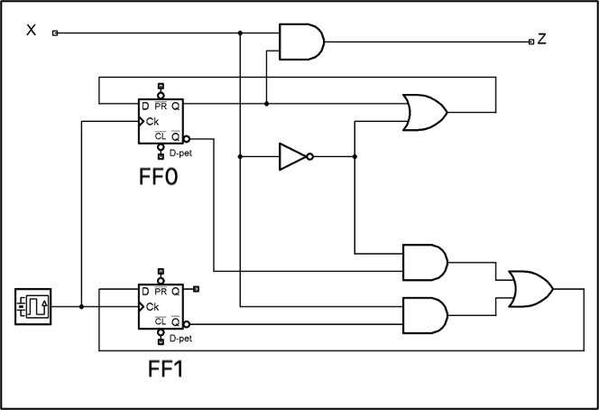
Figure 2
- Built circuit in Figure 2 in DEEDS. Please complete the circuit until it can work as a counter.

- Investigate the behaviour of the counter by observing the next state of the counter for all combination of Present State and X values. Complete the NextState table of the counter in Table 3.

Table 3
External Input | Present State |  | Next State
X | Q1 LED 1 | Q0 LED 0 | Q1 LED 1 | Q0 LED 0
0 | 0 | 0
0 | 0 | 1
0 | 1 | 0
0 | 1 | 1
1 | 0 | 0
1 | 0 | 1
1 | 1 | 0
1 | 1 | 1

- By referring to the Next-State in Table 3, sketch the state diagram of the counter.

- What is the main indicator to decide that the counter is a synchronous counter?

- How many states are available for the counter and what are they?

- What is the function of switch X in the circuit?

- What were the missing wires that were not drawn in the original Figure 2? What are their functions?

- List all the characteristics of this counter.

