

Field of Computer Science

School of Computing, Faculty of Engineering

UNIVERSITI TEKNOLOGI MALAYSIA

COURSE : SECR1013 DIGITAL LOGIC
SESSION/SEM : 2021/2022 - 1
LAB 2 : COMBINATIONAL LOGIC CIRCUIT DESIGN
SIMULATION USING DEEDS SIMULATOR
NAME : ………………Oon Yee Sem……………………………….

SECTION & LECTURER: ………………Dr Haswadi Bin Hasan……………..

DATE : …………12/12/2021……………………………………………………….

A. Objective
- To expose student with producing digital logic circuit, generating truth table with Deeds Simulator.
- To expose student with conversion between basic gates circuits and universal gates circuits.
- To expose student with a complete cycle process of a combinatorial circuit design and simulate with Deeds Simulator.

B. Material
Deeds Software for Windows.
Lab Activities

Part A
Simulating and converting logic circuit and construct truth table with Deeds.

- Draw circuit in Figure 1 in Deeds.
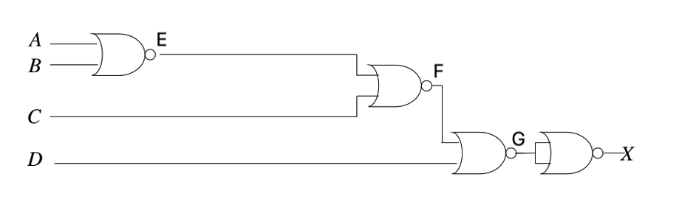
Figure 1: NOR Universal gates circuit
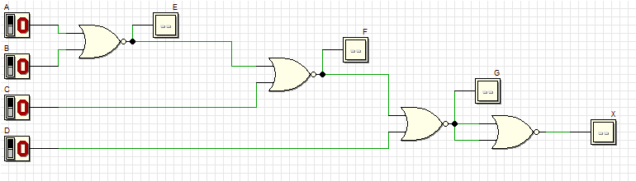

- Simulate the circuit and built the truth table using the following headers.
Truth Table 1
 |  | INPUT |  | OUTPUT
A | B | C | D | E | F | G | X
0  0  0  0  0  0  0  0  1  1  1  1  1  1  1  1 | 0  0  0  0  1  1  1  1  0  0  0  0  1  1  1  1 | 0  0  1  1  0  0  1  1  0  0  1  1  0  0  1  1 | 0  1  0  1  0  1  0  1  0  1  0  1  0  1  0  1 | 1  1  1  1  0  0  0  0  0  0  0  0  0  0  0  0 | 0  0  0  0  1  1  0  0  1  1  0  0  1  1  0  0 | 1  0  1  0  0  0  1  0  0  0  1  0  0  0  1  0 | 0  1  0  1  1  1  0  1  1  1  0  1  1  1  0  1

- Change the gates in your chosen level to dual symbol. Draw them using AND gate and 2 NOT gates in Deeds. Paste the circuit (Figure 2) here.

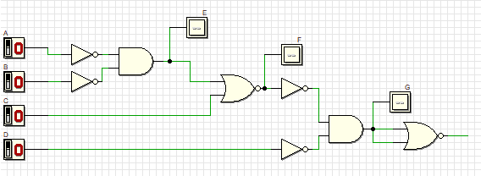

- Simplified the circuit in Question 3. Paste the circuit (Figure 3) here.

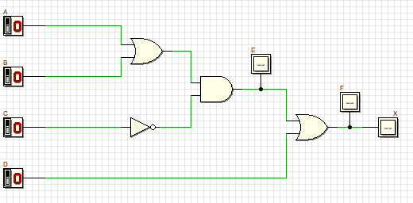

- Confirm circuit in Figure 3 is equivalent to circuit in Figure 1 by simulating the circuit and building Truth Table 2.
- Truth Table 1
 |  | INPUT |  | OUTPUT
A | B | C | D | E | F | G | X
0 | 0 | 0 | 0 | 0 | 0 | 1 | 0
0 | 0 | 0 | 1 | 0 | 0 | 0 | 1
0 | 0 | 1 | 0 | 0 | 0 | 1 | 0
0 | 0 | 1 | 1 | 0 | 0 | 0 | 1
0 | 1 | 0 | 0 | 1 | 1 | 0 | 1
0 | 1 | 0 | 1 | 1 | 1 | 0 | 1
0 | 1 | 1 | 0 | 1 | 0 | 1 | 0
0 | 1 | 1 | 1 | 1 | 0 | 0 | 1
1 | 0 | 0 | 0 | 1 | 1 | 0 | 1
1 | 0 | 0 | 1 | 1 | 1 | 0 | 1
1 | 0 | 1 | 0 | 1 | 0 | 1 | 0
1 | 0 | 1 | 1 | 1 | 0 | 0 | 1
1 | 1 | 0 | 0 | 1 | 1 | 0 | 1
1 | 1 | 0 | 1 | 1 | 1 | 0 | 1
1 | 1 | 1 | 0 | 1 | 0 | 1 | 0
1 | 1 | 1 | 1 | 1 | 0 | 0 | 1

- Derive the output expression from Figure 1 and show that it is equivalent to the expressions from Figure 3.

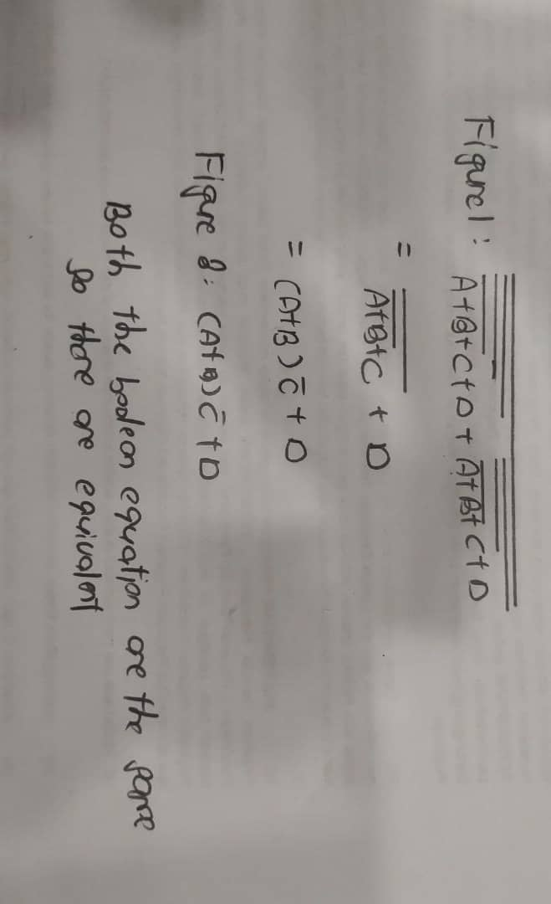

Part B
Combinational circuit design process and simulate with Deeds Simulator.

Design Process
- Determine Parameter Input/Output and their relations.
- Variable definition (not needed here)
- Construct Truth Table.
- Using K-Map, get the SOP optimized form of all Boolean equation outputs.
- Draw the circuit and use duality symbol.
- Simulate the design using Deeds Simulator. Check the results according to Truth Table.

Problem Situation
A new digital fault diagnoses circuit is requested to be designed for analysing four bit 2’s complement input binary number from sensors A, B, C, and D. Sensor A represents input MSB and sensor D represents input LSB. As shown in the following Figure 4, bit pattern analysis from input sensors A, B, C, and D will trigger four different output errors (active HIGH) of type E1, E2, E3, and E4.
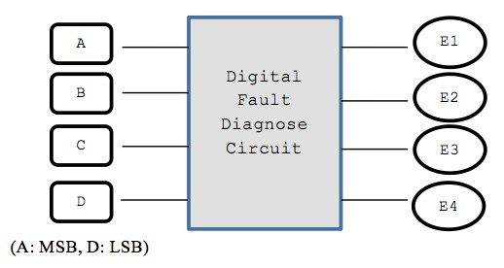

Figure 4

The following rules are used to activate the error’s signal type:
RULE 1: | E1 is activated if the input number is positive even and the majority of the bits is ‘0’.
RULE 2: | E2 is activated if the input number is positive odd and the majority of the bits is ‘0’.
RULE 3: | E3 is activated if the input number is negative even and the majority of the bits is ‘1’.
RULE 4: | E4 is activated if the input number is negative odd and the majority of the bits is ‘1’.
RULE 5: | The output of error signal is invalid if the input has equal bit ‘0’ and bit ‘1’

NOTE: Positive odd is positive numbers that are odd
Negative even is negative numbers that are even.
Zero is considered positive even number.

Experimental Steps

1.Create Truth Table 3 for Digital Fault Diagnose Circuit. Use variables A, B, C and D as inputs; E1, E2, E3 and E4 as outputs.

 |  | INPUT |  | OUTPUT
A | B | C | D | E1 | E2 | E3 | E4
0 | 0 | 0 | 0 | 1 | 0 | 0 | 0
0 | 0 | 0 | 1 | 0 | 1 | 0 | 0
0 | 0 | 1 | 0 | 1 | 0 | 0 | 0
0 | 0 | 1 | 1 | x | x | x | x
0 | 1 | 0 | 0 | 1 | 0 | 0 | 0
0 | 1 | 0 | 1 | x | x | x | x
0 | 1 | 1 | 0 | x | x | x | x
0 | 1 | 1 | 1 | 0 | 0 | 0 | 0
1 | 0 | 0 | 0 | 0 | 0 | 0 | 0
1 | 0 | 0 | 1 | x | x | x | x
1 | 0 | 1 | 0 | x | x | x | x
1 | 0 | 1 | 1 | 0 | 0 | 0 | 1
1 | 1 | 0 | 0 | x | x | x | x
1 | 1 | 0 | 1 | 0 | 0 | 0 | 1
1 | 1 | 1 | 0 | 0 | 0 | 1 | 0
1 | 1 | 1 | 1 | 0 | 0 | 0 | 1
Truth Table 3

- Using K-MAP, get minimized SOP Boolean expressions for E1, E2, E3 and E4 circuits. Post your K-MAP here.
E1:
AB/CD | 00 | 01 | 11 | 10
00 | 1 | 0 | x | 1
01 | 1 | x | 0 | X
11 | x | 0 | 0 | 0
10 | 0 | x | 0 | X

E1 = A’D’

E2:
AB/CD | 00 | 01 | 11 | 10
00 | 0 | 1 | x | 0
01 | 0 | x | 0 | X
11 | x | 0 | 0 | 0
10 | 0 | x | 0 | X
E2 = A’B’D
E3:
AB/CD | 00 | 01 | 11 | 10
00 | 0 | 0 | x | 0
01 | 0 | x | 0 | x
11 | x | 0 | 0 | 1
10 | 0 | x | 0 | x
E3 = BCD’

E4:
AB/CD | 00 | 01 | 11 | 10
00 | 0 | 0 | x | 0
01 | 0 | x | 0 | x
11 | x | 1 | 1 | 0
10 | 0 | x | 1 | x

E4 = AD

- From the Boolean expression in the step (2), draw your final E1, E2, E3 and E4 circuits. Use Deeds Simulator and paste your circuit here.

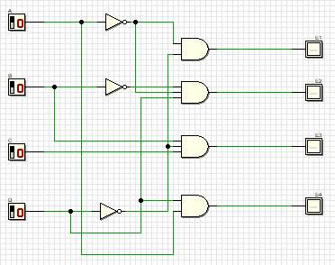

- Simulate the Deeds circuit in step (3) and update the output (Truth Table 4) based on the simulation result.

A | B | C | D | E1 | E2 | E3 | E4
0 | 0 | 0 | 0 | 1 | 0 | 0 | 0
0 | 0 | 0 | 1 | 0 | 1 | 0 | 0
0 | 0 | 1 | 0 | 1 | 0 | 0 | 0
0 | 0 | 1 | 1 | x | x | x | x
0 | 1 | 0 | 0 | 1 | 0 | 0 | 0
0 | 1 | 0 | 1 | x | x | x | x
0 | 1 | 1 | 0 | x | x | x | x
0 | 1 | 1 | 1 | 0 | 0 | 0 | 0
1 | 0 | 0 | 0 | 0 | 0 | 0 | 0
1 | 0 | 0 | 1 | x | x | x | x
1 | 0 | 1 | 0 | x | x | x | x
1 | 0 | 1 | 1 | 0 | 0 | 0 | 1
1 | 1 | 0 | 0 | x | x | x | x
1 | 1 | 0 | 1 | 0 | 0 | 0 | 1
1 | 1 | 1 | 0 | 0 | 0 | 1 | 0
1 | 1 | 1 | 1 | 0 | 0 | 0 | 1
Truth table 4

- From the circuit in step (3), show the conversion of basic gates in E1, E2, E3 and E4 circuits to NAND universal gates. Post your workings here.
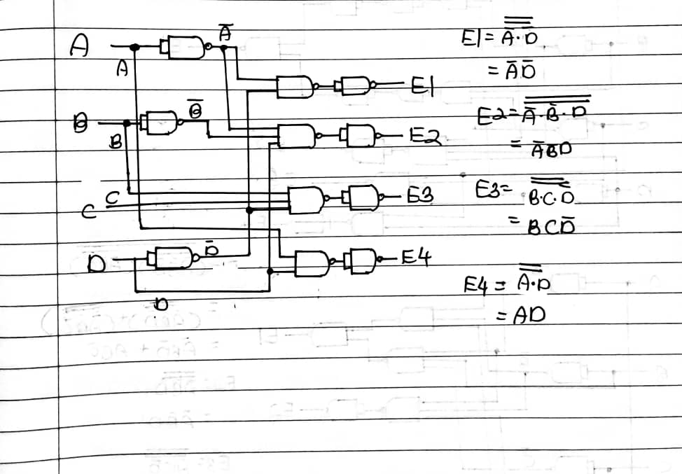

- Draw the results of Step (5) in DEEDS. Post the circuits here.
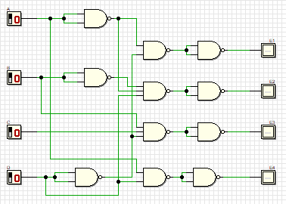

7.Confirm your circuit by simulating the circuits. Build Truth Table 5.
Truth Table 5

A | B | C | D | E1 | E2 | E3 | E4
0 | 0 | 0 | 0 | 1 | 0 | 0 | 0
0 | 0 | 0 | 1 | 0 | 1 | 0 | 0
0 | 0 | 1 | 0 | 1 | 0 | 0 | 0
0 | 0 | 1 | 1 | x | x | x | x
0 | 1 | 0 | 0 | 1 | 0 | 0 | 0
0 | 1 | 0 | 1 | x | x | x | x
0 | 1 | 1 | 0 | x | x | x | x
0 | 1 | 1 | 1 | 0 | 0 | 0 | 0
1 | 0 | 0 | 0 | 0 | 0 | 0 | 0
1 | 0 | 0 | 1 | x | x | x | x
1 | 0 | 1 | 0 | x | x | x | x
1 | 0 | 1 | 1 | 0 | 0 | 0 | 1
1 | 1 | 0 | 0 | x | x | x | x
1 | 1 | 0 | 1 | 0 | 0 | 0 | 1
1 | 1 | 1 | 0 | 0 | 0 | 1 | 0
1 | 1 | 1 | 1 | 0 | 0 | 0 | 1

8.Are all your Truth Tables 3, 4 and 5 equal or differ? Why are they the same and/or why are they different? Give your reasonings.

Truth table 3,4 and 5 are equal because all basic gate can be represented by the universal gate, NAND gate.

Edited by Marina Md Arshad, 28112021

