 | Department of Computer Science  Faculty of Computing  UNIVERSITI TEKNOLOGI MALAYSIA

SUBJECT NAME: | COMPUTER ORGANIZATION AND ARCHITECTURE
SUBJECT CODE: | SCSR 2033
SEMESTER: | 1 - 2014/15
LAB TITLE: | Programming 1: Assembly Language Fundamentals
INSTRUCTION: | Student is required to have instructor’s signature before proceed from each lab work.
STUDENT INFO : | Name: Mek Zhi Qing  Metric No: A20EC0077  Section: 01  Email: mekqing@graduate.utm.my  Name: Zereen Teo Huey Huey  Metric No: A20EC0173  Section: 01  Email: zereen@graduate.utm.my
SUBMITTED DATE: | 10 April 2021

COMMENTS:

Lab # 1

Simple program to familiarize with Program Code, Rebuild & Start Without Debugging

Execute the programs below.

- Part A: Adding and Subtracting Integers

TITLE Add and Subtract (AddSub.asm)

;This program adds and subtracts 32-bit integers.

INCLUDE Irvine32.inc
.code

main PROC
mov eax,10000h ; EAX = 10000h
add eax,40000h ; EAX = 50000h
sub eax,20000h ; EAX = 30000h
call DumpRegs ; display registers
exit
main ENDP

END main

Experimental Results:
- Rebuild & Start Without Debugging CamStudio:

Completed Fully Partially : Checked by: ______________

- Rebuild & Start Without Debugging
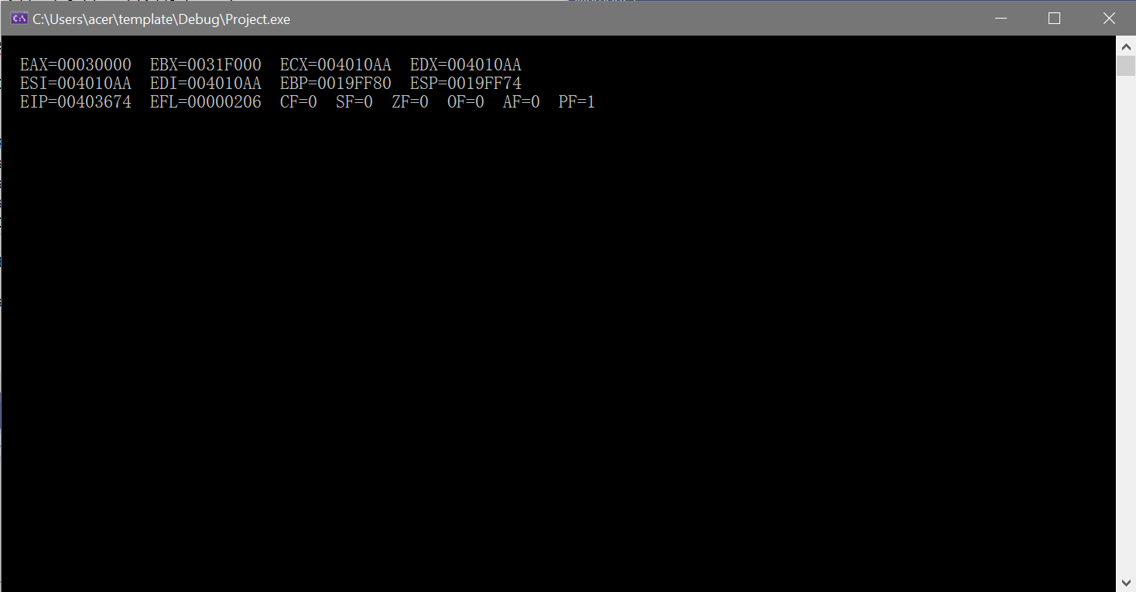

- 4 Windows
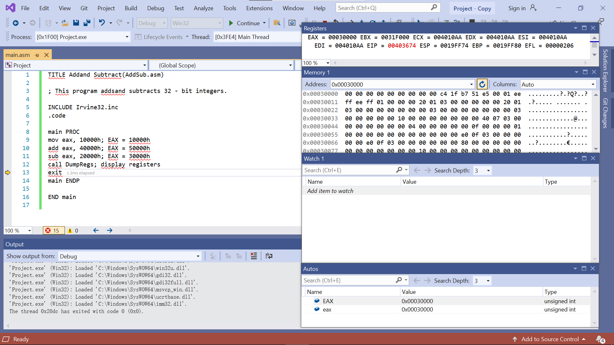

- Part B: Adding Variables

TITLE Add and Subtract, Version 2 (AddSub2.asm)
; This program adds and subtracts 32-bit unsigned
; integers and stores the sum in a variable.

INCLUDE Irvine32.inc
.data
val1 DWORD 10000h
val2 DWORD 40000h
val3 DWORD 20000h
finalVal DWORD ?
.code

main PROC
mov eax,val1 ; start with 10000h
add eax,val2 ; add 40000h
sub eax,val3 ; subtract 20000h
mov finalVal,eax ; store the result (30000h)
call DumpRegs ; display the registers
exit

main ENDP
END main

Experimental Results:
- Rebuild & Start Without Debugging CamStudio:

Completed Fully Partially : Checked by: ______________

- Rebuild & Start Without Debugging
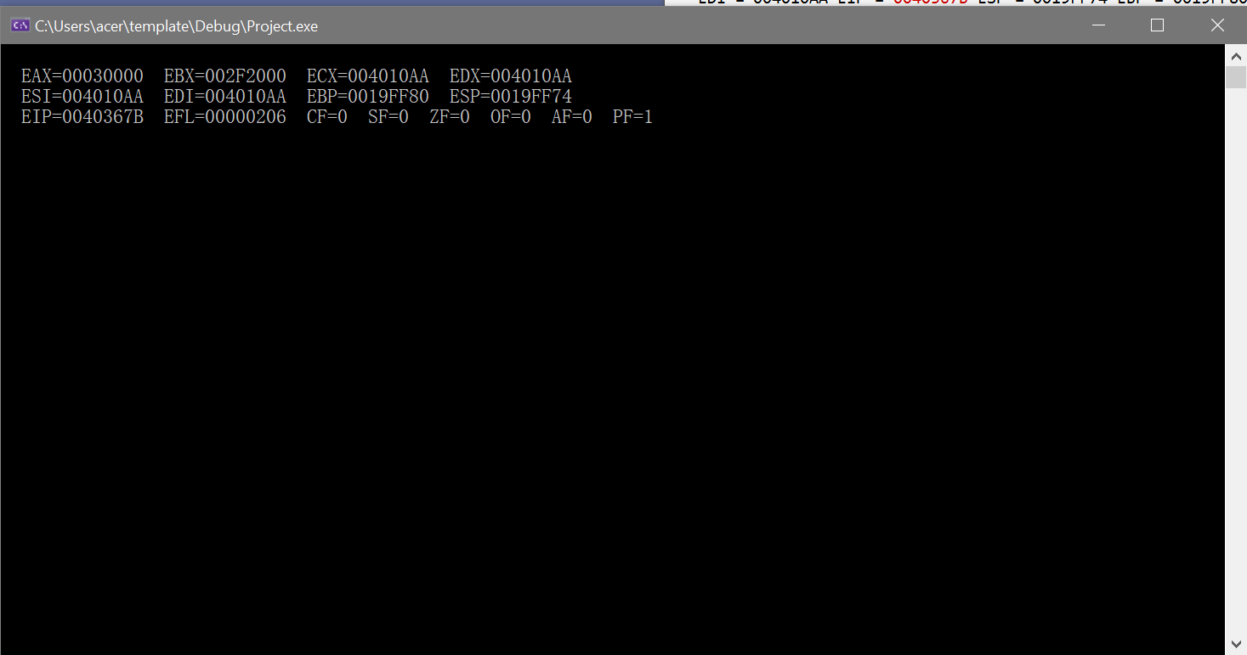

- 4 Windows
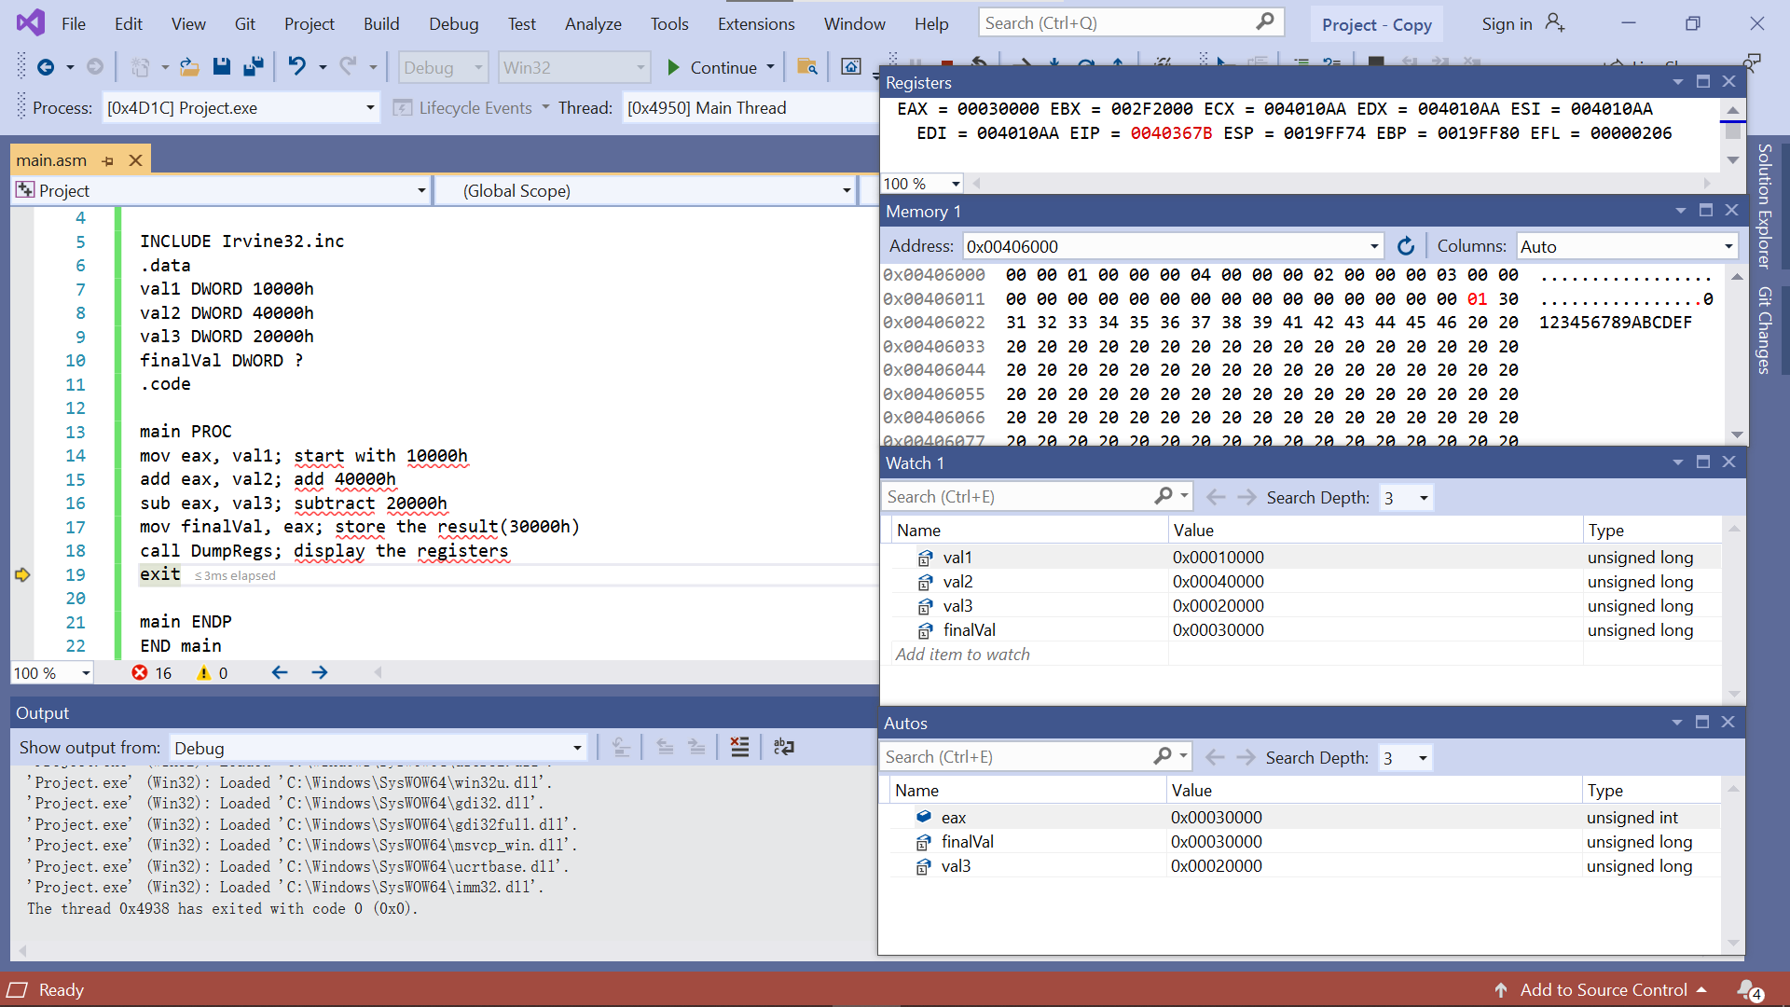

- Part C: Add and Subtract 8 and 16-Bit Version

TITLE Add and Subtract, Version 3
; This program adds and subtracts 8 and 16 bit ;unsigned integers and stores the sum in a variable.

INCLUDE Irvine32.inc
.data

valw1 WORD 1000h
valw2 WORD 4000h
valw3 WORD 2000h
finalValw WORD ?

valb1 BYTE 10h
valb2 BYTE 40h
valb3 BYTE 20h
finalValb BYTE ?

.code

main PROC
mov ax,valw1 ; start with 10000h
add ax,valw2 ; add 40000h
sub ax,valw3 ; subtract 20000h
mov finalValw,ax ; store the result (30000h)
call DumpRegs ; display the registers

mov ah,valb1 ; start with 10000h
add ah,valb2 ; add 40000h
sub ah,valb3 ; subtract 20000h
mov finalValb,ah ; store the result (30000h)
call DumpRegs ; display the registers

exit
main ENDP
END main

Experimental Results:
- Rebuild & Start Without Debugging CamStudio:

Completed Fully Partially : Checked by: ______________

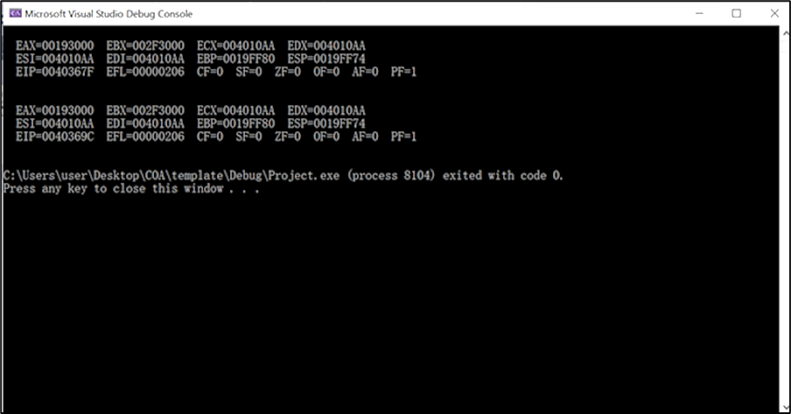
- Rebuild & Start Without Debugging

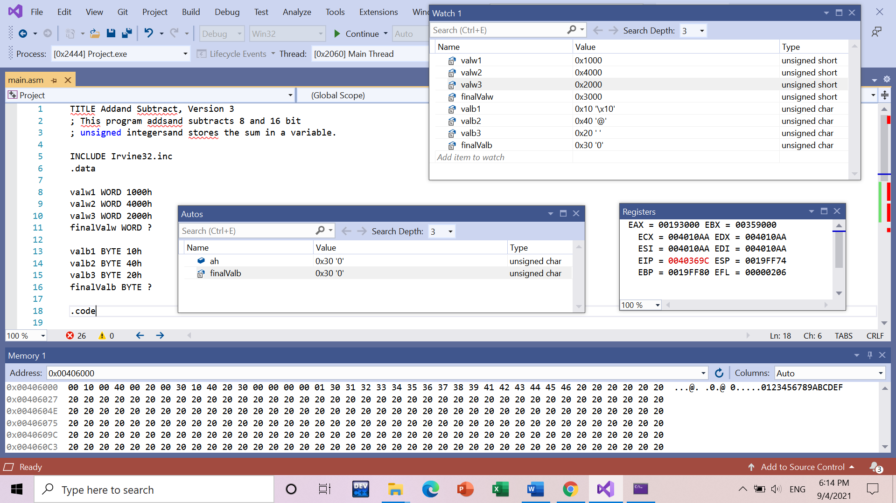
- 4 Windows

