

SECJ 1023-02 PROGRAMMING TECHNIQUE II
20202021/2

PROJECT 1:
FOOD DELIVERY SYSTEM

LECTURER’S NAME:
DR. ARAFAT

GROUP MEMBERS:
NAME | MATIRC NO.
HONG PEI GEOK | A20EC0044
LOW JUNYI | A20EC0071
ONG HAN WAH | A20EC0129
YONG ZHI YAN | A20EC0172

Table of Contents

INTRODUCTION 2
BACKGROUND PROBLEM 3
PROBLEM STATEMENT 4
PROPOSED SOLUTION 5
METHODOLOGY 6
RESULT 7
CONCLUSION 12

INTRODUCTION
Procedural programming and object-oriented programming (OOP) are two of the common programming methods. Previously, most software development was implemented by using procedural programming. However, the data in procedural programs can give rise to some problems as programs evolve to become bigger and sophisticated. Then, object-oriented programming (OOP) addressed the problems, causing a shift from procedural programming to OOP. While procedural programming focuses on making procedures or functions, OOP is centered on creating objects. An object is an entity containing data and procedures while a class is a blueprint for an object which has its own attributes and member functions. OOP has several advantages over procedural programming due to its encapsulation, abstraction, inheritance and polymorphism features. It also helps to reduce codes and encourage object reusability. This project aims to build a small program that implements object-oriented programming concepts in C++ language including encapsulation, abstraction, inheritance and polymorphism. The purpose of the project is to improve our understanding and implementation of OOP in C++ language in practice.

BACKGROUND PROBLEM
Nowadays, there have been various products or websites being developed due to the advance of technology. This also caused people to interact with these technologies no matter conscious or unconscious. Many fields have obtained the advantages from this and one of the fields is food. As we know, the number of food delivery services has increased dramatically in order to fulfill demand. For instance, Food Panda and Grab food. This situation is not only caused by the development of technology but also the changes of human behaviour. However, not all of them are user friendly and easy to use especially for the older, busy and unfamiliar with technology people. Some of these applications even did not provide the details of food properly. Consequently, users are unable to enjoy the convenience of these technologies but feel frustrated. This will be a loss not only for food sellers but also for the users themselves.

PROBLEM STATEMENT
- Still can login as a guest which lets a lot of scammers scam the delivery rider.
- Lack of design in the food delivery system.
- Confusing food delivery system which breakfast menu, lunch menu and dinner menu mixed together
- Do not mention price in the food delivery system.
- Still using a cash payment system which is not safe.

PROPOSED SOLUTION
Our team has a plan to make a better food delivery system which provides a more simple and convenient way for the users to experience it. As from the problem statement we know that user login systems are still weak and flawless, do not have good design to attract the customers, confusing food delivery system, prices are not included in the menu and still manage to use the cash payment method.

In this project, our team has proposed to make an account login for the users as currently some of the delivery systems still allow login as guests which the user can simply put wrong information or prank the delivery rider. Thus, users of our program are required to put their account details such as name, mobile number and the address to ensure the safety and guarantee of the delivery rider. We also use some of the basic design to design the menu as the main page of the system as we can’t design a very good food delivery system using C++ language. We will also categorize the food to breakfast, lunch and dinner. But of course we will remain a full menu set inside. In this new programmed system, we will provide a list of prices for every food inside to ensure our users know the price for every food inside. Lastly, we will enable the newly implemented card payment system and online banking system. To pay with the card, users have to key in the card number and password to the system. To pay with online banking, users have to key in the name of the bank followed by user name and password. The cash payment method remained as not everyone can pay with card or online banking.

For each and every problem in the problem statement, we had proposed a suitable solution to encounter it by using our system.

METHODOLOGY
We have implemented our project by using the concept of object oriented programming in C++ language. Before this, we need to master all the concepts in OOP such as association, inheritance, polymorphism and encapsulation. Thus, we have also been using resources like Google in order to more understand these principles. For example, we learned how to implement the concept of polymorphism and the criteria to implement it.
Next, after we all have enough knowledge about our project, we have decided our project title which is food delivery system to implement these concepts. Since there is no face to face due to the pandemic, Whatsapp is being used as our communication medium in terms of dividing our work and discussing any questions that are faced by our members. This is because it is convenient and allows us to have good communication to avoid any conflict.
After that, a proposal and UML diagram about our system have been drawn in order to have a clear direction about the implementation of our project. Other flows of our project are preparing the source, report and also a demo video. All of these processes are carried out according to the plan.

RESULT

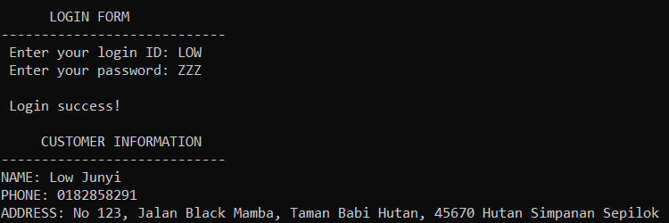
Figure 1: Customer Information

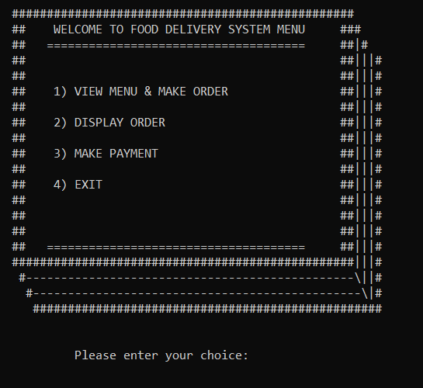
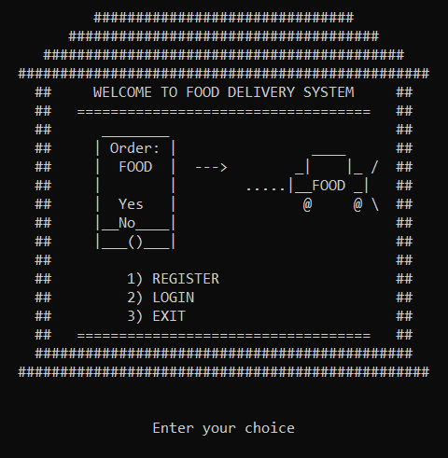
After the newly implemented system, the system is able to know and track the phone number so as the address of the user which can enhance the safety of the system.

Figure 2: Design for Home Menu Figure 3: Design for System Menu
The figure above shows the newly designed system for both home menu and system menu. The home menu is a design of the restaurant with a food delivery car while the system menu is a design of a menu book.
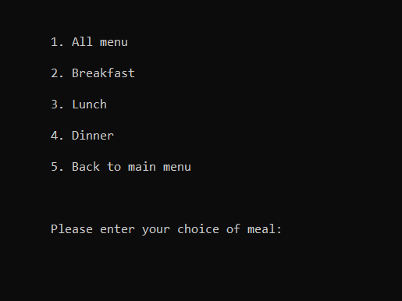
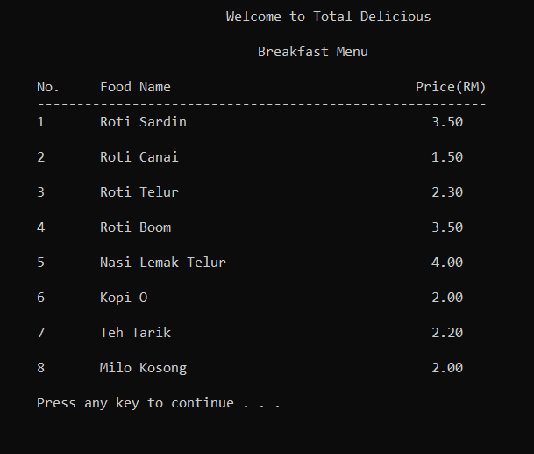

Figure 4: Categories of menu Figure 5: List of food menu with price
We had categorized the menu into 4 parts, which is an all menu which contains all food menu while for breakfast menu which only meals that are suitable for breakfast. From figure 5, through our newly implemented menu, our users are able to know the price for every meal in the delivery system.
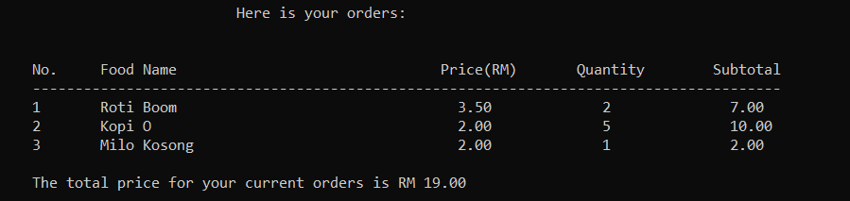

Figure 6: Display order with price
After the customers have ordered their meals, they can proceed to display the order to see what they have ordered which includes the total price.

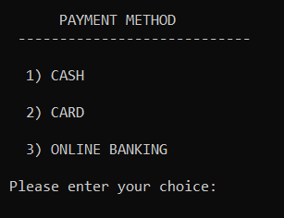
Figure 7: Payment Method
Through the newly implemented system, our users can choose to pay via cash, card or online banking.
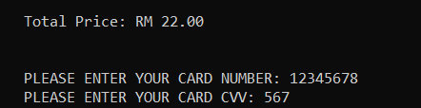
Figure 8: Card Payment
Users are required to enter their card number so as the CVV to pay with a card.

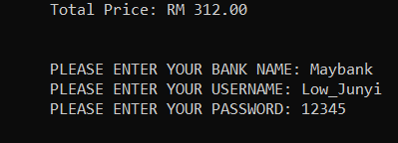
Figure 9: Online Banking
To use online banking, users are required to enter their bank name, username and password to proceed the transaction.
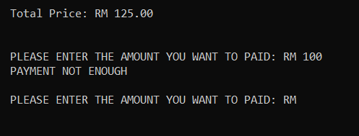
Figure 10: Cash Payment
If the cash payment is not enough, the user needs to pay the amount that’s bigger than the amount of the bill.

CONCLUSION
The object-oriented programming (OOP) in C++ language has allowed us to code less but more efficiently by object reusability and reducing the repetition of codes. We are able to build a simple food delivery system program using C++ language and implement OOP concepts including encapsulation, abstraction, inheritance and polymorphism principles in the program. Through this project, we have improved our understanding and coding skills in OOP in C++ language. The project also boosts our teamwork skills because we need to separate tasks and work in a team. This project will definitely benefit and help us to build programs better in the future.

