
Probability and Statistical Data Analysis
(SECI 2143-02)

Semester 2 Session 2020/2021
Group Name: Team Yeagerist
Project 2 : Stroke

Group Members:
No | Name | Matric No
1. | Eddie Wong Chung Pheng | A20EC0031
2. | Singthai Srisoi | A20EC0147
3. | Chong Kai Zhe | A20EC0186
4. | Nurfarrahin Binti Che Alias | A20EC0121

Lecturer: Mr Chan Weng Howe
Date of Submission: 3 July 2021

Table of Content
1.0 Introduction 3
2.0 Dataset 4
3.0 Data Analysis 5
3.1 Hypothesis testing 2 samples 6-7
3.2 Correlation Test 8-9
3.3 Regression Test 10-11
3.4 Chi-Square Test of Independence 12
3.5 Goodness of Fit Test 13
4.0 Conclusion 14
5.0 Reference 15
6.0 Appendix 16
7.0 Video Presentation 16

1.0 Introduction

Stroke is a condition where the blood supply to the brain is disrupted, resulting in oxygen starvation, brain damage and loss of function. Did you know that stroke has already reached epidemic proportions. According to the World Stroke Organization, globally 1 in 4 adults over the age of 25 will have a stroke in their lifetime and over 13 million people will have a stroke each year and around 5.5 million people will die as a result. Current trends suggest that the number of annual deaths will climb to 6.7 million annually without appropriate action.
To probe into the cause of this, we decided to choose the healthcare stroke as our dataset. There are a lot of factors that can leading to stroke. Hence, the aim of this project is to study the factors like gender, age, hypertension, heart disease, type of job, average of glucose level, body mass index (BMI) and smoking status of patients of the relationships between the variables. We also want to try predicting which factor is most likely to cause a patient to get stroke. Hence, we use several statistical methods to estimate the relationships between each of the variables.
We expected to see the hypothesis testing of the mean of male patients and female patients are different. Besides, We also expect to see there is a linear relationship between body mass index BMI) and average blood glucose level from correlation test. Other than that, we also want to see linear regression does exist between body mass index (BMI) and average glucose level. Moreover, we want to see the type of job of patient is dependent on the heart disease using the Chi-Square test of independence. Lastly,we would like to see the number of different types of smokers among the patients are not equal.

2.0 Dataset
The dataset used was collected by fedesoriano on Kaggle, thus it can be considered as secondary data. This dataset is used to predict whether a patient is likely to get stroke based on the input parameters like gender, age, various diseases, smoking status, hypertension, heart disease and others. Each row in the data provides relevant information about the patient.

The dataset consists of 4795 patients of data in total. There are 11 variables on the original dataset and we use 7 of them which are gender, age, average glucose level, BMI, type of job of patient, heart disease and smoking status as we prefer to choose the ratio and nominal type of variable as it is easier for conducting the analysis. We will carry out 5 statistical tests which are listed below.
- Hypothesis testing 2 sample using variable of gender and age,
- Correlation test using variable of average glucose level and body mass index (BMI)
- Regression test using variable of average glucose level and body mass index (BMI)
- Chi-Square test of independence using variable of type of job and heart disease,
- Goodness of fit test using the status of smoke among patients.

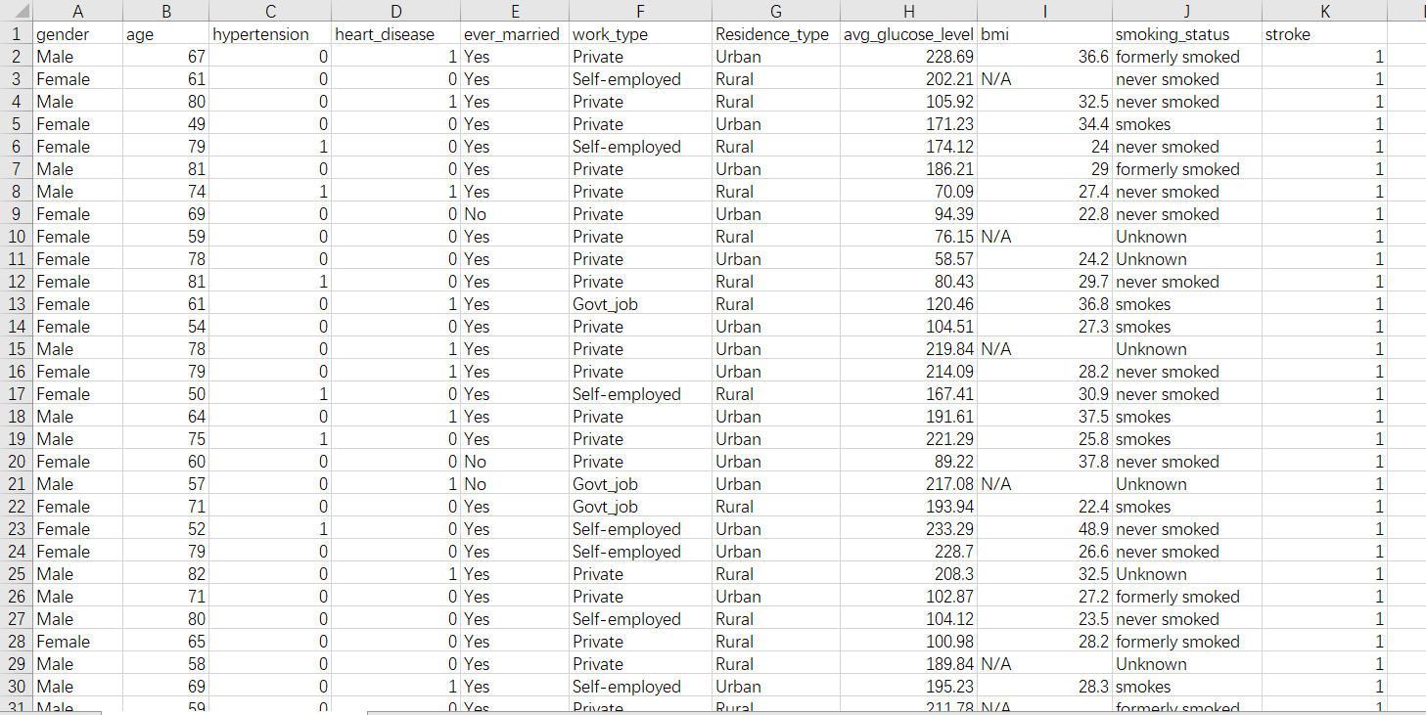
Before we start our analysis, we need to remove some unnecessary data such as the non-integer value from 0.08 to 1.88 of age as shown in Figure 1.
Figure 1: Healthcare ( Stroke )

We also remove unwanted data of bmi such as N/A to make the prediction more accurately as shown in Figure 2.
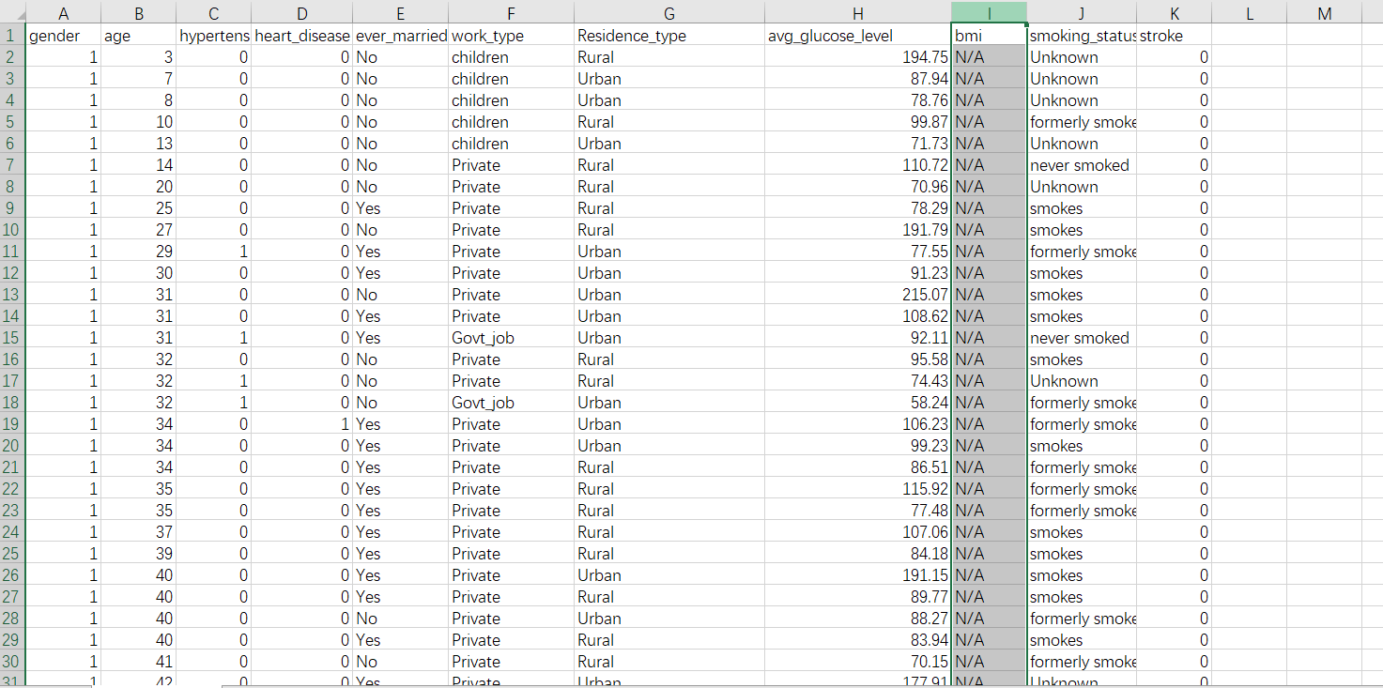
Figure 2: BMI of patients

We also modify some changes of the gender dataset such male and female to “1” and “2” accordingly as shown in Figure 3 as the Rstudio does not work well with the previous version of the dataset. We also extract 455 patients as our sample and create a new dataset of excel as our Rstudio has some problems when doing 2 sheets in 1 excel.
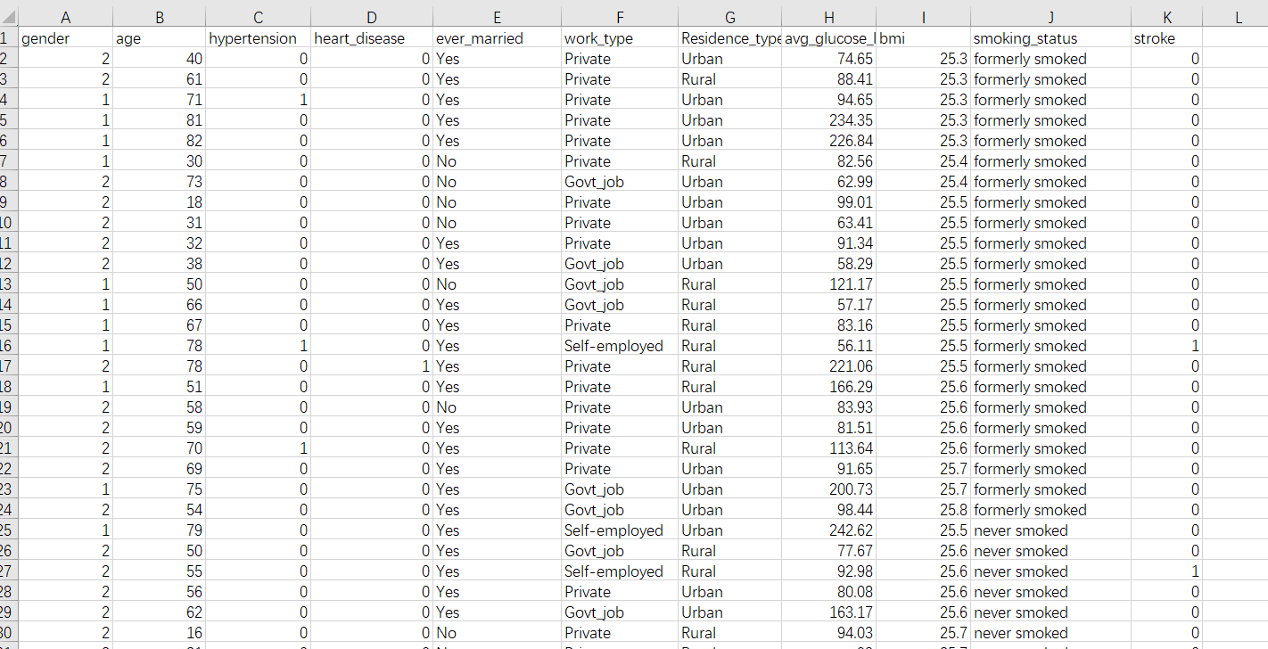
Figure 3 : Finalist of dataset

3.0 Data Analysis

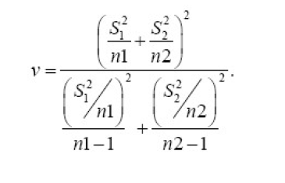
3.1 Hypothesis testing 2 samples
We chose 455 patients as our sample. The sample test consists of 222 male as the first group and second group consist of 233 females and this means the two samples are independent as they were not matched. Hence, we want to test on the difference between the mean of male population and the mean of female population under 0.05 significance level and assume that both variances of both variables are unknown.
Hypothesis statement:
$H_{0}$ : $µ_{1}=$$µ_{2}$
$H_{1}$ : $µ_{1}≠$$µ_{2}$
${ test statistic, z}_{0}$= $\frac{{X̅}_{1} - {X̅}_{2} - 0}{\sqrt{\frac{{s_{1}2}^{}}{n_{1}}+\frac{{s_{2}2}^{}}{n_{2}}}}$ Degree of freedom, v =
Where,
$u_{1}$= Mean of male population
$u_{2}$ = Mean of female population
${X̅}_{1}$ = Sample mean of male population
${X̅}_{2}$= Sample mean of female population
$s_{1}$ = standard deviation of the sample of male population
$s_{2}$ = standard deviation of the sample female population
$n_{1}$= Size of the sample of male population
$n_{2}$= Size of the sample of female population
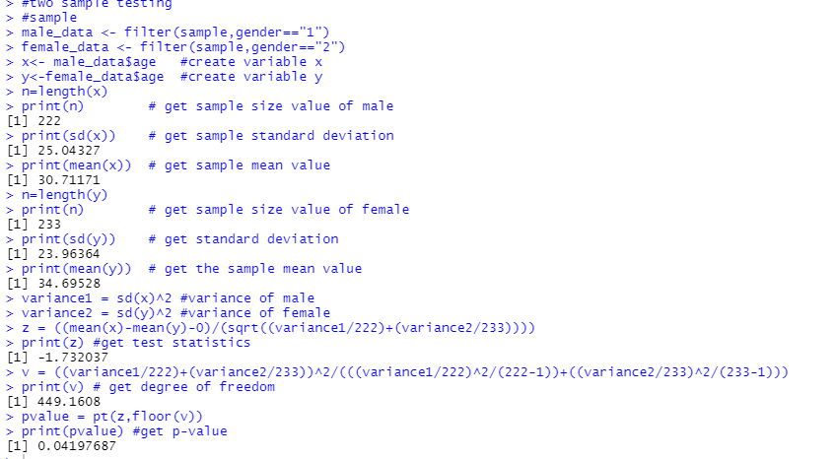
Figure 4: Calculation of hypothesis testing 2 samples

From the Rstudio,
 | Male | Female
Size of the sample | $n_{1}$=222 | $n_{2}$= 233
Mean of sample of population | ${X̅}_{1}$ =30.71 | ${X̅}_{2}$= 34.70
Standard deviation of the sample | $s_{1}$ =25.04 | $s_{2}$ = 23.96
Table 1: Result of hypothesis testing 2 samples
Significance level, α = 0.05 Degree of freedom, v = 449.16
Test statistic, ${ z}_{0}$ = -1.73 P-value = 0.042
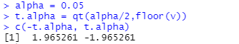
Figure 5: Calculation of critical region

From the table, $t_{0}>t_{0.025,30}$ = 1.965 or $t_{0}<t_{0.025,30}$ = -1.965
Reject $H_{0}$if $z_{0}$ > 1.965 or $z_{0}$< -1.965
Decision: Since test statistic, $z_{0}$= -1.73 < -1.965 and does fail within the critical region, we need to reject $H_{0}$.
Conclusion: There is evidence to conclude that the mean of the male population and the mean of the female population is different.

3.2 Correlation Test
We want to carry out correlation tests to measure the strength of the relationship between the average glucose level in mg/dL and the body mass index (BMI). We assume the confidence level to be 95%, significant level , α = 0.05
Hypothesis statement:
H0: ρ = 0 (no linear correlation between the average glucose level and body mass index (BMI).)
H1: ρ ≠ 0 (linear correlation between the average glucose level and body mass index (BMI).)
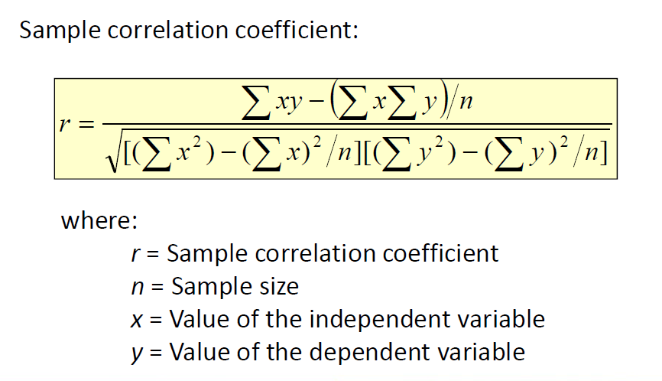
where,
r = Sample correlation coefficient
n = Sample size
x = Value of the independent variable
y = Value of the dependent variable
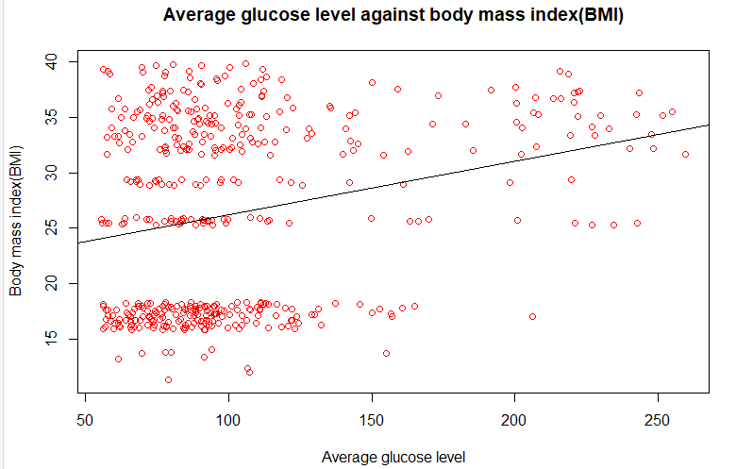Figure 6: Scatter plot of average glucose level against body mass index (BMI)
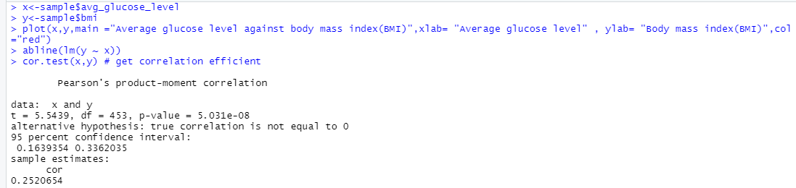
Figure 7: Calculation of correlation test
From the R studio, correlation coefficient, r = 0.1754489 (weak positive linear relationship).
This also indicates that when average glucose level increases, body mass index (BMI) will increase too.
Significance test for correlation
Test statistic, t = $\frac{r}{\sqrt{\frac{1-r^{2}}{n-2}}}$ Degree of freedom, df = 453
t =5.54
Significance level,$α=0.05$ P-value = 5.03 x${10}^{-8}$
$α=0.025 as it is 2 tailed test$
Confidence interval of the correlation coefficient at 95% is (0.1639354, 0.3362305).
Decision: Since P-value is 5.03 x${10}^{-8}$ < less than 0.05, hence we reject the null hypothesis.
Conclusion: There is sufficient evidence to conclude that there is a linear relationship between average glucose level and body mass index (BMI) at the 5% level of significance.

3.3 Regression Test
In the regression test, we want to predict the value of body mass index(BMI) based on the value of average glucose level . The dependent variable is body mass index(BMI) while the independent variable is average glucose level. We assume the confidence level to be 95%, significant level , α = 0.05 .
Hypothesis statement:
$H_{0}$: $β_{1}$ = 0 (no linear regression)
$H_{A}$: $β_{1}$$≠$0 (linear regression exists)
Estimated Regression Model: Y = $b_{0}$+ $b_{1}x$
where,
Y = Estimated (or predicted) Y value
$b_{0 }$= Estimate of the regression intercept
$b_{1}$ = Estimate of the regression slope
X = Independent variable
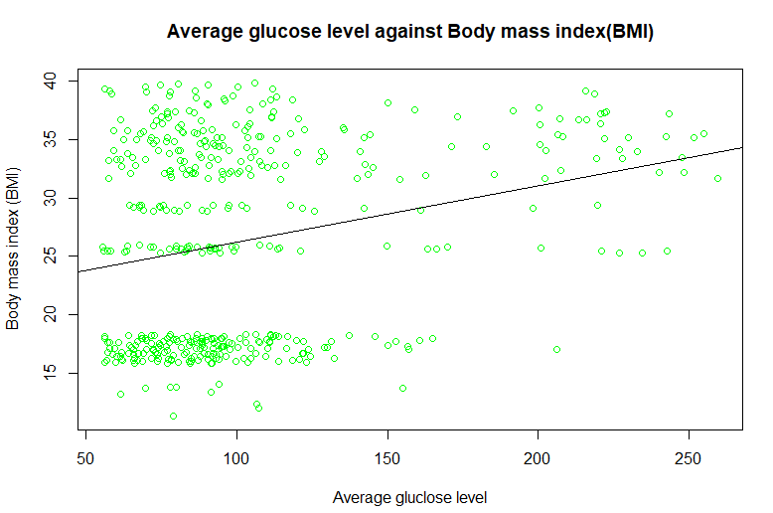
Figure 8: Scatter plot of body mass index (BMI) against average glucose level

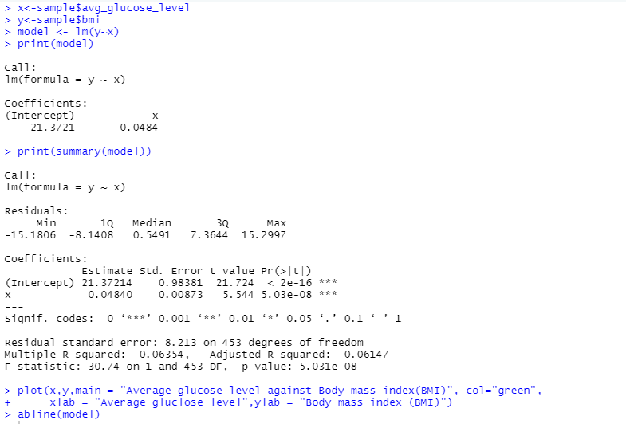
Figure 9 : Summary of graph by using Rstudio
From figure 9, we can get the the formula for estimated regression model is:
Y= 21.37 + 0.0484X
$b_{0 }$ is the estimated average value of y when the value of x is zero
$b_{1}$ is the estimated change in the average value of y as a result of a one-unit change in x
From $b_{0 }$, we can interpret that when the average glucose level is 0 in mg/dL (normally cannot drop below than 70 mg/dL), the body mass index (BMI) is 21.37 which is considered as normal. From $b_{1}$, we can interpret that the average value of body mass index (BMI) increases by 0.0484 as a result of each addition of average glucose level in mg/dL.
From Figure 9, we can also get the coefficient of determination, $R^{2}$is 0.06147. This shows that there is only 6.147% of the variation body mass index (BMI) is explained by the average glucose level. This also shows that only some but not all the variation in body mass index(BMI) is explained by variation in average glucose level
Test statistical for Regression
Test statistic, t = $\frac{b_{1}- β_{1}}{s_{b_{1}}}$
where,
$b_{1}$= Sample regression slope coefficient slope $s_{b_{1}}$= Estimator of the standard error of the slope
$β_{1}$= Hypothesized slope Degree of freedom, d.f = 453
Decision: Based on Figure 6, we can get the test statistic, t = 5.544 and P-value = 5.03 x ${10}^{-8}$. From here, we can see that P-value is < than significant level , α = 0.05 . Hence, we reject the null hypothesis.
Conclusion : There is sufficient evidence that linear regression does exist between body mass index(BMI) and average glucose level.
3.4 Chi-Square test of independence
In the Chi-Square test of independence, we want to test whether there is a relationship between type of job and heart disease. The data is represented in contingency table where each row represents one variable and another column represents another variable.
$H_{0}$: Type of job of patient is independent with heart disease
$H_{1}$: Type of job of patient is dependent with heart disease
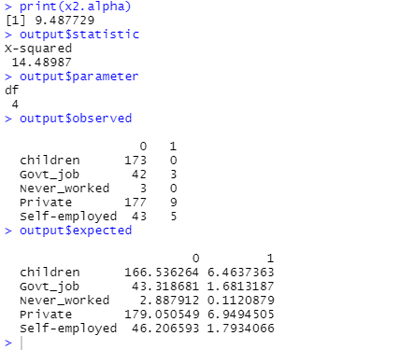
Figure 10: Drawing of contingency table using Rstudio
Test statistic,
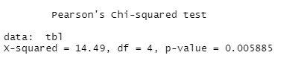
$x^{2}=\sum_{all cells}{}$$\frac{[o_{ij}-e_{ij}]{}^{2}}{e_{ij}}$
From the calculation, we get
$x^{2}=14.49$
Degree of freedom, df = 4
P-value = 0.005885
Let significance level,$α=0.05$, the critical value is 9.488
Decision: Since the test statistic,${ x}^{2}=14.49$is greater than the critical value which is 9.488 and P-value is smaller than 0.05. Hence, it does not fall within the critical region and we can reject the null hypothesis.
Conclusion: There is enough evidence that the type of job of patient is dependent with the heart disease.

3.5 Goodness of Fit Test
Goodness-of-fit test is used to test the hypothesis that an observed frequency distribution fits some claimed distribution distribution. A sample data of 455 patients are selected and we wish to test if the number of different types of smokers among 455 patients are equal.
Test Hypothesis:
$H_{0}$: $p_{1}=$$p_{2}=... = p_{455}$
$H_{1}$: At least one of the proportion is different from other
Expected frequencies : E = $\frac{n}{k}$
where,
0 represents the observed frequency of an outcome
E represents the expected frequency of an outcome
k represents the number of different types of smokers
n represents the total number of trials
We assume the confidence level to be 95%, significant level , α = 0.05 .
Exprected, frequencies, E= $\frac{n}{k}$
= $\frac{455}{4}$
= 113.75
Patient | Formerly Smoked | Never smoked | Smoke | Unknown
Observed Patient | 23 | 26 | 223 | 183
Expected Patient | 113.75 | 113.75 | 113.75 | 113.75
(O-E)${}^{2}$/ E | 72.40 | 67.69 | 104.93 | 42.16
Table 2: Observed and expected frequencies of patient
Test statistic, $x^{2}=\sum{}(O-E){}^{2}/ E= 72.40+67.69+104.93+42.16=287.18$
Critical value, $x_{3,0.05}^{2}$= 7.815
Reject $H_{0}$if $x^{2}$> 7.815
Decision: Since test statistic, $x^{2}$= 287.18 > 7.815 and fall within the critical region, thus $H_{0}$ is rejected.
Conclusion: There is sufficient evidence to conclude that the number of smokers are different among the patients.

4.0 Conclusion

As a conclusion, firstly, for the hypothesis testing for two samples, the mean of male samples is different from the mean of the female sample. For the correlation, it is shown that there is a linear relationship between the average glucose level and body mass index, BMI. For regression analysis, the regression model fits the correlation between average glucose level and BMI. The analysis also implies that “Y= 21.37 + 0.0484X” is a good predictor or factor that gives significantly high impact in predicting the BMI using average glucose level. Moreover, the chi square test of independence shows that the type of job of patient is dependent with the heart disease at the 0.05 level of significance.Lastly, the Goodness of Fit Test shows that the number of smokers are different among the patients.

In short, the purpose of this project is to study the factors of the relationship between the variables that can cause strokes. Beside that,we hope that the finding of the project can be used as a guideline to alert the condition of health and the dangerous behavior that may lead to strokes.We have also learned several factors such as removing unnecessary data first before carrying out the analysis process. This project also helps us to practice our R programming in the R studio.

5.0 Reference
- Learn about stroke. (n.d.). World Stroke Organization. https://www.world-stroke.org/world-stroke-day-campaign/why-stroke-matters/learn-about-stroke

- Hypothesis Testing. (2021, June 28). Statistics How To. https://www.statisticshowto.com/probability-and-statistics/hypothesis-testing/
- Chi-Square Statistic: How to Calculate It / Distribution. (2021, June 7). Statistics How To. https://www.statisticshowto.com/probability-and-statistics/chi-square/

6.0 Appendix

- Fedesoriano. (2021,February). Stroke Prediction Dataset. Kaggle. https://www.kaggle.com/fedesoriano/stroke-prediction-dataset

7.0 Video Presentation
- Video presentation link
https://youtu.be/j6M0BU8sCuc

