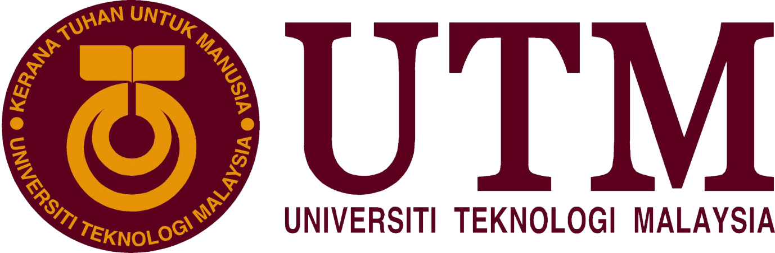

ONEMAKER INDUSTRIAL VISIT REPORT

Dr. Nor Bahiah Hj Ahmad

SCSP 1513-06
GROUP 5:
MUHAMMAD RIDHA
RAJA AIDID
ATIKAH
THATTSHINI
TAUSIF HOSSAIN
Introduction : Introduction and details of the visits
On the 24th of November, we went to Forest City and One Maker Group company located at the Medini Mall, Nusajaya, Johor. Forest City is a joint Mega project between Malaysia and China. China has invested RM100 Billion USD to build Forest City. 4 islands with 3,425 acres of land are used to build the environmentally friendly urban development, Forest City. The goal of the development of Forest City is to make a green city that is filled with trees and plants, thus the name Forest City came. Its strategic location that is adjacent to Singapore, attracts not only locals but also tourist to visit the place. Forest City does not only develop houses, schools and office but also hotels and tourist attraction places. Next, on our visit to Medini Mall, we managed to have a look onto a technology-based company, One Maker Group. We were introduced to technologies that is used by the One Maker Group. The company have so many new technologies such as 3D printers, drones and other devices. It was a fortune for us because we had the chance to have hands-on experience to handle the devices. Not only that, we were also given a seminar by the One Maker Group. There were 3 session. The first session was the tour inside the One Maker Group makerspace, then we were given a short seminar titled “The cool technologies.” and we were given a task to make a robot that is capable to eliminate rivals on a game that is similar to sumo. Lastly, we had design thinking seminar as our third session of the day. The activities including the visit to Forest City started around 8.30 a.m. and ended at 8.00 p.m. After the activities ended, we went straight back to UTM and arrived around 10 p.m.

Organization Details :
One maker that is that the company is leading maker-centric service supplier during in this business. One maker is that the company from Singapore was introduced since 2004 then they open their first branch at Johor Bharu, Malaysia. The company also provided some services to the people who want to learn new things in their life like makerspace development. Makerspace was offered consultation and building services to customize the makerspace that you wish to set up. Then, prototyping and consultation services such as 3D printing, laser cutting, computer numerical control (CNC). In short, this service to print your design and model with the machine. They can see how it work to print their design for the customer always right no matter how it so hard for them to do it. This company also conduct several events to the people to join them with some activities for example craft classes, Student Innovation & Product Development Programs, Corporate Creative Technology Innovation & Team Building, Hackathons, and others. There is two achievement from the one maker company. Firstly, an officially certificate Arduino Creative Technology in the Classroom (Arduino CTC 101) is one-of-a-kind STEAM (Science, Technology, Engineering, Arts, and Mathematics). The students are introduced to the foundations of programming, electronics, and mechanics through a series of playful, well-documented projects and easy-to-assemble experiments. CTC is an immersive educational experience consisting of an online platform, video tutorials, detailed documentation with step-by-step instructions, a classroom toolbox with more than 20 hands-on experiments based on themed modules. However, this company also have a professional certificate as a High-end IT Training and Consulting. One Maker Group is in partnership with Fast Lane Asia. Fast Lane, a leading provider of advanced IT training courses, offers complete authorized training solution. They help the company gain and develop technology skills to cope with modern high-end challenges.

Various Activities:
Workshop 1- Disruptive technologies learning journey

As an introduction to the workshop, students were given a brief talk on Artificial Intelligence which ranges from how it functions to its applications. The talk was brilliantly delivered by a representative of the OneMaker company.Students we made aware of disruptive technologies in the robotic world and planted with the seed of thought on the future of Artificial Intelligence and its undertaking as one of the most brilliant invention ever existed. Students were also questioned on the future of employment rate with the prevailing force of Artificial Intelligence as an opponent.

There were four stations of different applications of Artificial Intelligence.The first station was “Drone programming and flying experience”. There were two different size of drone; medium-sized and small-sized. Students were guided on the basic parts of the drone and the steps on handling it using a controller. Each of us was given an oppurtunity to control the drone. The small-sized drone was programmed through a software in the computer to perform a stunt;backflip.

The next station was “3D-printing experience”. A software connected to the printer was used to design the prototype where it is later printed. The printer displayed in the station was Malaysia-made and was relatiely small in size. The material used is PLA where it is melted to temperature between 160-200 celsius before printing. The time taken varies according to the size of the object.

The next station was “computer-aided design challenge” where the software Sketchup is used to sketch a prototype based on user’s idea. User’s can use the tools provided to come up with a creative idea.The last station was “Color/Line Following Robot Demo” where a small robot is placed on the colours where it will react accordingly to it’s programming. For an example, it stopped when it passes red and slows down for yellow.

Workshop 2- QuirkyBot battle royale

All students were gathered and was given a talk on Artificial Intelligence (AI) and Internet of Things (IOT). The representitive of OneMaker gave a little deep talk of the basic idea mainly brushing on Internet of things(IOT).After the talk students were briefed right into the challenge covering the rules and the materials provided.

The materials provided were mainly Recyclable and reusable items such as tin cans, plastic bottles and boxes. Students were also provided with other items such as penknife,scissors, double-sided tapes and strings. The challenge mainly focuses on builing a robot using the battery and motor provided alongside the other materials that is able to move forward fast and is strong enough to fight the opponent’s robot where the robot that is pushed out of the little arena provided looses. An approximate 30 minutes were given for students to come up with an idea an assemble it.

Reflections :
- How this event give impact to our goals:

` we're a computer science student and field for this sector is very big. So we have to be determined from the very first stage that what we are doing and what is may we’re doing software engineering and our goal is, to be a good programmer. Regarding this One Maker group made a such a spontaneous work. They gave an opportunity to join their workshop. Basically, their motto was the enrichment of our thinking. They showed us some amazing things and they also showed us how Programming is working behind the technology. There We saw Google Assistant and that touched our soul. We was like, how this machine can understand our language, how she can follow our command. This thing bound us to think twice about it. Thinking is the best procedure to create a new invention. If one can think differently then no one can stop him. Then we learned how to fly a drone. That was a good experience of ours.
We did a lot of stuff which will help us in our future. After finishing our graduation these things will help us to deal with our upcoming activities.
- What is the action/improvement/plan neccessary for us to improve our potential in the industry?

Based on field visits to onemaker companies, we are very open minded that all this time the work life was not what we thought. Where onememaker they demand all elements not to think about what their goals are but demand their minds to think critically so they can produce works that can have a huge effect for the next few years before other people or companies think that it will be very profitable going forward . That is where the onemaker makes our minds open that in working we are not required to continue to rely on skills from what we have learned. Examples: programming skills, creative design or so on. But onemaker teaches us to be more involved in exploring the hidden ideas our minds have. Workers are required to imagine freely without any pressure to work. The work space is also made as comfortable as possible to make all workers feel comfortable and will produce brilliant ideas from all aspects experienced. I think in the future we will develop all the talents we have without focusing on what majors we take. For example, we majored in software engineering, but from that experience we were open minded not to be motivated that we would become programmers. By exploring all the talents and creativity that we have and coupled with the skills we learn from the department, I think in the future we will love any work we do and we will work happily without being burdened. All of that will greatly enhance an individual to be more potential in working in an industry. So dig up all the talent and creativity that is in you so that you are not driven in one point. Because in an era like now many companies are looking for workers not based on values or CGPA achieved but also from extraordinary thinking.

References :
- https://www.onemakergroup.com/medini
- https://en.wikipedia.org/wiki/Virtual_reality
- https://www.interaction-design.org/literature/article/5-stages-in-the-design-thinking-process

Looks of our visit:
