
SCSP 1513
SECTION 07

GROUP REPORT:
DESIGN THINKING

SCHOOL OF COMPUTING

NAME: | MATRIC NUMBER:
MUHAMMAD FIRDAUS BIN NOR AZMAN | A18CS0149
TOON SHU HUI | A18CS0268
CHOY WAN LING | A18CS0049
IDZNI BIN MOHAMED RASHID | A18CS0075

LECTURER:
SIR HAIRUDIN BIN ABDUL MAJID

1.0 Table of Content
No | Description | Page
1.0 | Table of Content | 2
2.0 | Introduction | 3 – 5
3.0 | Content
3.1 | Step 1: Emphasize | 6 – 7
3.2 | Step 2: Define | 8
3.3 | Step 3: Ideate | 9
3.4 | Step 4: Prototype & Step 5: Testing
3.4.1 | Prototype #1 | 10
3.4.2 | Testing #1 | 11
3.4.3 | Prototype #2 | 11 – 12
3.4.4 | Testing #2 | 12
3.4.5 | Prototype #3 | 13
3.4.6 | Testing #3 | 14
4.0 | Reflection | 15

2.0 Introduction
Design Thinking is a process included the design concepts and developed by designer or a design team which normally used for proposal of new products. It is a creative problem-solving process that utilizes empathetic, creative, innovative and analytical skills to provide innovative solutions to an established and understood problem. It integrates the needs of people, the possibilities of technology, and the requirements for business success. By understanding the human needs involved, design thinking extremely useful in tackling complex problems that are ill-defined or unknown, by re-framing the problem in human-centric ways, by creating many ideas in brainstorming sessions, and by adopting a hands-on approach in prototyping and testing.

There are five phases or stages in design thinking.
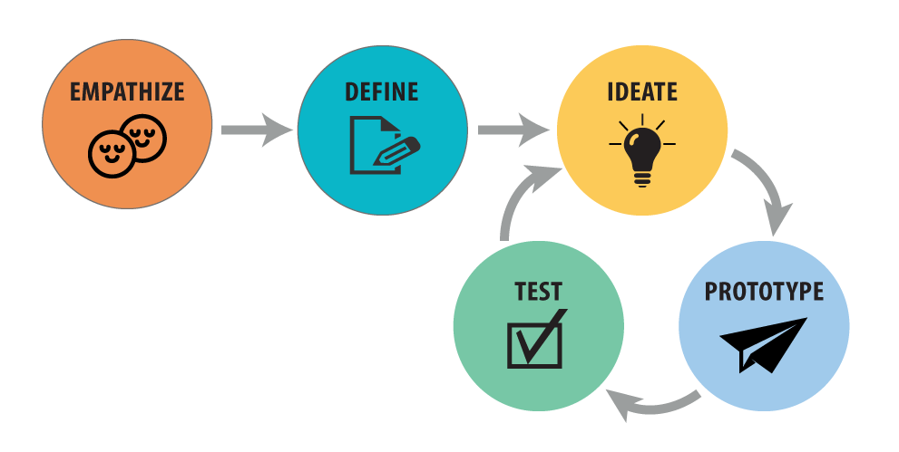

First stages: EMPATHIZE
A stage which is the foundation of a human-centred design process. At this stage, we must understand the problems. To empathize, we can observe the users and their behaviour in the context of their lives. Next, we can engage by interact with and interview users through both scheduled and short ‘intercept’ encounters. After this step, we better immerse in the experience which our users experienced. This helps us to get an empathic understanding of the problems that you are trying to solve.

Second stages: DEFINE
A stage which you unpack and synthesize your empathy findings into compelling needs, insights and scope a specific and meaningful challenge. It is a mode of “focus” rather than “flaring”. Define mode has two goals. One of the two goals is to develop a deep understanding of your users and the design space based on that understanding. Next, it is goals to come up with an actionable problem statements: your point of view. The point of view should be guiding statement that focuses on specific users, insights and needs that you uncovered during the empathize mode. Your point of view is your unique design vision that you crafted based on your discoveries during your empathy work more than simply defining the problem to work on. Usually we use the flip chart to try out a number of options and playing with each variable and the combination of them.

Create a point of view:
[GROUP] needs to [GROUP’S NEED] because [SURPRISING INSIGHT]

The design challenge is to improve the National Direct Consultation process:
- Who is your group?
- What are their needs?
- What are some surprising insights?

Understanding the meaningful challenge to address and the insights that you can leverage in your design work is fundamental to creating a successful solution.

Third stage: IDEATE
A stage that focus on idea generation during your design process. Mentally it is a mode which represents a process of “going wide” in terms of concepts and outcomes and also a mode of “flaring” rather than “focus”. The goal of ideation is to explore a wide solution space which included both a large quantity of ideas and a diversity among these ideas. You can build prototypes to test with users from this vast depository of ideas.

Idea Selection
We will select our favourites based on the following categories. The idea with the most votes regarding the category is what we will prototype.

- The rational choice
- The most likely to delight
- The darling which means your favourite
- The long shot

Fourth stage: PROTOTYPE
A stage that build a physical model which combine all the ideas. A prototype can be anything that takes a physical form such as be it a wall of post-it notes, a role-playing activity, a space, an object, an interface or even a storyboard. The resolution of your prototype should be commensurate with your progress in your project. In early explorations, we can keep the prototype rough and rapid to allow yourself to learn quickly and investigate a lot of different possibilities. This stage is important because it allows your users and the design team can experience your ideas and interact with the draft product. Through this stage, we can drive deeper empathy as well as to shape a successful solution.

Steps of making a prototype:
- Start building with some cheap and easily-gain materials.
- Build the prototype with your group in mind. During the building process, the sorts of questions that you wonder and the problems that you faced and wish to improve can get answers and solutions from your group members. The solutions help you to focus on your ideas and allow you to receive meaningful feedback in the feedback phase.
- Label your POV. This step is identified what’s being solved for with your idea. It would be helpful to your audience if you wrote down and presented what need you are addressing your POV statements.

Fifth stage: TEST
Testing stage is the chance to refine our solutions and make them better. The test mode is another iterative mode in which we place our low-resolution in the appropriate context of the user’s life. Testing the prototype is allow us to know what’s the mistake is and can improve the products better based on the user’s needs. Usually in this stage we make an interview or a survey to gain the responses and comments from users on our prototype and ideas.

The prototype stage will be repeat if we meet problem or mistake in testing stage. Repeat do the prototype is to ensure that the products is fulfil the user’s needs. Then go to testing stage again to gain the responses and comments again based on the new prototype.

3.0 Content
3.1 Step 1: Empathize
In this step, we are required to ask our friends or people around us regarding the problem there are facing. We find out that the problem is that the trolley in shopping mall is not in an organized matter. In regard with this, our group has interview some of the students in our faculty regarding what they think about the condition of the trolley in the mall.

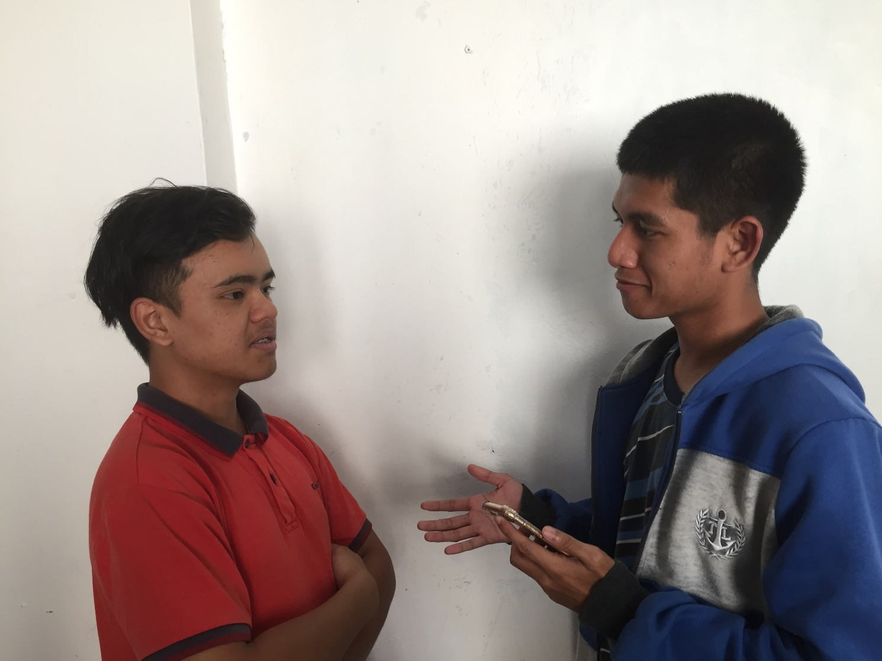
Our group member Firdaus has a short interview session with student in School of Computing

Based on our interview, we get to collect some problem stated by the users regarding the trolley in the shopping mall:
- It is hard for user to find the shop or the places they want to visit in a mall and directories has limited access.
- The trolley in the mall is not put back to the original place after being used by another user.
- The trolley has caused many incidents in the parking lots as they are all around the parking lot and sometimes car might crash onto it.
- The trolley all around the parking lot made it difficult for user to find a parking lot due to the lot is occupied by the trolley.

3.2 Step 2: Define
For defining problem, we together discussed we are a bunch of searching for the origin of why the existence of the problem. In times of heavy and precise we found some problems why the occurrence of why trolley in the parking lot not correctly arrange.
The problems are:
- Trolley not returns to original place. most users will retain their trolley might be because your newfound free time

- Trolley user are too lazy. There are also users who like to keep an attitude of arrogant because too selfish cause trolley is not put in place.

- Trolley parking are very far. sometimes mistaken operators house trolley that much because users do not want to waste energy to corporate social

- Users who do not know what's on that level of the mall/supermarket. in this case the user may be misguided in the mall/supermarket and make problems to users

Once we find the origin of the problem, we finally had found the path to pre-solutions for that problem.
The pre-solutions are:
- Educate user with instruction. By teaching the user through proper instruction. Thus, the user will continue to be sensitive to the circumstances surrounding the.
- Shorten the distance of the location of auto pay and trolley parking. With closer distance with trolley parking with the parking lot. User right can be economical times and continued to be cut off from the trolley which is not composed.
- Apply the proper technology. With the appropriate technology. Employers can fun party users to use trolley easily. with that, the State will continue to advance in the field of technological innovation
Thus, the completed we are looking for a problem and looking for a pre-solution. Finally, we talk to build a technology named TRBS, Trolley Return Barcode System.
3.3 Step 3: Ideate
We have done a brainstorming after we get a survey to get an empathy. Brainstorming is the process needed to proceed first because it is a process which collect the ideas from people and allow you to discuss the ideas with your group members later. It is physically record and collect the ideas using stick notes or other electronic gadgets. After this we can see and discuss the ideas based on the stick notes. Brainstorming allow us gather the ideas which gives us greater creativity and able to produce better solutions. There are some brainstorming rules:
- One conversation at a time
- Go for quantity
- Headline
- Build on the ideas of others
- Encourage wild ideas
- Be visual
- Stay on topic
- Defer judgement which is no blocking
We have brainstorming an idea to fulfil the requirement based on the survey we have done. We discuss and group the problem and define the problem and give the best solution to solve the problem. After several meeting We got an idea to make Trolley Read Barcode System to teach community to arrange trolley in a proper way.
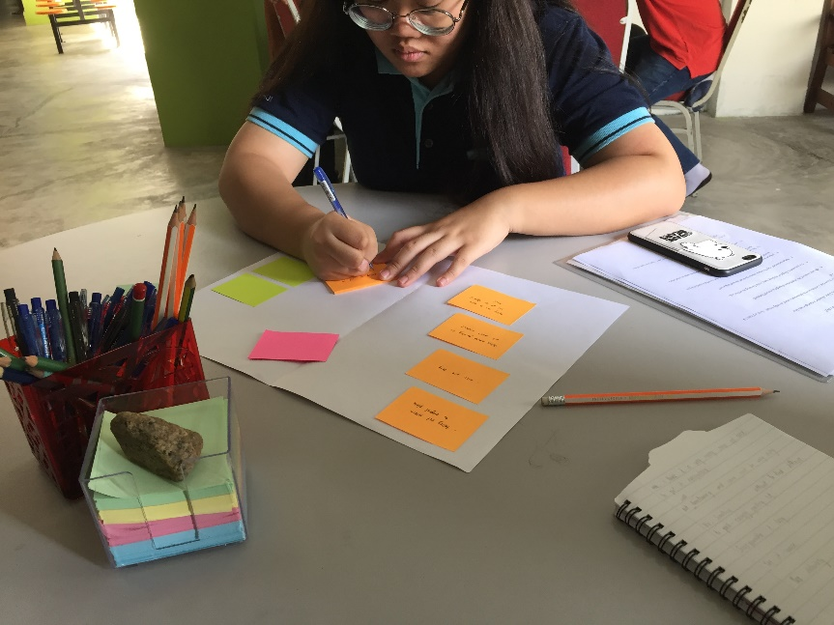

Brainstorming to problem the solve

3.4 Step 4 and Step 5: Prototype & Testing
3.4.1 Prototype #1:
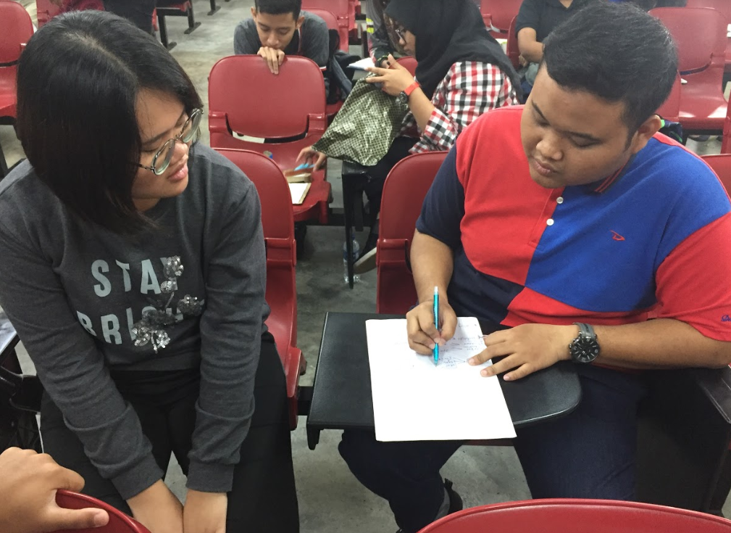
In this step, we have produced a prototype by using cardboard for our design.
Our group member discussing how to design the prototype

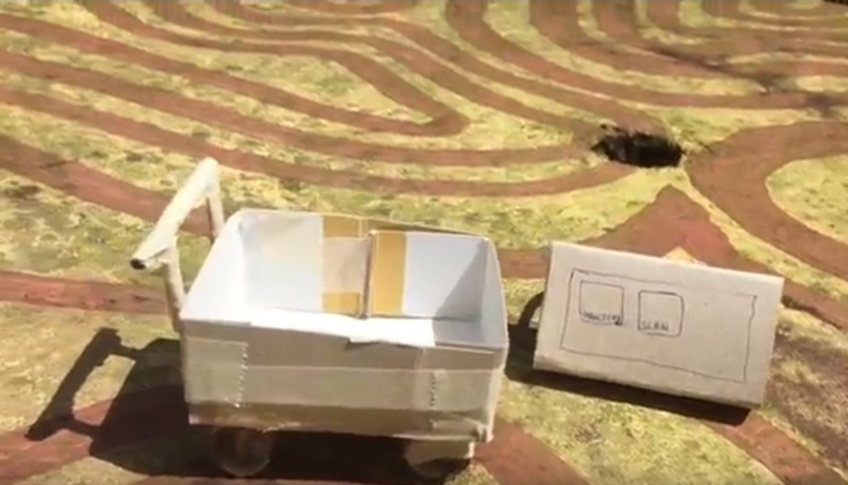

First prototype with the trolley (left) and the barcode scanning and directory system (right)

3.4.2 Testing #1:
This prototype is done in a very short time and in the testing stage, users are not able to understand our concept hence the first prototyping and testing is failed

3.4.3 Prototype #2:
Due to the failed in our first prototype, our group has decided to made our second prototype which we remade another prototype of the barcode and directory system.
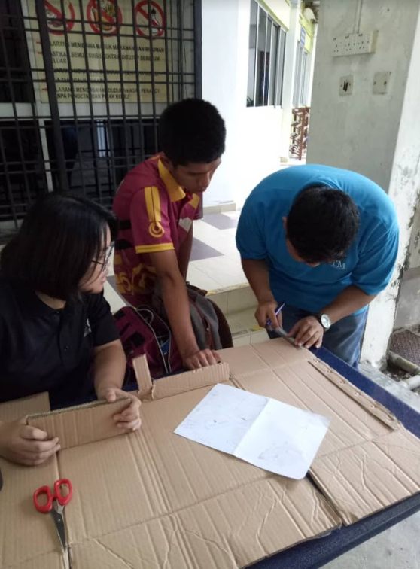

Photo showing that our group creating the second prototype

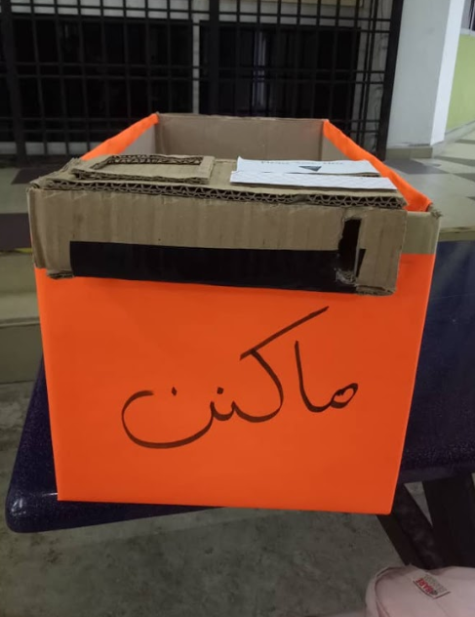

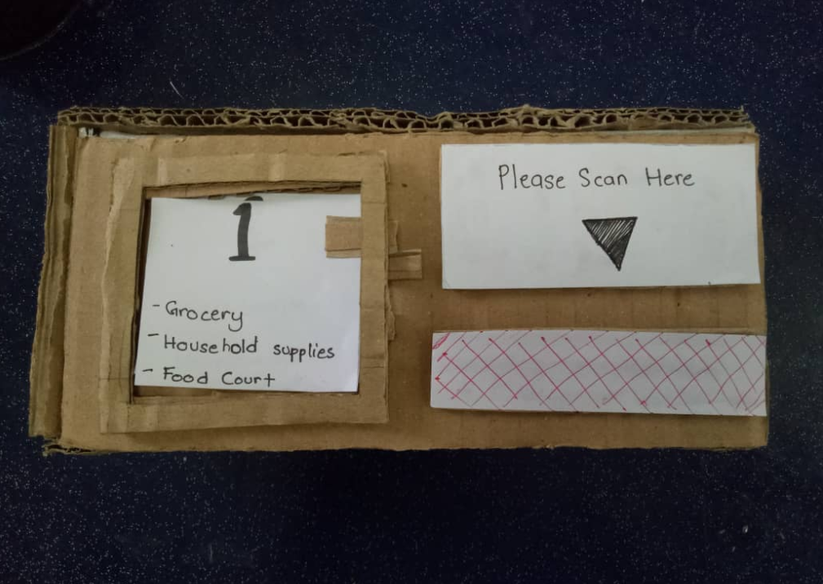

Photos show the second prototype done by our group with trolley (left) and the barcode scanning and directory (right)

3.4.4 Testing #2:
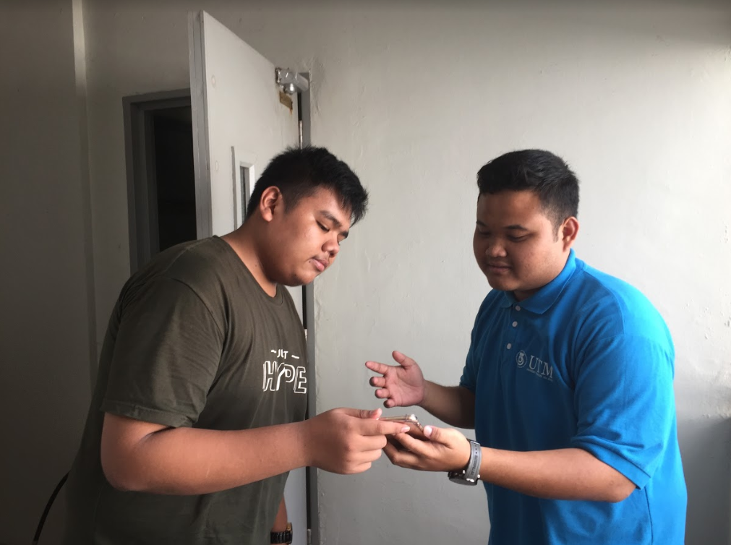
The second prototype is not a success as well because there are still parts where the users are still not understanding with our concept.

Photo show that our team member Idzni explaining the second prototype to user
3.4.5 Prototype #3
For the third prototype our group has decided to perform out prototype in a video since users cannot understand our concept through literal explanation. We have included our second prototype in the video shooting.
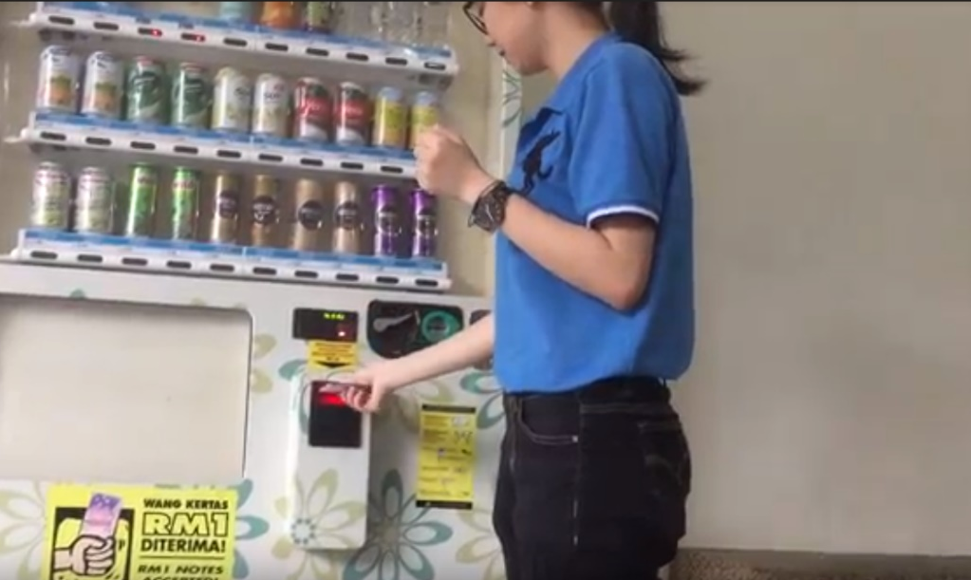
Photo show a snapshot from our 3rd prototype which is a video.

The link of our third prototype can be viewed in the link below:
https://drive.google.com/open?id=1tC7WDYTt6yB_KwBC_7N7E2lSY9rEOc3x

3.4.6 Testing #3:
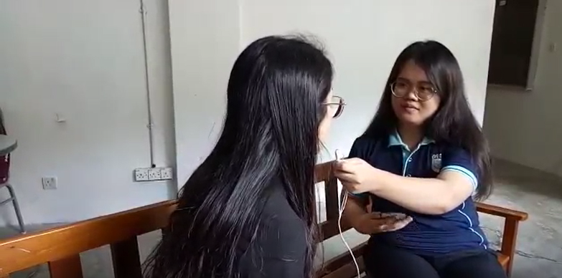
For the third testing, users are satisfied with our design and we have interviewed some users after showing them the third prototype. Feedback from users are that they think that this system can effectively control the user to return the trolley back to the original place and they think it is a workable idea in solving the problem like hard to find a parking lot and so on.
Photo show our group member Toon interviewing user after reviewing the third prototype

4.0 REFLECTIONS
As a reflection of this Design Thinking Project we can know how we can innovate and make a new product for use to community and industry for the better and reliable future. In the future our goal is for to make this course can enter industry and can fulfil current industrial revolution which is industrial revolution 4.0, As the fast rate of this industrial revolution this course needed don’t just learn about the core subject but also can learn other side subject to reliable and versatile to work in harsh environment industry which always change of scope job in Information Technology (IT) industry.

This design Thinking project give a huge impact to encourage student brainstorming their mind to ideate and make innovation to solve the current state problem that always change among the community. As the job scope this program is in IT. This program helps to inspire and make student learn a new way to explore no just in the subject core of this course but also a new thing to other.

From this we can know the impact from this project can give an opportunity us to improve in soft skill to gain more knowledge. It also we determine our problem and give a chance an improvement in soft skill and find a new knowledge in innovation and information technology. A lot of improvement we need to done. A lot of innovation program we can participate and also learn a new knowledge not just in university or just class but also in internet and environment to gain long life learning education.

