
SCSP 1513
SECTION 07

GROUP REPORT: INDUSTRIAL VISIT 1
CICT UTM

SCHOOL OF COMPUTING

NAME: | MATRIC NUMBER:
MUHAMMAD FIRDAUS BIN NOR AZMAN | A18CS0149
TOON SHU HUI | A18CS0268
CHOY WAN LING | A18CS0049
IDZNI BIN MOHAMED RASHID | A18CS0075

LECTURER:
SIR HAIRUDIN BIN ABDUL MAJID

Introduction

Centre for Information and Communication Technology (CICT) ^{[1]} in University Teknologi Malaysia (UTM) is an ICT centre which supports the ICT services for university staffs and students especially in ICT infrastructure, system development and academic or administrative activities. It is located at Block D07 which is near to the Faculty of Computing (N28) because it is like an ICT information library and ICT knowledge centre for students in school of computing. Hence, we take a visit to CICT to understand more about how the systems in UTM work and function.

CICT acts as a consultant of computer technology system takes a role in maintenance of network system in UTM. It provides some ICT services such as internet and Wi-Fi, infrastructure and security, ID account and access, multimedia, installation of software and ICT facilities that is CICT Gallerium and training Lab. These ICT services ensure network systems in UTM to conduct well.

As we know, the students of UTM have their own user unique ID that is ACID account after they registered the courses of their respective faculties. For the UTM staffs, they can apply ACID account after they have an official UTM mail account. Having ACID account is easily for students get to access the Wi-Fi UTM and MyUTM Login page for purposes of education like e-learning which the students can upload their assignment or read the slides of courses uploaded by lecturers. For everyone in UTM, we have an official UTM mail account to receive important announcements from UTM. It is easy for us to manage our timetable and schedules. These examples show how a systematic system in UTM provided by CICT which give benefits for us.

CICT is a centre which handles the system of UTM. It controls and stores the data of all staffs and students in UTM. We can visit if we face ICT such as fail to access UTM Wi-Fi, error when access MyUTM and others. CICT as an ICT centre that has different departments which each has respective roles and works that cooperate with each other to conduct our ICT systems in UTM.

CICT also provides installation of software such as antivirus software and research software. As the students of UTM, we can install the software and get the license of some software for free. Besides, the quality management of CICT is maintain by unit of environmental (OSHE), International Organization for Standardization (ISO) and software quality engineer (QE) which ensure the software quality assurance of UTM.

List of departments in CICT and software provided by CICT for us to install:

Departments | Software
- Top Management  - Project Management Office (PMO)  - Strategic Management (SM)  - Infrastructure & Operation Management (IOM)  - Application development (ADM)  - Business Development Office (BDO)  - Corporate Management (CM)  - Attachment & Sinergi  - IT Academic Fellow | - Antivirus  - Research Software  - Software License by UTM  - Microsoft Product

Work Plan

On the 1st of October, an industrial visit has conducted for the first year SCSR student by our subject Technologies and Information System Lecturer, Dr. Hairuddin. We have our industrial visit to Centre for Information & Communication Technology, University Technology Malaysia (CICT). We were all given a talk regarding ICT services and regulations in UTM on 2PM in seminar hall by Mr Mohd Zahari bin Zainal Abidin. After that Mr Zahari has brought us to the computer lab (PPICTP) for a short visit. Lastly, we were allowed to visit the CICT Gallerium and the visit ends here.
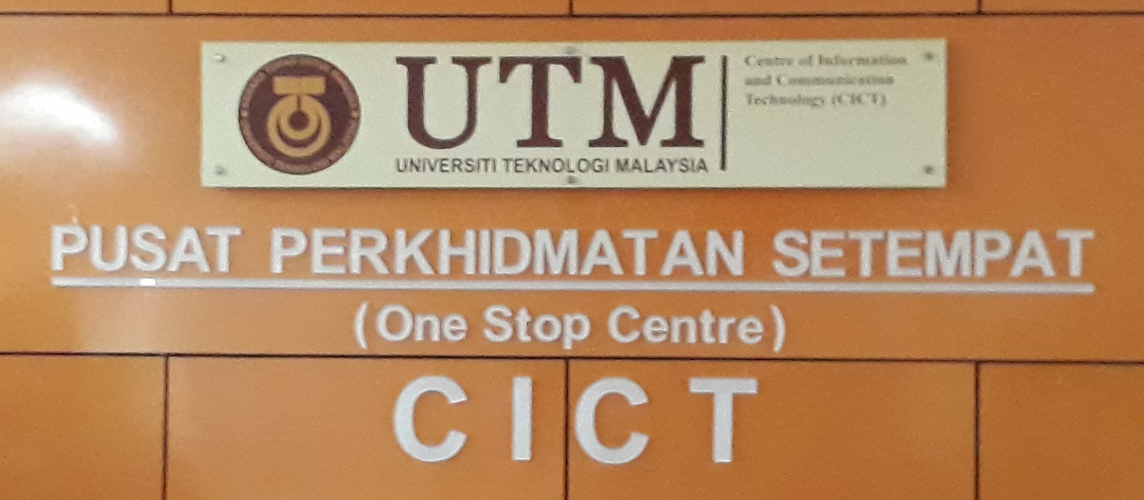

Content

What is CICT?

CICT is the centre of information and communication technology of UTM where it is a support unit that offers and delivers ICT services for the university (staffs and students) especially in ICT infrastructure, system development and academic or administrative activities.

Vision of CICT:
For UTM to be a “A frontier digital university spearheading academia centric service delivery”.

Mission of CICT:
To lead in the development of an entrepreneurial digital ecosystem by nurturing innovative digital professionals and promoting collaborative digital services.

CICT Organization Structure:

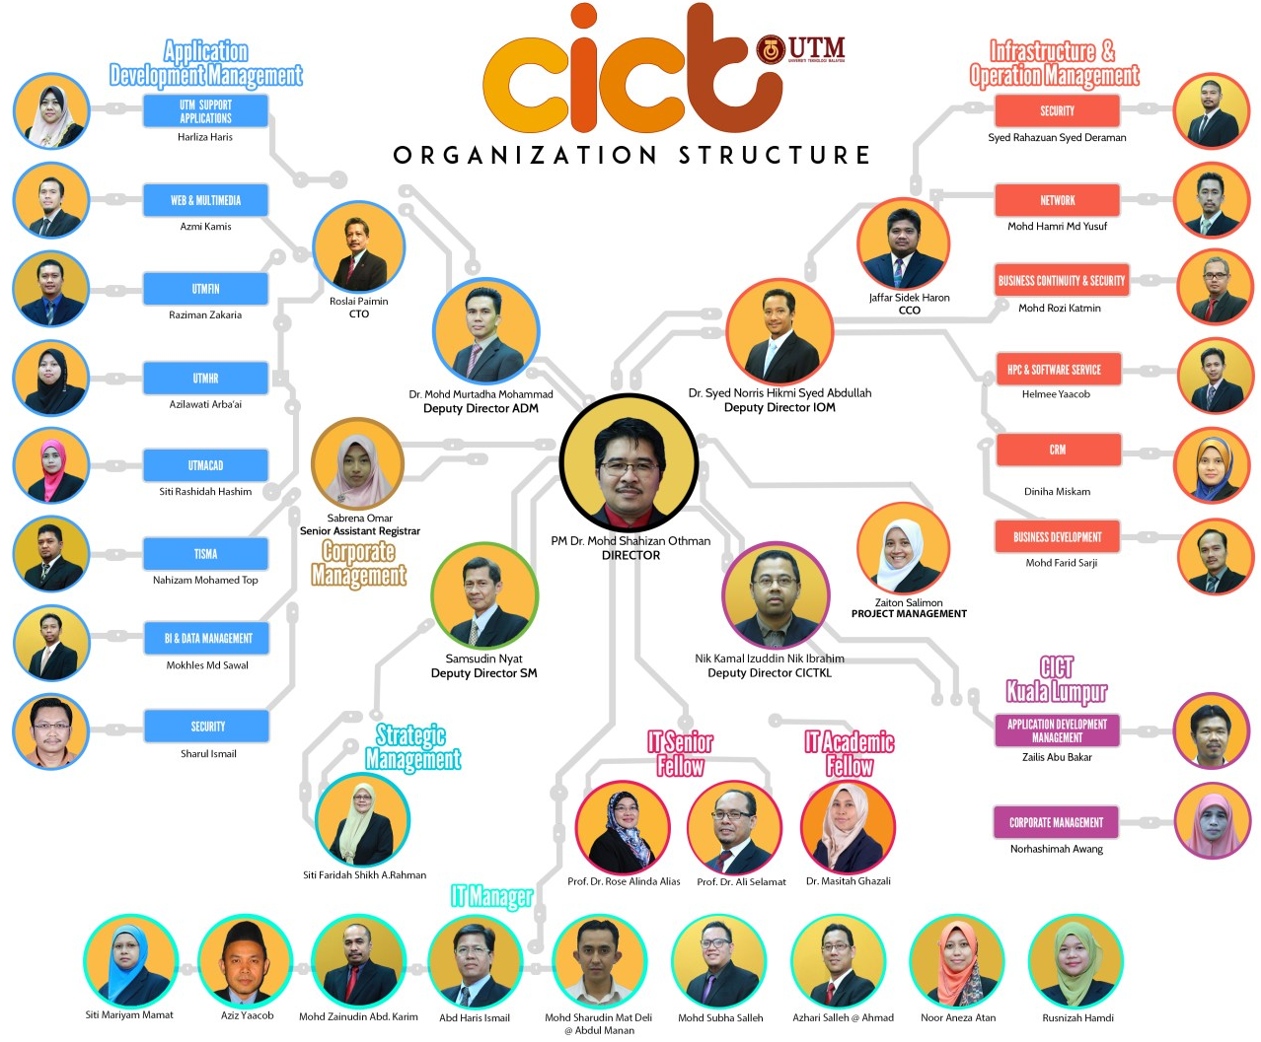
CICT Organization Structure credits to CICT official website http://cict.utm.my/organization-structure/
ICT services provided by CICT for students:

- Student Lab
- UTM ID
- Wi-Fi
- VPN
ICT SERVICES

- Student Management Service
- ICT Instructional Services
PORTAL MYUTM
PORTAL MYUTM

- MyUTM Portal
- Microsoft Dreamspark
SOFTWARE

Student Lab

- Computers
  - Windows Platform 100 Computers

- Project discussion area
  - 3 areas included

- Printing, scanning and CD/DVD burning

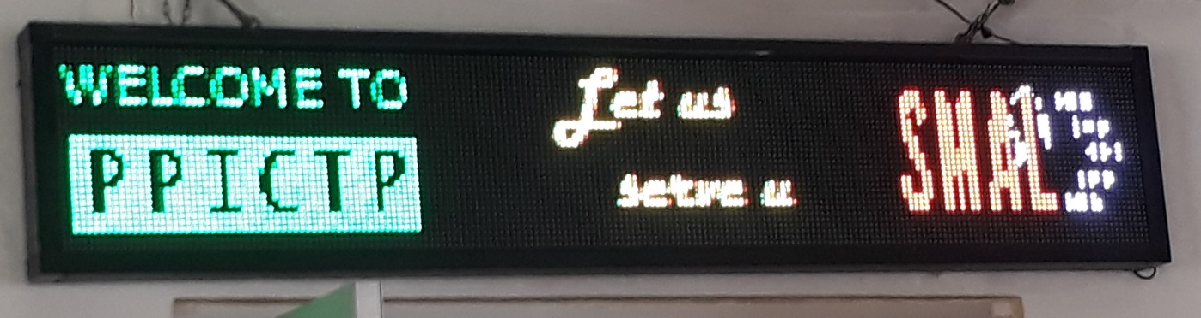

- Specialised Multimedia & Content Authoring Production Lab (SMAL)
  - Facilities Available:
    - MAC PRO
    - Lighting & Chroma Key
    - Whisper Room
    - Mixer

  - Software Available:
    - Final Cut Pro
    - DVD Studio Pro
    - Sound Track Pro
    - Color
    - Aperture
    - Motion
    - iWork
    - iLife
    - Adobe Suite
    - Roxio Toast
    - SDK
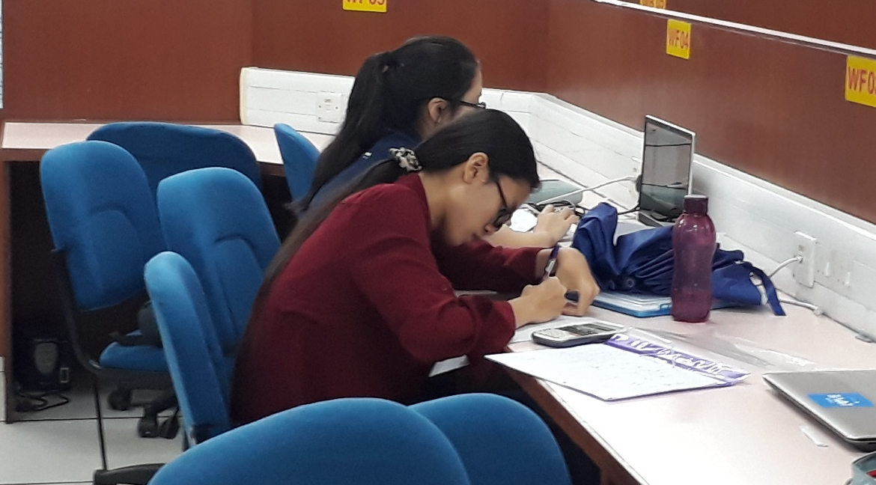
Computer Lab also provide WLAN socket for student to connect to internet with Laptop.
UTM ID

UTM ID are setup and given to every new student to UTM by CICT. New students will have their very own ACID ID and UTM email. There are several accesses which required students’ UTM ID to logged in such as:

- UTM Portal (MyUTM)
- UTM Mail
- Software Account
- Access from outside of UTM (VPN)
- Wi-Fi connection

With UTM ID, it is more convenient for all staffs and students as there don’t have to remember several usernames and passwords for different access as CICT has made all these under one ID which is UTM ID.

Software Account

CICT also made every student a software account which is a live email ID which student can download all Microsoft products (Microsoft Imagine) except Microsoft Office using this account.

Besides that, there are also several software which can be downloaded by student from MyUTM website such as Matlab and antivirus software.

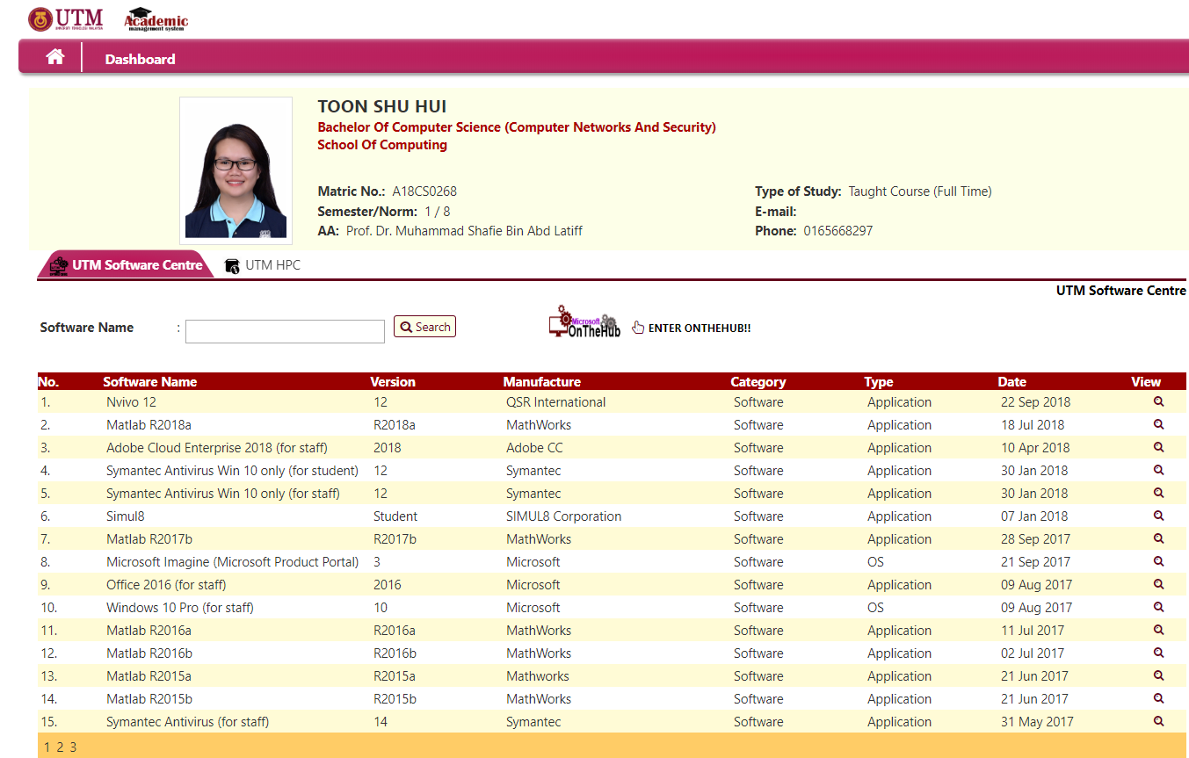
Example of software available for students in MyUTM

Wireless / Wi-Fi Zone

CICT has provided a wide range of Wi-Fi for UTM students and staffs which is the UTMWiFi as shown in the picture below.

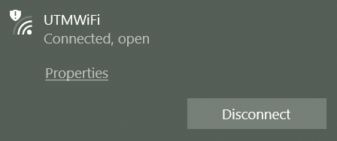

Under the Wi-Fi Expansion Project @ Residential Colleges by CICT on 3rd of June 2018, CICT has completed installed Wi-Fi at 200 new locations on 14th June 2018. On the 26th of June until 12th July 2018 network bridges to support Wi-Fi infrastructure has been installed at 36 locations without network cabling infrastructure. Meanwhile on the 31st August 2018, CICT has successful made a 100% Wi-Fi coverage in all colleges with total of 1600 locations.

Although UTM Wi-Fi is a facility opened to every UTM-ians but there are still an Acceptable Usage Policy to be followed by all users. ^{[2]}

Virtual Private Network (VPN)

UTM VPN is set up by CICT for the ease of students to access UTM intranet services from outside of UTM campus. Students only have to surf http://vpn.utm.my and log in with UTMID.

Portal MyUTM

Portal MyUTM can be accessed by surfing https://my.utm.my/ , it is a one stop services for students which included the access gate for e-Learning, course registration and others as shown below:
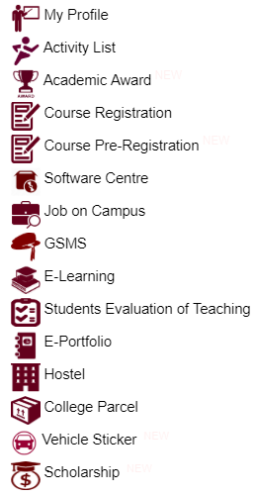

Example of services for students in MyUTM portal

e-Learning

e-Learning is an educational portal that assists students and lecturers in the teaching and learning process to be more effective and flexible. Lecturers can upload their teaching materials such as slides and assignment for students to access. Lecturers can also conduct online tests or quizzes via e-Learning for students.

For students, they can get to know the topic to be teached by lecturer before lesson and get prepare for it. Besides that, students can also submit their assignment via e-Learning which will be easier than submitting assignment by hand.

e-PPP

Lecturer’s Teaching Evaluation is a web application which enables students to evaluate and give comments to lecturer’s teaching performance. This system benefits both students and lecturers. For students, this system allows students to evaluate and give honest comment to lecturer. For lecturers, they get to know their student perspective and can improve themselves more.

e-Portfolio

e-Portfolio is an online compilation of documents that is flexible and is based on artefact evidences of which students are:

- Directly involved in a continuous reflection process towards their own learning
- Reporting the progress of their achievement and knowledge, technical and generic skills
- Plan their personal, academic and career development

e-Portfolio also act as a resume for students which students can records all of their achievement and for later reference.

CICT Gallerium:

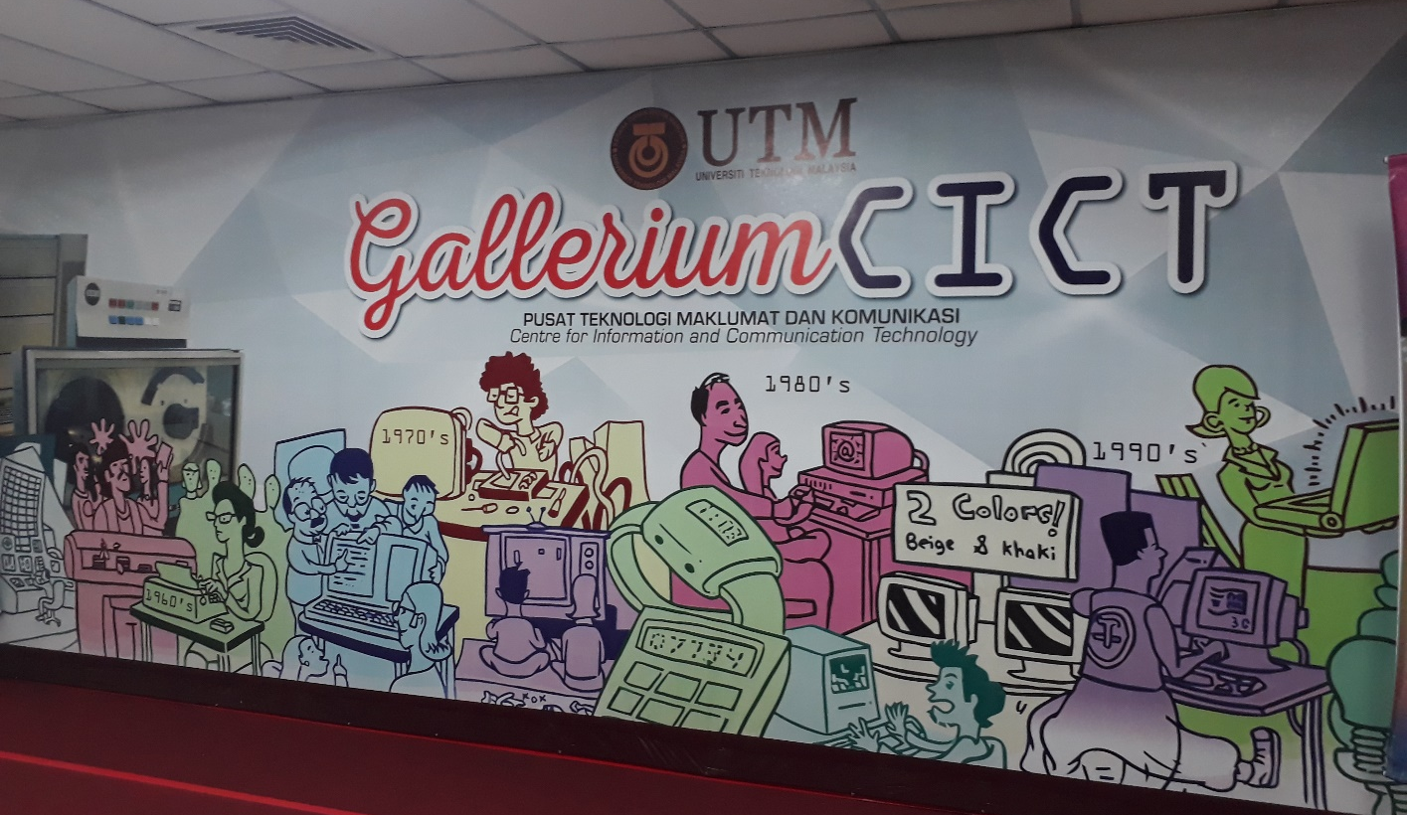

The CICT Gallerium are places where CICT display technologies gadget such as computers, hard disk, controller and others.

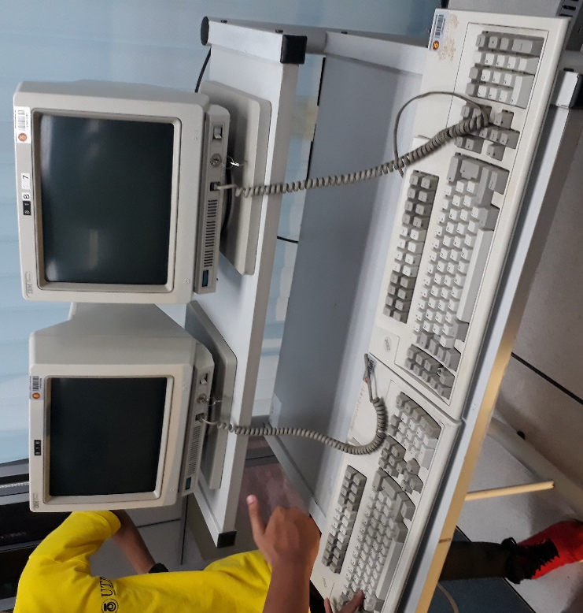
Mainframe Terminal (IBM 3471 InfoWindow) ^{[3]}
The InfoWindow 3471 features a choice of keyboard, choice of warranty period in some models, and either 14-inch green or amber-gold monochrome monitor with a flat, smudge-resistant screen, capable of displaying up to 1920 characters.

It offers high-quality, superior ergonomics and functions that include: Variable Auto Dim, Extended Vital Product Data, Extended Attribute Buffer, Record/Play/Pause with security options, Country Extended Code Page and Improved Set-Up Mode.

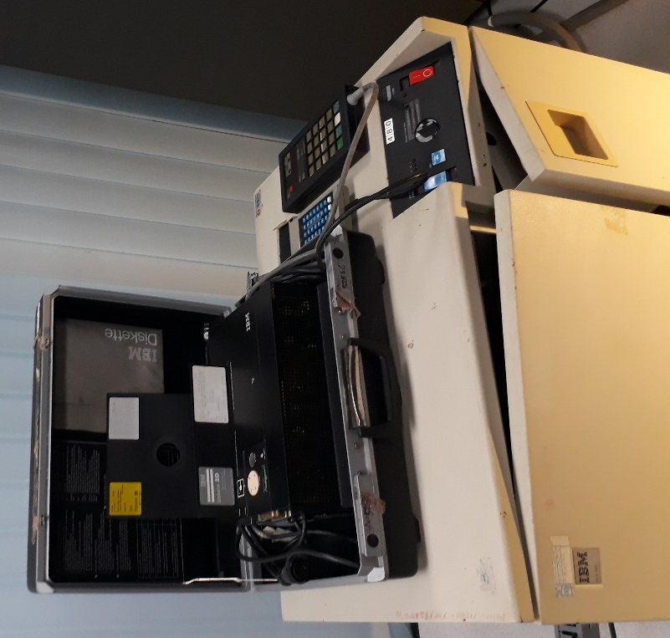
Controller (IBM 3274 41D) ^{[4]}
The IBM 3274 Model 41D provides a local (3272) attachment for up to 32 terminals/printers to a S/370 or 4300 processor. Model 41D comes with 192k storage size.
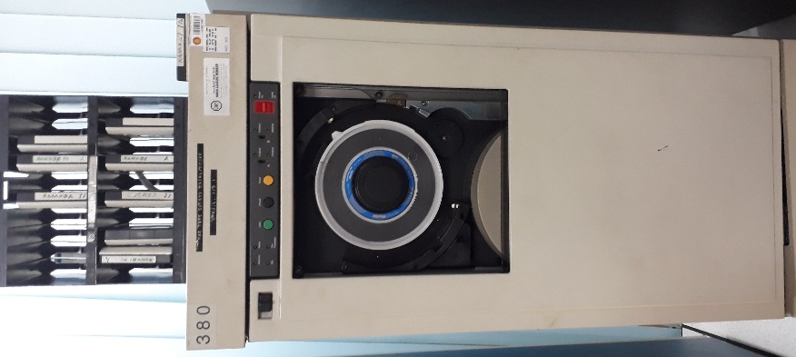
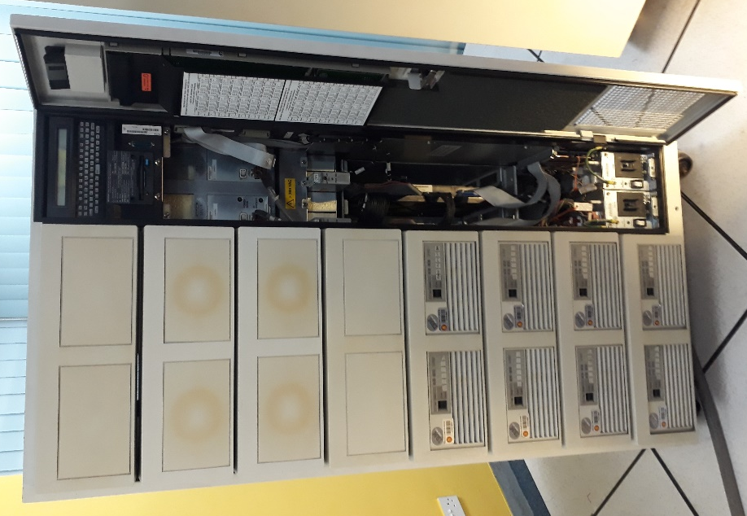
Mainframe Tape Subsystem Control Drive (IBM 3422 A01) ^{[6]}
The 3430 was a dual density, 50 inch-per-second tape drive. It read or wrote either 1600 bytes-per-inch phase encoded (PE) or 6250 bytes-per-inch group coded recording (GCR). The GCR mode provided more efficient detection and correction of tape read errors while the PE mode provided compatibility with and conversion of existing 1600 BPI tape files. GCR also provided a greater tape density (6250 BPI), which improved performance up to 312K bytes per second. Model A01 is consisted of the subsystem control unit and one tape unit housed in the same frame.
Mainframe Data Storage (IBM 9394 2) ^{[5]}
The RAMAC 2 Array Subsystem (IBM 9394 002) offers extensive flexibility: 11.35-180 GB of data storage in one rack (two B13 drawers minimum); controller cache sizes ranging from 64 MB to 2 GB; 3380-K or 3390-3 DASD emulation modes, which can be intermixed in a Model 003 rack, B13 drawers can be reformatted; software transparency, supported in MVS/ESA*, MVS/XA*, MVS/370, VM/ESA*, VM/XA* SP, VM/SP HPO, VM/SP, VSE/ESA*, and VSE/SP environments; parallel (3.0 and 4.5 MB/Sec) and 128 logical path ESCON (10 and 18 MB/Sec) channel support; high degree of modularity and upgradeability.

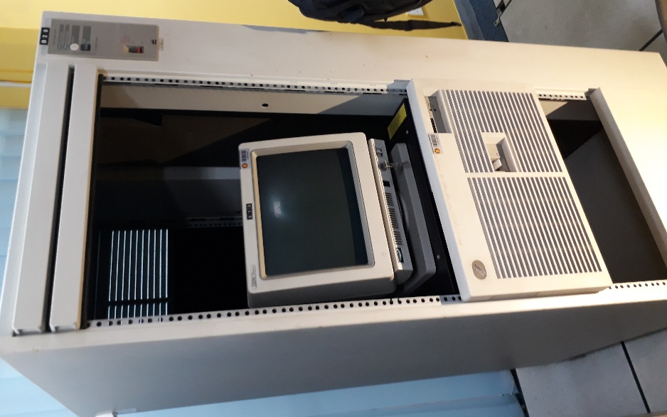
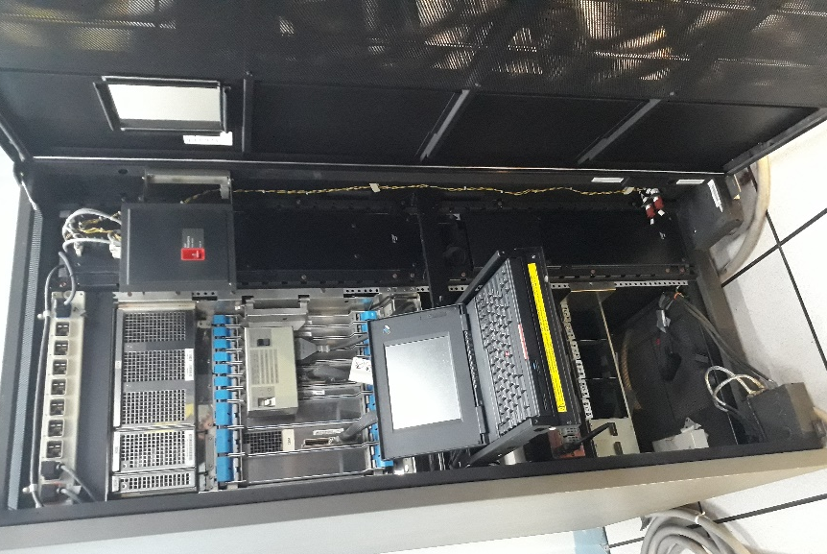
Mainframe Main System Power (IBM 9309 2) ^{[8]}
The 9309 Model 002 offers an industry-standard rack enclosure with 32 Electronic Industries Association (EIA) standard units. The 9309 Model 002 has side, top and bottom panels, and all cables enter and exit from the rear of the rack. The 9309 Model 002 is 1.6m (62.1 in) high, 650mm (25.6 in) wide, 921mm (36.3 in) deep, and weighs 138kg (303 lbs).
IBM Mainframe CPU (IBM 9672-R21) ^{[7]}
The 9672 Model R21 is a Parallel Enterprise Server that contains one CEC (two-way central processor). The CEC capacity includes: storage ranging from 128 MB to 2 GB and ESCON and/or Parallel channels up to 48 in increments of three. For IBM US, this model is no longer available as of December 29, 1998)
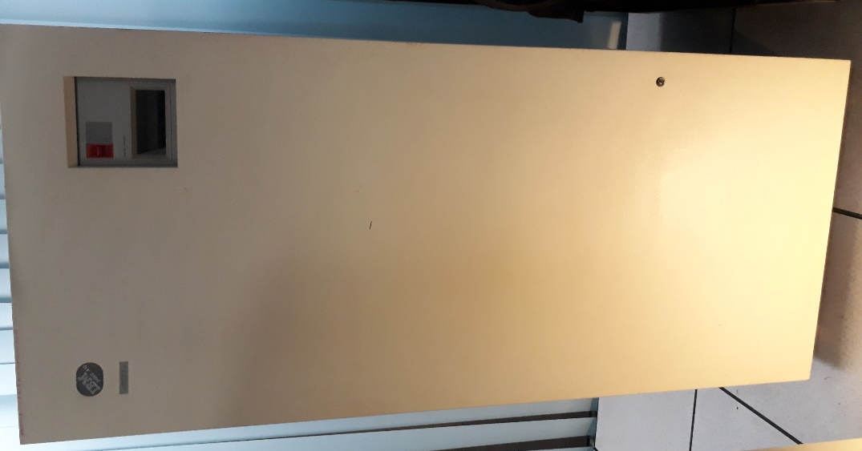
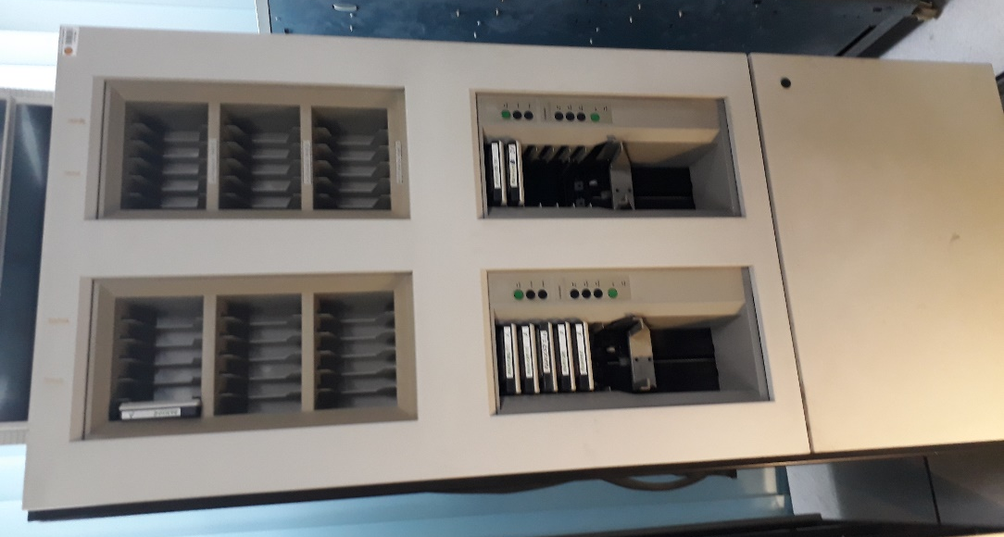
IBM Tape Drive Systems (IBM 3490E A10) ^{[9]}
In the early 1990s, IBM extended the capabilities of its 3480 product family by launching the 36-track 3490E drive and a new extended-length chromium dioxide tape. The 3490E provided 800MB of storage in the same cartridge format as the earlier 3480. With Improved Data Recording Capability (IDRC), introduced in 1986, the capacity of the 3490E was expanded to over 2.4GB, the highest data capacity at that time. At announcement, the A10 could be purchased for $62,100.

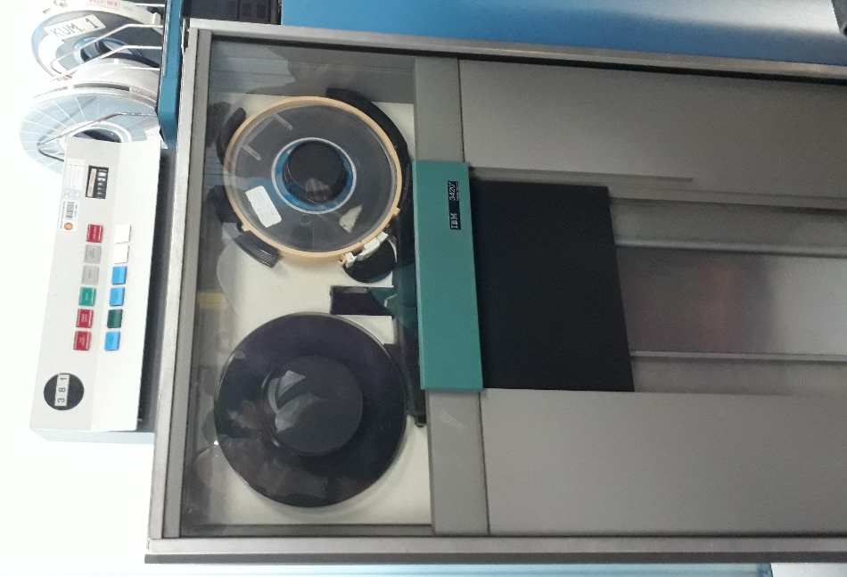
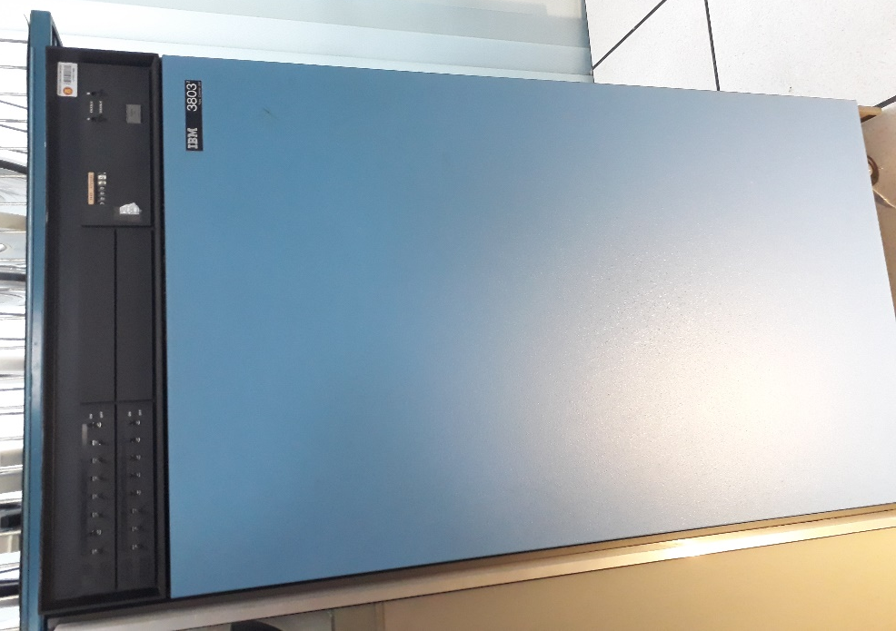

IBM Magnetic Tape Control Unit (IBM 3803) ^{[10]}

Although half-inch magnetic tape stores a great deal of information per unit volume at a relatively low cost, it does present certain limitations, the greatest being that of the time interval required for data access. To overcome this limitation, it would be necessary either to increase tape speed, increase density, decrease head-gap / data distance, increase the number of parallel tracks, or, for certain applications, raise the rewind speed. The IBM 3420 is the new tape drive and the IBM 3803 its control unit. Improved access time was achieved by positioning the readhead gap closer to the data, thereby reducing the access time interval in subsequent reads. Improved rewind time was achieved by more positive control over the tape as it enters the vacuum columns, and the control was obtained with a new configuration of tachometers for high-resolution tape speed information. The IBM 3803/3420 is a total replacement for any existing IBM 2803/2400 tape subsystem. The former now includes features called a two-channel switch, which allows connection to two separate channels, and device switching, which allows up to four control units to communicate with up to 16 tape drives.
IBM Magnetic Tape Unit (IBM 3420) ^{[10]}

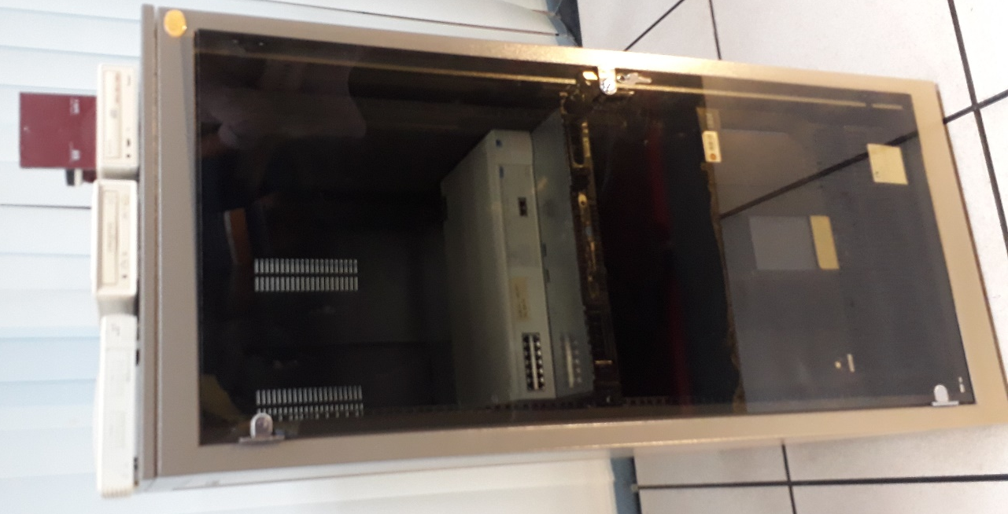
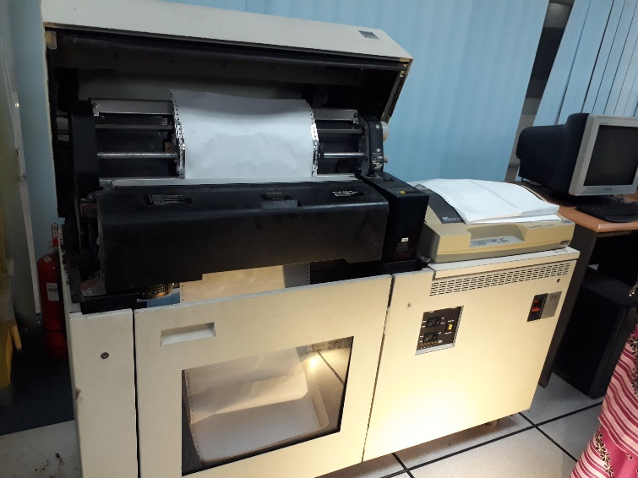
Rack Mount Server by Com-Rack ^{[12]}
A rack-mounted server is a computer dedicated to use as a server and designed to be installed in a framework called a rack. The rack contains multiple mounting slots called bays, each designed to hold a hardware unit secured in place with screws. A single rack can contain multiple servers stacked one above the other, consolidating network resources and minimizing the required floor space. The rack server configuration also simplifies cabling among network components. In an equipment rack filled with servers, a special cooling system is necessary to prevent excessive heat build-up that would otherwise occur when many power-dissipating components are confined in a small space.
Impact Printer (IBM 4245 12) ^{[11]}
The IBM 4245 is a line printer and can achieves a print speed of 1,200 lines per minute. This model attaches to the 3174 and 3274 Models 41 and 61 controllers, the 9370 Workstation Controller, and 4361 processor Workstation Adapter and Display/Printer Adapter.
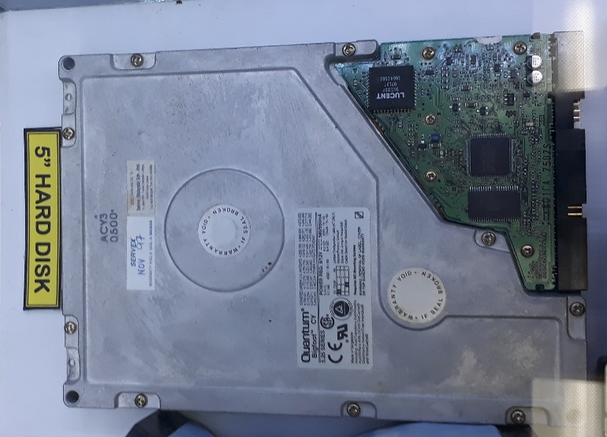
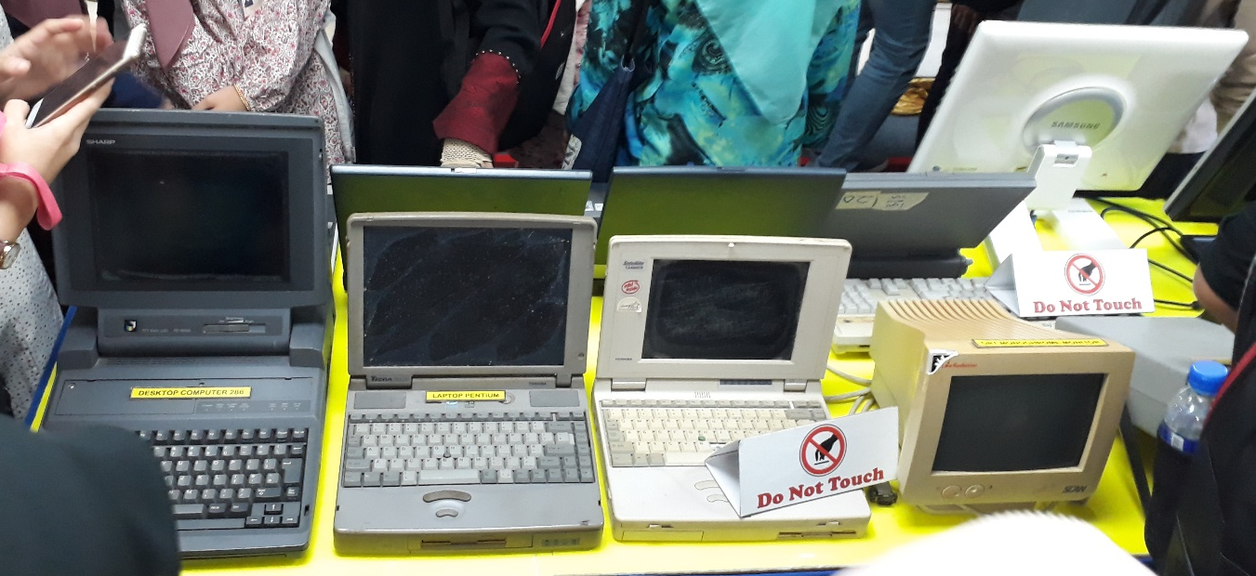
The Quantum Bigfoot Hard Disk
According to Speaker Mr. Mohd Zainudin, he mentioned that the Big Foot Hard Disk is the hardest hard disk ever.
Many ancient laptops and desktop computers are displayed in the gallerium included the Desktop Computer 286 (1st form left to right), Laptop Pentium (2nd) and CRT Monochrome Monitor (4th).
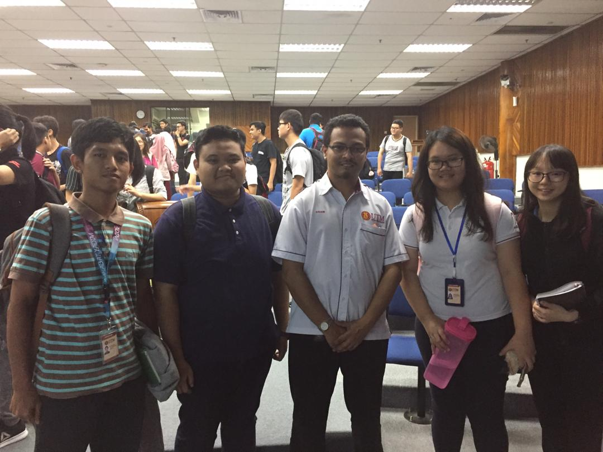
Our group get to take a photo with our speaker Mr. Mohd Zainudin. (From left to right: Muhammad Firdaus Bin Nor Azman, Idzni Bin Mohamed Rashid, Toon Shu Hui and Choy Wan Ling)
Job requirements and specifications:

As the IT is advancing at the high rate with the creation of new technology a lot of Job opportunities has opened up. However, different skill is needed with the advancement of IT to fulfil current roles in IT the sector either in research and development, manufacturing and other more. In CICT also also exist a lot of job opportunity and some special requirement and specification in IT career is required as well to be hired at this please. The job available in IT career include technician, programmer, web developer and other more.

IT Technician ^{[13]}

IT technicians advise people in computer installation processes and troubleshooting, and also maintain computer systems, provide technical support and teach their clients the basic skills they need to operate newly installed programs. Aspiring technicians can find certificate and degree programs in information technology and acquire industry-recognized certifications. There are several education options that teach the knowledge and skills needed for this job. Numerous certifications are available as well. This job is among demand job in digital company or other else.

IT technicians need strong knowledge of computers and how they operate, which includes having a broad understanding of hardware and software, operating systems and basic computer programming. Familiarity with electronic equipment, Internet applications and security may also be required. Technicians may also need good communication skills because this position requires frequent interaction with clients.

Many employers prefer to hire an IT technician who has some level of formal training with global recognised certificate or bachelor's degree in computer science, information technology or computer information systems. Courses in these programs may cover from computer security, hardware configuration to technical support. Students can also learn about database programming, operating systems and software installation.

While not all companies require IT technicians to be certified, taking the extra step to earn a certification can show employers that technicians have the required skills and training to fulfil job requirements. Common certifications for IT technicians include A+ and Linux+ certifications offered by CompTIA. IT technicians can also pursue Microsoft Certified IT Professional and Cisco Certified Network Associate credentials. The International Information Systems Security Certification Consortium offers a variety of certifications for IT professionals pursuing information security positions.

According to the most recent information provided by the U.S. Bureau of Labor Statistics (BLS), computer support specialists could see employment growth of 12% between 2014 and 2024 (www.bls.gov). Upgrades to existing systems should play a major part in this employment growth. In May 2015, the BLS reported that computer user support specialists earned an average wage of $25.21 per hour.

An information technology technician is a computer support person who can work for various companies. They should have an associate's degree, bachelor's degree, or certificate in a computer field. IT technicians may look into obtaining certifications to promote job potentiality

Required Education | Associate's or bachelor's degree or certificate
Certification | Voluntary; options include A+ certification,  Linux+ certification,  Microsoft certified IT professional certification,  Cisco certified network associate certification,  International information systems security certification consortium certification
Projected Job Growth (2014-2024) | 12% for all computer support specialists
Average Salary (2015) | $25.21 per hour for all computer user support specialists
Source: *U.S. Bureau of Labor Statistics

Computer Scientist ^{[14]}

Computer scientists conduct research to develop new computer technologies in order to solve problems in a variety of fields. A doctoral degree is usually required for this career although there might be some opportunities with only a bachelor's degree. Computer scientists develop new technologies, systems and computer-based solutions. The most common educational requirement for advanced research positions in the field is a doctorate degree in computer science; however, those working for the federal government may hold only a bachelor's degree in computer science or a similar field. A career as a computer scientist is most suitable for those who have strong math skills and are detail-oriented.

Computer scientists, also called computer and information scientists, can work for government agencies and private software publishers, engineering firms or academic institutions. Businesses and government agencies usually employ these scientists to develop new products or solve computing problems. Computer scientists employed by academic institutions are typically involved in more theoretical explorations of computing issues, often using experimentation and modelling in their research.

Computer scientists often work as part of a research team with computer programmers, information technology professionals, and mechanical or electrical engineers. Their research often is used to design new computer technology. They typically investigate technological topics like artificial intelligence, robotics or virtual reality. The results of their research can lead to the improved performance of existing computer systems and software as well as the development of new hardware or computing techniques and materials.

Most computer scientists hold a bachelor's degree with a major in computer science, information systems or software engineering. After completing this 4-year program, computer scientists often earn a Ph.D. in computer science, computer engineering or a similar area of study. This additional program includes coursework in hardware and software systems, program languages and computational modelling as well as a research project.

Required Education | Bachelor's or doctoral degree in computer science
Projected Job Growth (2014-2024) | 11% (all computer and information research scientists)
Average Salary (2015) | $115,580 (all computer and information research scientists)
Source: *U.S. Bureau of Labor Statistics

In May 2015, the U.S. Bureau of Labor Statistics (BLS) reported that computer scientists earned a mean annual wage of approximately $115,580. The BLS also forecast that job opportunities for these professionals would increase 11% between 2014 and 2024, which is faster than average Computer scientists not only work with cutting edge technologies, but they develop them too. Due to the amount of research that computer scientists conduct, those with a doctoral degree in either computer science or a related field will have the greatest prospects. If one wishes to specialize in his or her research, choosing a concentration in a particular subfield is ideal.

Web Developer ^{[15]}

A web developer works as an employee or contractor creating web-based applications for a company. Web developers should understand various programming languages and web design. A bachelor's degree is the typical academic requirement for this occupation.

Web developers use design and programming software to create Internet websites. They determine the website's content and implement the tools, links and other aspects that make the site effective for its audience. This career generally requires a bachelor's degree that is related to computer science, although exceptions may be made for those with the required skills and professional experience. These professionals also must possess an understanding of programming languages, database management and Web design. Although it is optional, Web developers can seek industry certification through such vendors as Microsoft.

Many employers prefer prospective Web developers to hold a bachelor's degree in computer science or a related field. Coursework often includes programming, database management, mathematics, Web design and networking. Work experience accompanied by a professional certification may be an adequate substitute for formal education in some cases. Certification in current Web development systems and software may benefit an applicant, especially one without a bachelor's degree. Such certifications are available through continuing education institutions, software companies or professional associations.

Microsoft, for example, offers the Microsoft Certified Professional Developer certification, which requires applicants to pass the Microsoft Certified Technology Specialist exam and have 2-3 years of relevant work experience. The World Organization of Webmasters also offers three levels of certification related to Web developers, all of which include an exam that assesses varying levels of proficiency in programming, Web design, Web security, database management, servers and networking.

Required Education | Bachelor's degree related to computer science
Other Requirements | Optional certification through software companies and professional organizations
Projected Job Growth (2014-2024) | 27%
Average Annual Salary (2015) | $70,660
Source: *U.S. Bureau of Labor Statistics

Common entry-level job titles in Web development include Web designer, webmaster and graphic artist. Increased education and work experience can lead to advanced positions such as senior Web developer, designer and software designer. The U.S. Bureau of Labor Statistics (BLS) forecast that careers in Web development would grow by 27% from 2014-2024, which is much faster than average. Web developers with programming and multimedia expertise should have the best job prospects. As of May 2015, the average annual wage for Web developers was $70,660, according to the BLS.

To become a web developer, one should usually earn a relevant bachelor's degree, though gaining a decent amount of work experience and obtaining professional certification is occasionally sufficient. A 27% increase in employment openings is expected between 2014 and 2024, so job prospects should be promising.

Conclusion

From time to time, technology has advanced sophisticatedly and forward. Therefore, humans need some technology to make their lives better. For example, in hospital, for immune deficiency patients they will need technology which could help them to breathe. Then, every educational institution, students and teachers need internet technology to search for information quickly and accurately. Here, we can say that the human mind is constantly changing in line with the times.

Therefore, it becomes a task for Centre and Information Communication Technology (CICT) to facilitate all students, lecturers and staff with a wealth of useful software.

Reflection in this report, our goals regarding to our course in line with the mission of the School of Computing University Technology Malaysia is to be a leader in the development of high-quality society, innovation and services in ICT that will contribute to the nation’s wealth creation. We also want to produce excellence IT professionals that will fulfil the need of industry in Information Technology because all the companies nowadays need IT professionals to handle their computer and systems.

Our goals also include building a special program that encourages all ages to learn IT and promote IT culture to citizen and society. We want to create an activity that can promote innovation in design technology, invite the community to participate in entrepreneurship in terms of shaping the business using technology. Thus, our country will be more comparable in global.

The impact of this visit to our goals with regard to our program is that we are able to learn in detail how CICT itself works well. We also get to know how hardware technologies evolve quickly and sophisticated. For example, an old mainframe could change to a new one in within a very short period and a laptop that has old operating systems has already changed to one with functions similar to desktop nowadays.
In addition, this visit encourages us to continue to learn actively so that we achieved our gaol successfully. It also sparks ideas in us to develope Malaysia's technological innovation which is easy to use and can be accepted by all generations. Besides, it helps us to manage our skills and monitor network performance while able to predict and plan the future growth of computer networks.

The benefits of Centre of Information and Communication Technology, CICT to students are that they provided the study laboratory that inside there have computers, project discussion area (3A), printing, scanning CD/DVD burn and for multimedia students they also have an authoring production lab. They also made UTMID for students which enable them to access UTMWIFI. If students need an access to UTM pages which only can be assessed within UTM university area, they can log in to Virtual Private Network, VPN.

CICT also created a special portal called “MyUTM” which have student personal information. There, students can see their results and GPA/CGPA, downloading all lessons reference provided by lecturers and etc. CICT also as a support unit and ICT services for university.

The actions that necessary for us to improve our potential in the industry is that firstly, we need to learn proper etiquette so that we can respect each other, able to work together with colleagues, and be able to receive as well as give opinion to each member of the group. Secondly, always be alert to each of the activities that involve technological revolution cause nowadays different brands always compete frequently with each other to be the first brand.

Thirdly, always identify the problem frequently faced by an industry in terms of computer technology in order to make a thoughtful problem solving. Lastly, always active in class and participate in all activities organized by the University. Thus, as a result we are able to build self-confidence and better thinking skills and build smooth communication to communicate with colleagues.
End of the report; do not be afraid to seek knowledge. As we learn increasingly diligent, as a result we will become increasingly ingenious in anything. Colin Powell once said.

“Success is the result of perfection, hard work, learning from failure, loyalty and persistence.”

References

- http://cict.utm.my/ ; CICT UTM ; last surveyed on 09th October.

- http://cict.utm.my/wp-content/uploads/polisi/PolisiVersiBM.pdf ; ICT Policy CICT ; last surveyed on 09th October 2018.

- https://www.argecy.com/3471 ; Argecy Computer Cooperation ; last surveyed on 09th October 2018.

- https://www.argecy.com/3274 ; Argecy Computer Cooperation ; last surveyed on 09th October 2018.

- http://www-01.ibm.com/common/ssi/printableversion.wss?docURL=/common/ssi/rep_sm/2/877/ENUS9394-002/index.html&request_locale=en ; IBM ; last surveyed on 09th October 2018.

- https://www-03.ibm.com/ibm/history/exhibits/storage/storage_3430.html ; IBM ; last surveyed on 09th October 2018.

- http://www-01.ibm.com/common/ssi/ShowDoc.wss?docURL=/common/ssi/rep_sm/2/897/ENUS9672-_h02/index.html&lang=en&request_locale=en ; IBM ; last surveyed on 09th October 2018.

- http://www-01.ibm.com/common/ssi/ShowDoc.wss?docURL=/common/ssi/rep_sm/2/760/ENUS9309-002/index.html&lang=en&request_locale=en ; IBM ; last surveyed on 09th October 2018.

- https://www-03.ibm.com/ibm/history/exhibits/storage/storage_3490.html ; IBM ; last surveyed on 09th October 2018.

- https://pdfs.semanticscholar.org/3db1/d6eaed080bb3de257c97364bbbec1fdeff52.pdf ; The IBM 3803/3420 Magnetic Tape Subsystem by J. W. Irwin, J. V. Cassie and H. C. Oppeboen ; last surveyed 10th October 2018.

- https://www.argecy.com/4245 ; Argecy Computer Cooperation ; last surveyed on 10th October 2018.

- https://whatis.techtarget.com/definition/rack-server-rack-mounted-server ; whatis.com ; last surveyed 10th October 2018.

- https://study.com/articles/Information_Technology_Technician_Job_Description_and_Education_Requirements.html ; study.com ; last surveyed 13th October 2018.

- https://study.com/articles/Computer_Scientist_Job_Description_Duties_and_Requirements.html ; study.com ; last surveyed 13th October 2018.

- https://study.com/articles/Web_Developer_Education_Requirements_and_Career_Information.html ; study.com ; last surveyed 13th October 2018.

