
SCSI 2143 – PROBABILITY & STATISTICAL DATA ANALYSIS
PROJECT TITLE :- THE STUDY OF STUDENTS’ FINANCIAL ABILITY DURING THEIR STUDIES IN UTM.

LECTURER’S NAME: DR. NOR ERNE NAZIRA BAZIN
GROUP MEMBERS:
- AINA MARDHIAH BT ABDUL RUSLI (A17CS0007)
- FATIN NADHIRAH BT ABDULLAH (A17CS0046)
- TUNKU SHARIFAH AINUN NABILA BT TUNKU SYED AZHAR (A17CS0300)

INTRODUCTION
Nowadays, money has become an essential for every person in the world, especially for university students. This is because financial is considered as the main resource for students to finance university life. Financial problems can be said into many aspects, either you are facing or not, it’s beyond our imagination. In conjunction of that, we chose to investigate more about this matter in our project.
In this project, we are trying to figure out the number of students in UTM who are having financial problems. The reason why we are interested in this project is because we wanted to know the percentage of students that are having financial problems.
From the data that we have obtained, we hope that we can see this an opportunity to know the number of students having problem in financial and also to get the opinions on how to improve financial problem in our country.

DATA COLLECTION
Through questions from our survey, the type of data and scale of measurement are stated as below:
No | Variable | Type of data | Level of measurement
 | Gender | Nominal | Qualitative
 | Year | Nominal | Qualitative
 | Faculty | Nominal | Qualitative
 | Course | Nominal | Qualitative
 | The number of siblings | Discrete | Quantitative
 | Average of parents’ monthly income | Ratio | Continuous
 | Financial source | Discrete | Quantitative
 | The amount of money that spent in a day | Discrete | Quantitative
 | Do you have any hardship (financially) while studying in UTM? | Discrete | Quantitative
 | Have you ever borrow money to make a living? | Ordinal | Qualitative
 | Have you ever experienced for not having any meal in a day? | Ordinal | Qualitative
 | Do you think it is necessary for you to get more income? | Nominal | Qualitative
 | If yes, choose or suggest a way to get more income | Ordinal | Qualitative

DATA ANALYSIS

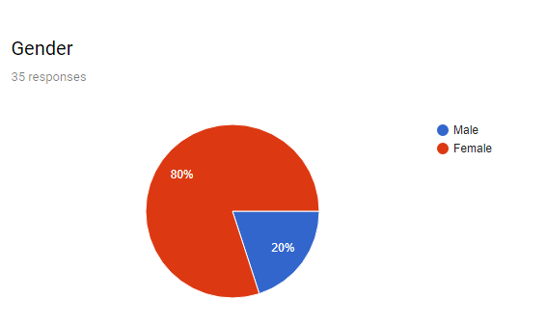
Graph 1
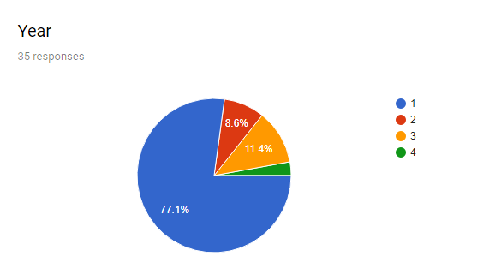
Graph 2

To analyse overall of our survey, there are about 28 females and 7 males who answered our questionnaire (Graph 1). Most of them are from year 1, 3 persons from year 2, 4 persons from year 3 and one person from the 4th year student (Graph 2).

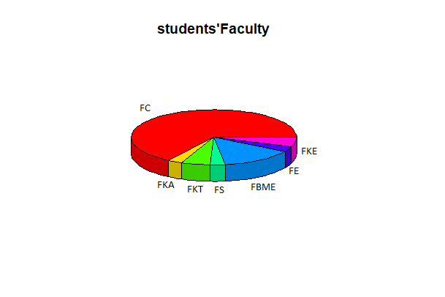
Graph 3
As how the graph shows at Graph 3, Faculty of Computing has dominated the most number of students who answered our questionnaire, while others are from other faculty in UTM as well.

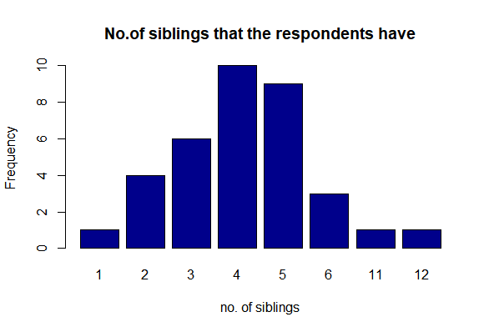
Graph 4
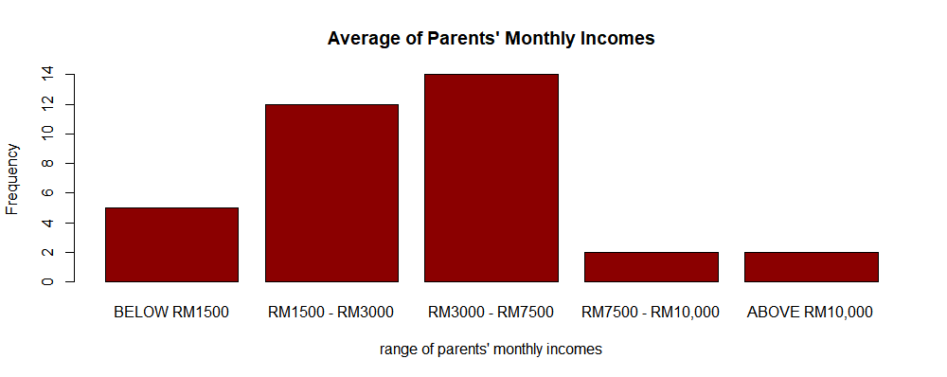
Graph 5

No | Average Monthly Income(RM) | Statistical Value
 | Mean | 5.086
 | Lower bound:  Upper bound: | 1  3
 | Median | 5.107
 | Variance | 4.303
 | Standard deviation | 2.074
 | Minimum | 2
 | Maximum | 14
 | Range | 12
Table 6
Based on Graph 4, we can see that the most answers from the respondents are 4 siblings in a household, while the least number of siblings by respondents are only one, 11 and 12 siblings. Moreover, the average of parents’ monthly incomes is in the range of RM3000 – RM7500, whereas the least are RM10,000 and above which is stated at Graph 5. This shows that most of the students are not from a high-end family and comes from the average family, which can also be seen at Table 6.
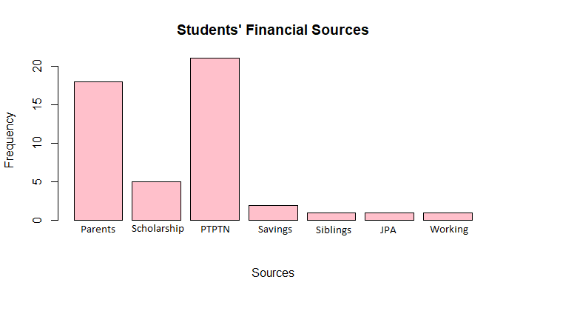
Graph 7

As for the financial sources at Graph 7, we can conclude that most of the students’ financial sources came from PTPTN (loan), whilst the second most answer for the students’ financial sources are from their own parents. The other answers that stated are through scholarships, savings, siblings and loan from JPA.
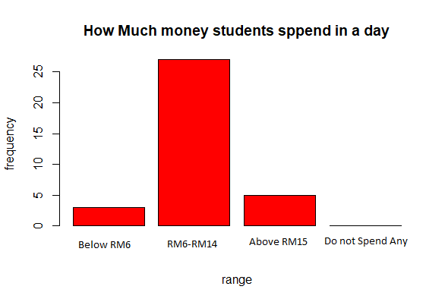
Graph 8

Based on Graph 8, we can say that the average that student spend their money in a day is from RM6 – RM14, while none of them does not spend any of their money in a day, which means, they do spend their money to eat in a day, at least. As for the least response, we can conclude that some students do spend for their meals above RM15.

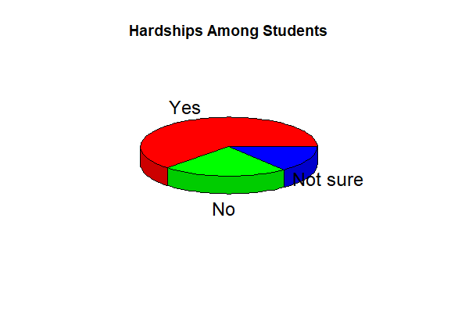
Graph 9
From our survey, we found that most of our respondent are having hard time financially which is 22 people while there are 8 respondent that answered they aren’t having hardship in financial. The others answered that they are not sure whether they are having hardship or not in financial.

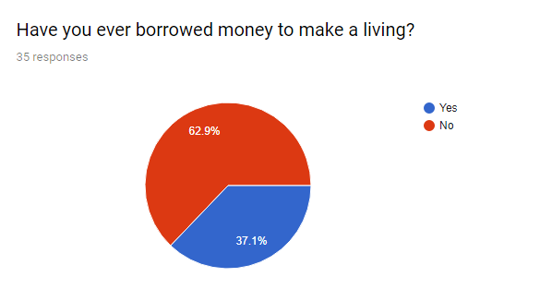
Graph 10
From the data that we collected, 13 respondents answered that they have borrowed money to make a living while 22 respondents answered that they haven’t borrow money from anyone.

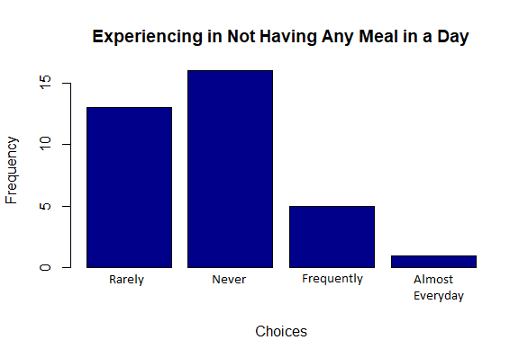
Graph 11

Graph 11 shows UTM students’ answers to a survey, which asked them if they have experienced in not having a meal in a day. It can be seen that 45.7% of those surveyed has never experience in not having any meal in a day. 37.1% respondents said they rarely experience for not having any meal in a day while 14.3% respondents is frequently for not having a meal in a day. However, there is one respondent that answered that he has experienced for not having any meal in a day.

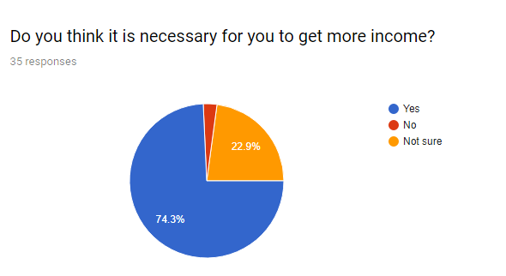
Graph 12
Over half said they think it is necessary for them to get more income while 8 respondent answered they are not sure if it necessary for them to get more income or not. While the rest of the respondent answered that it is not necessary for him to get more income.

CONCLUSION
In conclusion, we can conclude that most of the UTM students did experienced in having financial problem while studying in UTM. This is because half of the respondents declared that they are having financial problem in our questionnaire.
Based on the survey we did on how to improve financial problem in our country, we can conclude that by giving a lot of job opportunities and scholarships can help us to solve and improve financial problem in our country.
Last but not least, we hope that more people will realize about financial problem among the students’ especially in UTM students and also with the survey we did, we hope that it can improve more on our country financial problem.

